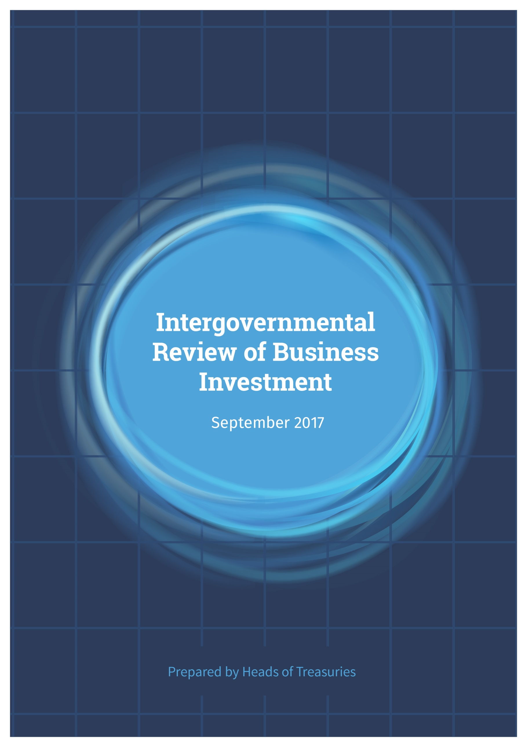

© Commonwealth of Australia 2017

ISBN 978-1-925504-67-5

This publication is available for your use under a [Creative Commons BY Attribution 3.0 Australia](http://creativecommons.org/licenses/by/3.0/au/deed.en) licence, with the exception of the Commonwealth Coat of Arms, third party content, the Treasury logo, photographs, images, signatures and where otherwise stated. The full licence terms are available from <http://creativecommons.org/licenses/by/3.0/au/legalcode>.

CC by_grey

Use of Treasury material under a [Creative Commons BY Attribution 3.0 Australia](http://creativecommons.org/licenses/by/3.0/au/deed.en) licence requires you to attribute the work (but not in any way that suggests that the Treasury endorses you or your use of the work).

**Treasury material used ‘as supplied’**

Provided you have not modified or transformed Treasury material in any way including, for example, by changing the Treasury text; calculating percentage changes; graphing or charting data; or deriving new statistics from published Treasury statistics — then Treasury prefers the following attribution:

*Source: The Australian Government and Heads of Treasuries*

**Derivative material**

If you have modified or transformed Treasury material, or derived new material from those of the Treasury in any way, then Treasury prefers the following attribution:

*Based on The Australian Government and Heads of Treasuries data*

**Use of the Coat of Arms**

The terms under which the Coat of Arms can be used are set out on the It’s an Honour website (see [www.itsanhonour.gov.au](http://www.itsanhonour.gov.au)).

**Other Uses**

Inquiries regarding this licence and any other use of this document are welcome at:

Manager  
Communications  
The Treasury  
Langton Crescent Parkes ACT 2600  
Email: [medialiaison@treasury.gov.au](mailto:medialiaison@treasury.gov.au)

Contents

[Summary 1](#_Toc496097048)

[Introduction 5](#_Toc496097049)

[Macroeconomic factors 7](#_Toc496097050)

[An unusual decade 7](#_Toc496097051)

[Structural factors 14](#_Toc496097052)

[Business strategies and risk appetite 16](#_Toc496097053)

[Uncertainty and firm behaviour 18](#_Toc496097054)

[Ai Group survey of Chief Executive Officers 22](#_Toc496097055)

[Institutional settings and policies 23](#_Toc496097056)

[Regulation and red tape 25](#_Toc496097057)

[Competition 28](#_Toc496097058)

[Supplier payment times 29](#_Toc496097059)

[Small business finance 29](#_Toc496097060)

[Energy 31](#_Toc496097061)

[Taxation 33](#_Toc496097062)

[Policies to support a transitioning economy 34](#_Toc496097063)

[Innovation 34](#_Toc496097064)

[Skills and the labour market 36](#_Toc496097065)

[Infrastructure 37](#_Toc496097066)

[Appendix A: stakeholders consulted 39](#_Toc496097067)

# Summary

In recent years, business investment in Australia, outside the mining sector, has underperformed relative to expectations given the trajectory of the broader economy. This has been of concern to Australian governments because business investment is critical to economic growth. In December 2016, the Council on Federal Financial Relations tasked Heads of Treasuries with exploring factors that might be impeding a broader recovery in business investment. To investigate this, Heads of Treasuries consulted widely with industry over several months during 2017 and prepared this report of observations for the consideration of the Council on Federal Financial Relations.

Business investment, which is critical to economic growth,  
has been underperforming in  
recent years.

Why is this the case?

Our consultations reveal a complex mix of factors:

* Positive and negative spill overs from the mining boom
* Slow recovery of confidence from the global financial crisis
* Evolving technological landscape and shifts in demand to less capital intensive sectors
* Changing business strategies and low appetite for risk
* Elevated uncertainty: technological innovations, macroeconomic, geo‑political and domestic policy
* High regulatory and tax burden
* Energy affordability and reliability
* Working capital constraints for small and medium‑sized enterprises.

Investing in new productive capacity creates employment, raises future incomes and both creates and embodies new innovation. While lacklustre business investment is not a problem unique to Australia, it is important to understand what is happening in our domestic context. Already over the past year Australian business investment data has been more positive and are showing promising signs of a recovery. Business investment has grown in the past three quarters after a prolonged period of weakness.

The environment for business investment in Australia has been influenced in the past decade by a mix of cyclical and structural factors. An important factor for Australia’s aggregate economic performance during this time has been the rise in demand for minerals and energy from large emerging economies like China. In response to higher prices, Australia’s mining sector experienced a once-in-a-hundred year investment boom to build new supply capacity. The rise in income generated through this sector had many positive impacts on the resource-rich ‘mining’ States during the boom. More recently the income spill-overs have been operating in reverse as prices have moved lower.

The trend in business investment in sectors outside of mining has been less encouraging over the past decade. Initially the spill-overs from the mining sector put upward pressure on the exchange rate and labour costs, and created challenges for businesses outside of the mining industry. Separate from the commodity cycle there was weak international demand as advanced economies slowly recovered from the global financial crisis (GFC). As commodity prices subsequently fell, slow national income growth has dampened domestic demand. The continued low interest rates, a pick-up in international demand and a lower exchange rate in recent years have not translated into the expected increase in non-mining business investment, though there have been promising signs of recovery recently.

Structural factors explain some of the weakness in  
non-mining business investment. There is a global trend, particularly in advanced economies like Australia, towards less capital intensive services as a larger share of the economy. This ongoing shift, combined with new technology, means there is a greater role for the skills of the labour force. Not all human capital investment is captured in business investment measures. Meanwhile the rapidly evolving digital landscape is creating as much cause for concern for existing businesses as are the opportunities for new businesses. Technological disruption is happening at a rapid pace, transforming industries and the competitive landscape.

Our consultations with businesses found that growth is not broad based, with variable sectoral and regional outlooks for demand. While some businesses indicated strong investment intentions and strategies to expand and grow their businesses, others indicated that business investment is increasingly being targeted at reducing costs and increasing operational efficiency. Other defensive business strategies evident include aggressive capital management approaches such as increasing debt to equity ratios, increasing dividend payout ratios, share buybacks and expansion via mergers, acquisitions and other brownfield investment strategies. A persistent theme from contacts was a lower risk appetite from both corporate boards of directors and investors. Over time, investors have expressed a preference for solid, steady returns over potentially higher returns due to the associated risk of volatility with the latter.

Our consultations highlighted the prominence of a sense of elevated uncertainty. There was almost universal feedback that uncertainty has been elevated for the past decade and that this is impacting firm behaviour – both business strategy and investment decisions. Sources of uncertainty of concern to businesses included the impact of technological innovations and disruption in the economy, global economic uncertainty, geo-political uncertainty and domestic policy continuity at all levels of government. There is a strong view that coming out of the financial downturn, the psychological impacts described as the ‘scars’ of the GFC on business decision‑makers, are deeper and more extensive than we had originally expected.

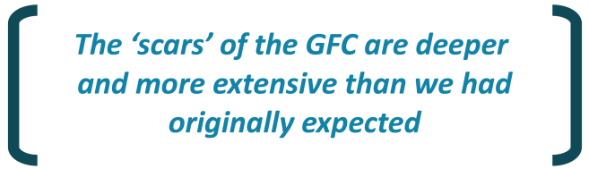

The GFC introduced new risk premia for advanced economies – meaning tail events, that is, low probability, high impact events, now weigh on the minds of business leaders and financial managers. It was suggested that this is reducing the risk appetite for sections of the business community. Businesses consulted were clear that, while much of the uncertainty is outside the control of Australian governments, the focus for governments should be on reducing their contribution to uncertainty.

The energy sector was raised as an example where appropriate regulatory and policy settings are vital for investment decisions. Affordable and reliable energy is crucial for investment decisions by small and large businesses across Australia as energy is a ubiquitous expense for all businesses and households. Resolution of uncertainty around energy policy is critical to build confidence in electricity affordability and reliability. Signals for new long-term generation investments require a nationally agreed and widely supported policy framework.

All levels of government influence the business environment as they set the institutional frameworks in which businesses operate. Governments need to strike the right balance between desired public policy objectives whilst allowing businesses to thrive. Concerns were raised at all of the roundtable discussions about the red-tape cost of doing business in Australia and the impact of the regulatory environment on the investment environment. A high regulatory burden, both in terms of the sheer volume of regulation and compliance costs, was identified as an impediment to business investment. Governments need to be vigilant in their efforts to reduce unnecessary regulatory burden, and place a greater focus on evaluating the burden of regulatory changes after they are made.

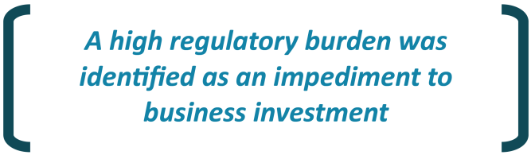

Regulatory settings need to enable and encourage effective competition and should promote innovation by businesses across all types of business. Small and medium-sized enterprises (SMEs) raised a range of issues around large firms with market power. Payment times by large suppliers and access to credit and the cost of debt financing were concerns for some SMEs.

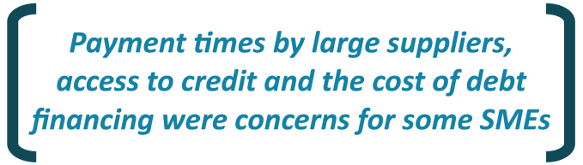

SMEs also raised concerns about State payroll taxes which are considered by some as a dis-incentive for companies to expand. Australia’s high corporate tax rate by international standards was identified as a barrier to investment as it sets a higher rate of return hurdle for new investments in Australia than in other countries. This gap has widened in recent years and is set to widen further. Businesses were concerned that large multinational companies not paying their ‘fair share’ of tax put other businesses at a competitive disadvantage – a level playing field is required.

The strength and stability of institutional arrangements impact on firm behaviour. Businesses are concerned that sudden reviews of longstanding policies can create uncertainty that discourages investment. Despite this, stakeholders acknowledge that policies need to change over time. As such, businesses emphasised the importance of ensuring that when policy is changed, this is an appropriate process – one that has adequate consultation and sensible implementation timeframes. Disingenuous consultations and reviews for purely political reasons are not well received.

Governments can implement well-designed policies to support structural transitions in the economy, such as for example, the National Innovation and Science Agenda. It was noted that Australia generally has a risk averse culture, which is negatively impacting on our innovation capabilities. Regulatory settings should support an environment for innovation, but should strike a balance in protecting investors.

The influence of new digital technology was broadly canvassed by business. Businesses were concerned about accessing the required skills and knowledge to create measurable value from investments in digital and other technologies. They urged the education system to continue to respond to the changing needs of the Australian economy, and acknowledged that industry has a role in training and signalling skills needs. Attracting and retaining skilled labour can be even more challenging for SMEs. Skilled visas should continue to act as a supplement to domestic skills shortages.

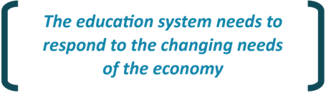

During our consultations, a broad range of factors impacting business investment in Australia were identified. While no single policy lever was identified, governments at all levels need to understand the mix of factors and continue to work to improve the investment environment. Continued cooperation and coordination between the Commonwealth and State Governments is clearly being requested by the business community. Now is the time for governments to redouble efforts to make Australia a better place to do business.

|  |
| --- |
| observations |
| Following extensive consultation, to review impediments to business investment, Heads of Treasuries note the following observations drawn from stakeholder’s views for consideration.  Stable macroeconomic conditions, through credible monetary policy frameworks, responsible fiscal policy and sound financial sector regulatory environments, remain central to long-term demand and growth in investment.  Predictable, stable and transparent business regulation and supervision, at all levels of government, is an important precondition for business investment. Developments in government policy and regulations, notably at the intersection of State and Commonwealth roles and responsibilities, continue to remain a source of uncertainty for many participants. A greater engagement with stakeholders at the onset, with appropriate lead times, can help provide a smoother transition for affected parties.  Given the long timeframes of many investments, the tax environment and policies should remain relatively stable and avoid creating impediments to new investment, particularly in terms of international competition. They should be subject to regular monitoring to prevent abuse. Tax neutrality towards different forms and structures of investment financing should be promoted.  Competition policy enables efficient businesses of all sizes to thrive and reduces unnecessary impediments to innovation. Competition policy should continue to develop and ensure that markets work in the long-term interests of consumers, as well as encouraging innovation, entrepreneurship and the entry of new players.  Heads of Treasuries propose further work in three specific areas:  There is widespread concern about the level of red-tape required to do business in Australia and businesses urged genuine efforts to ease the cumulative regulatory burden. A clear framework for making and managing regulation, rather than a single focus on red tape reduction, should be advocated across all levels of government. As a starting point, a greater focus should be placed on evaluating the burden of regulatory changes after they are made, as well as before. Selecting a small number of meaningful reform areas of regulation and significantly reducing the compliance burden in these could have meaningful impacts for industry.  Concerns were raised about the ability of firms to access skilled and qualified employees, which can be particularly challenging in smaller States, regional areas and for SMEs (regardless of location). Investment in human capital through the education and training system and the pool of skilled migrants available through immigration (e.g. skilled visas) requires constant attention to reduce skilled labour shortages. The Australian economy will continue to face the forces of technological change, ageing and globalisation, and both the education and immigration systems need to evolve to meet those demands. Consideration of the ‘future of work’ should be at the forefront of planning for industry and regional transitions. Skilled visa programs should continue to act as a supplement to skill shortages with flexibility depending on need in different parts of the country and industry sectors.  There is significant concern around energy prices, availability and reliability. Given the importance of energy inputs into the broader economy, this policy area will remain an ongoing area of interest for Treasurers. |

# Introduction

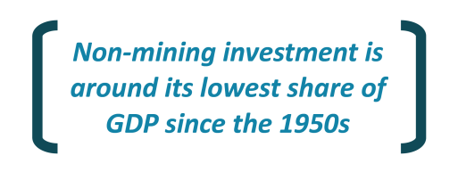In recent years, business investment in Australia, outside the mining sector, has underperformed relative to expectations given the trajectory of the broader economy. Non-mining investment is around its lowest share of gross domestic product (GDP) since the 1950s. While lacklustre business investment is not a problem unique to Australia, it is important to understand what is happening in our domestic context.

Business investment is critical to economic growth; investing in new productive capacity creates employment, raises future incomes and both creates and embodies new innovation (Box 1). Given the importance of business investment for the Australian economy, the Council on Federal Financial Relations, which comprises the Commonwealth and State Treasurers, tasked Heads of Treasuries with exploring factors that might be impeding a broader recovery in business investment.

The objective of this Review of business investment was to consult directly with a broad range of businesses (small, medium and large) and peak industry bodies to identify impediments to business investment in the Australian context.[[1]](#footnote-2) In total, views were sought from over 150 small, medium and large businesses and peak industry bodies across a range of industries. Of these, 25 provided written input and over 50 attended roundtable discussions in Darwin, Sydney, Perth, Adelaide, Hobart, Melbourne and Brisbane. A series of one-on-one consultations from other stakeholder activities were inputted into the analysis.

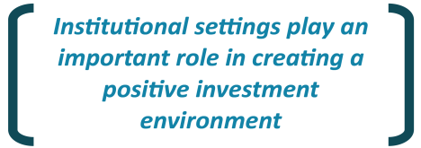The Review has sought to understand the major factors that drive investment decisions at the firm level. The consultations identified a mix of factors that are considered impediments to business investment (Figure 1). The various factors have been grouped into ‘macroeconomic’ factors and ‘institutional/policy’ factors, in seeking to identify which of the factors fit squarely within the realm of government influence, as opposed to factors determined by the broader macroeconomic environment. This report focusses on the concerns raised in the policy realm. This has enabled Heads of Treasuries to consider the role of institutional settings in creating a positive investment environment and better understand what policy levers should be of particular focus in improving business investment.

The report provides an introduction to the broader economic context and draws out relevant stakeholder comments which support the Review’s main findings and observations. In addition to the specific observations made in this report, the wealth of knowledge gathered through this review process is informing policy development within governments more broadly. We thank everyone who participated for their valuable input (Appendix A).

|  |  |
| --- | --- |
|  | Box 1: weak business investment – why worry? |
|  | Business investment is vital to the Australian economy. It accounts for about 13 per cent of Australia’s GDP and is an important determinant of future economic capacity. In recent decades, Australia’s labour productivity growth has largely been driven by capital deepening — that is, increasing capital per worker.[[2]](#footnote-3) Investment can be divided into a component that goes to the maintenance of existing capital and a component that increases the capital stock. The former expands as the capital stock gets larger and maintenance needs increase, but it is the latter component that drives capital deepening. Investment is a key determinant of productivity and in turn, Australia’s long-term potential economic growth and living standards. Investment is important for innovation and provides the main channel by which new technologies are applied to the production process. Weak business investment is not just about the current performance of the economy, it is much about the future. |

Figure 1: Consultations identified a broad range of factors that  
impact business investment

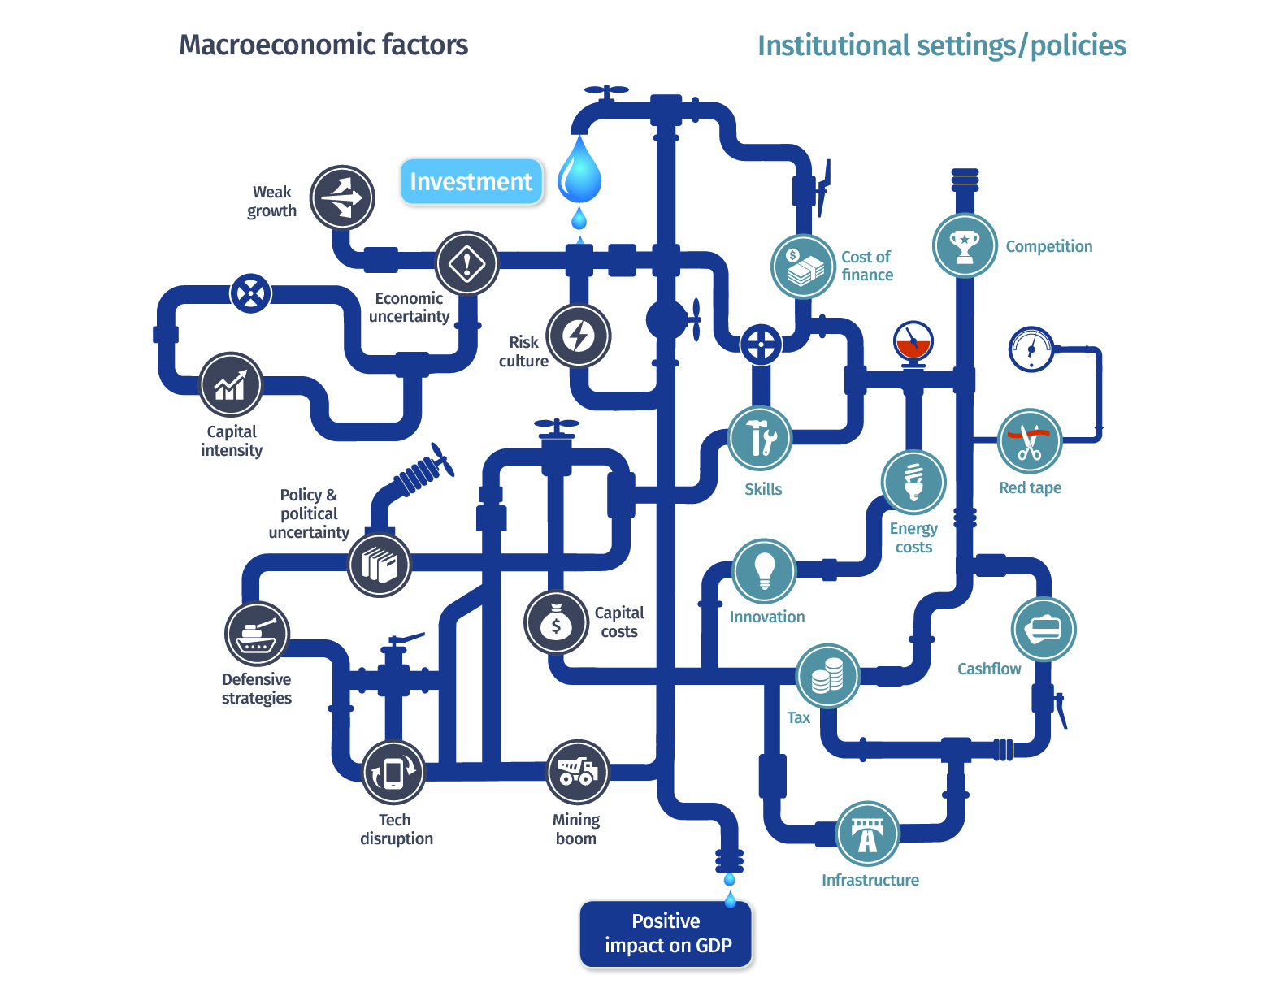

# Macroeconomic factors

|  |  |
| --- | --- |
|  | Key Points |
|  | The environment for business investment in Australia has been influenced in the past decade by a mix of cyclical and structural factors.  The mining boom delivered record investment, while the trend in business investment in sectors outside of mining has been less encouraging over the decade.  The weakness in business investment has to some extent reflected subdued national income growth.  Our consultations found variable sectoral and regional outlooks for demand.  Structural factors include the shift towards less capital intensive services sectors and the application of new digital technologies.  Defensive business strategies evident include cost cutting and aggressive capital management approaches.  A persistent theme from contacts was a low risk appetite in Australia from both corporate boards of directors and investors.  Our consultations highlighted the prominence of a sense of elevated uncertainty due to the impact of technological innovations including disruption in the economy and political and policy instability. |

## An unusual decade

The environment for business investment in Australia has been influenced in the past decade by a mix of cyclical and structural factors. Australia’s aggregate economic performance during this time has been unique both by its own historical standards and by international standards. An important factor over the decade has been the rise in demand for minerals and energy from large emerging economies like China. This demand started to rise before the GFC, and while it was temporarily impacted, Chinese demand returned relatively quickly.

Strong demand supported a once‑in‑a‑hundred year mining investment boom and a rise in overall national income. Total new business investment in Australia reached a peak of around 18 per cent of GDP in 2012-13 (Chart 1). Mining investment rose from below 2 per cent of GDP in 2000-01 to a peak of around 9 per cent of GDP in 2012-13. As large investment projects have been completed the flow of mining investment has contracted back towards more usual levels, though Australia still benefits from a permanently higher level of capital that is supporting higher mining production and exports.

Chart 1: Business investment (as a share of nominal GDP)



Source: ABS cat. nos. 5204.0, 5206.0 and Treasury.

The trend in business investment in sectors outside of mining has been less encouraging over the decade (Chart 1 and 2).In 2016‑17, non-mining business investment was just over 9 per cent of GDP, a level comparable to the recessions of 1991 and 1982 (Chart 1). The share of non-mining business investment as a per cent of GDP began to fall following the GFC, and in recent years has fallen to around its lowest share of GDP since the 1950s.

Chart 2: Business investment by industry

Source: ABS cat. no. 5204.0.

Notes: Household services include Healthcare and Social Assistance, Education and Training, Arts and Recreation services, and Accommodation and Food services. Business services include Financial and Insurance services, Administration and Support services, Professional, Scientific and Technical services, Rental, Hiring and Real Estate Services, and Information, Media and Telecommunications services. Goods-related industries include Agriculture, Wholesale Trade, Retail Trade, Transport, Postal and Warehousing, and Electricity, Gas, Water and Waste services.

The mining investment boom impacted activity in other sectors via spillovers. In the resource-rich or ‘mining’ States a substantial proportion of the activity outside the mining industry, during the boom, was attributed to activity in relation to resource extraction and investment. The industries that benefited the most were construction and business services (Chart 3).

Chart 3: Industry share of gross value added



Source: ABS cat. nos. 5204.0, 5206.0, 5625.0, 8412.0 and Treasury.

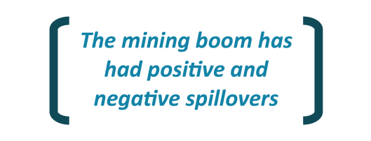With the contraction of mining investment in recent years, these spillovers have been operating in reverse. The downturn in mining construction has in some cases hurt investment and activity in mining-exposed industries. While it is difficult to be precise about the links, it is clear that, in recent times, non‑mining business investment has been weakest in the resource-rich States of Western Australia and Queensland (Chart 4). However these headwinds seem to be easing as mining investment stabilises and some contacts were upbeat in this regard.

* Western Australian mining sector businesses report that they are cautiously optimistic about the prospects for the economy in Western Australia given demand is currently the highest it has been in the past three years and there is a pick-up in mining exploration and investment.
* One contact in Western Australia commented that profit expectations is the biggest factor in business investment decisions and, with excess capacity and weak demand, firms have been looking to do more with what they have, rather than investing in new projects. Despite this, consumer confidence has recovered to a three-year high and some businesses are optimistic and restructuring their businesses in line with the changed circumstances.

Chart 4: Non-mining investment has been weaker in the mining States



Source: ABS cat. nos. 5204.0, 5206.0, 5625.0, 8412.0 and Treasury.

Note: Investment is in nominal dollars. Figures have been interpolated between industries and States using relevant benchmarks to capture estimated activity. Mining States consists of QLD, WA and the NT.

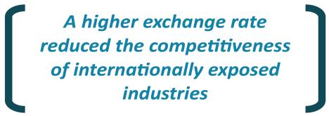The mining investment boom indirectly impacted overall economic activity and investment via a higher exchange rate. Between 2002-03 and 2012-13, Australia’s trade weighted exchange rate appreciated by over 40 per cent. This reduced the competitiveness of the internationally exposed industries, particularly the manufacturing sector. The surge in investment in the mining sector and income spillovers in the rest of the economy put upward pressure on labour costs. The higher exchange rate and labour costs created challenges for some traded industries (outside of the booming mining industry).

* The impact of these substitution effects were referenced by contacts in the non-mining sectors, with both the exchange rate channel and the pushing up of wages for blue and white-collar workers.

While the impacts on labour costs were experienced more broadly around the country, these were particularly acute in the mining States and are only slowly unwinding post-boom.

* Contacts in the Northern Territory were concerned that the gas and mining investment boom had driven up wages, due to labour shortages, which remain high as wages are downwardly sticky. One contact stated that the high wage economy and competition for labour has been particularly challenging for SMEs trying to compete with the huge liquefied natural gas (LNG) operations.
* Some contacts in Western Australia shared concerns around demands for wages being slow to adjust downward in response to the changed economy. Some contacts did provide examples of wages coming down – but often through hiring processes rather than it being easy to lower wages for people in existing roles.

The unprecedented surge in demand and activity in the mining sector and the subsequent contraction have impacted employment in the mining States and more broadly. The impacts on employment have, in turn, had impacts on consumer spending, housing and regional population movements.

* Stakeholders in Western Australia suggested that the unwinding of the mining boom phase has had significant impacts on the real estate sector, noting falling housing prices and rental yields, and increased rental vacancy rates. Investment in dwellings has reduced significantly in the past financial year.
* By contrast, contacts in Victoria described how the winding down of the mining boom has seen record interstate migration inflows that have contributed to strong population growth in Victoria in recent years (Chart 5). This has contributed to strong economic growth and helped maintain lower wage inflation in booming sectors such as construction.

Chart 5: 2015-16 interstate migration inflows to Victoria

**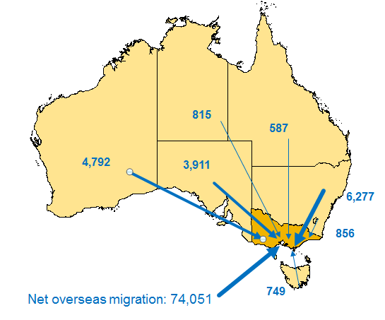**

Source: Victorian Department of Treasury and Finance, ABS cat no. 3101.0.

The strong demand for labour and capital in the mining sector has waned in recent years, in theory freeing these inputs to move to other activities. Residential property prices have risen strongly in some parts of Australia, supported by strong population growth and low interest rates. With the freeing of resources from the mining sector and rising house prices, construction activity has been strong. However, while there has been a significant boost in residential construction activity, business investment has remained subdued.

Separate from the commodity cycle there was weak international demand as advanced economies slowly recovered from the GFC. As commodity prices subsequently fell, slow national income growth has dampened domestic demand. Weakness in non-mining business investment has coincided with subdued income growth and weakness in wages growth and consumer confidence. Indeed, real net national disposable income per capita fell by more than 6 per cent between September 2011 and December 2015, though since that time it has begun to rise again. As business expectations of future demand are often heavily grounded in the present conditions, this weakness likely affects investment decisions (as these are contingent on business expectations of future demand and growth potential).

The continued low interest rates, a pick-up in international demand and a lower exchange rate in recent years have not translated into the expected increase in non-mining business investment, though there have been promising signs of recovery more recently. Business investment has grown in the past three quarters and firms are reporting stronger business conditions and a modest upgrade to investment plans. This recovery is expected to continue as mining investment stops contracting and investment in the non-mining sector firms up.

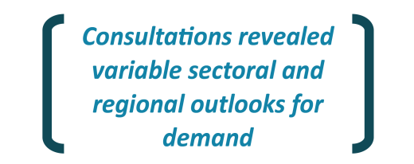Our consultations found variable sectoral and regional outlooks. As one contact explained, growth is not broad based, nor is the impact of technology, and some companies are seeing profits compressed. Another contact noted that growth is asymmetric – where the companies undertaking significant investment are being rewarded by growing strongly.

* The property sector has been performing strongly and continues to maintain a positive outlook generally. This is consistent with the shift in capital expenditure away from mining-related construction activity to residential, commercial and engineering construction. There are different dynamics in each of residential real estate, commercial property and retail development, which often depend on local factors such as population growth.
* A number of businesses commented on the current strength of the economies of New South Wales and Victoria – which are seen as high growth States offering growth potential for businesses. A few contacts commented on the current infrastructure boom in Sydney. Sydney and Melbourne are both experiencing strong growth in commercial property construction, underpinned by strong demand and low vacancy rates. By contrast, office vacancy rates in Perth and Brisbane are high following the mining investment downturn. More broadly, stakeholders consulted in Brisbane talked of strong investment intentions and were less concerned about the local economy being affected by the downturn.
* Contacts in Tasmania talked of the current strength in construction though it was noted that the local construction and civil contractor businesses are reliant to a considerable extent on government funded projects. Businesses in Tasmania noted that tourism is performing particularly well and the expected growth outlook is positive off the back of investments in new tourist offerings. Improvement in the State economy and investment by all tiers of government in road and water infrastructure were seen as factors in favour of business investment currently.
* Some of the services sectors (including retail and the financial services) which previously could be described as largely non-traded now face global competition resulting from disruptive technologies. For some businesses, this is depressing prices and revenue growth prospects, which encourages consolidation rather than investment and expansion. For example, contacts commented they expect that there will be a rapid consolidation within the life insurance sector.
* Contacts in the retail sector expressed concern that the high level of household indebtedness is reducing consumers’ capacity for consumption of other goods and services. While Australian consumers previously had a good appetite for debt, more conservative attitudes to debt and saving are giving rise to more value conscious and price sensitive consumers since the GFC. As technology has empowered consumers to shop harder, some growth strategies in retail will deliver high volume growth by trading off the price (meaning that this would not contribute to overall nominal GDP growth).
* Businesses in South Australia were relatively sanguine and noted concerns about the immediate challenges related to energy security and escalating prices. This is a significant factor for manufacturing and will lean against future investments to base operations in South Australia. More generally, businesses noted that because of the small size of the local market they have to overcome a negative perception around the fact that they are not able to test new innovations and drive sales in the local market before seeking to market the product overseas. By contrast, some noted that the need to grow their market outside of South Australia ensured they built the skills necessary to take their businesses overseas. It was noted that conditions across all sectors are not uniform – with tourism in South Australia performing strongly.
* Contacts discussed that some regional centres in Victoria are seeing growth due to commuters moving further out due to cost of living pressures in Melbourne. This has been facilitated by investment in regional rail transport upgrades. Other regional areas around the country were noted as experiencing strong conditions due to investments in medical facilities.
* In the Northern Territory, one contact suggested that the next round of mining investment will likely need to come from second tier firms as the top tier firms are consolidating. There is a diversified commodity set available but one impediment is a lack of supporting infrastructure to get goods to market.

Charts 6 and 7: Business investment by State

|  |  |
| --- | --- |
|  |  |

Source: ABS cat. no 5220.0.

Note: Data include second-hand asset transfers. Investment is in nominal dollars.

## Structural factors

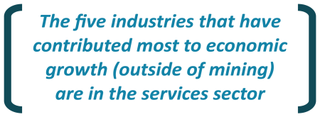Structural factors explain some of the weakness in non-mining business investment. There is a global trend, particularly in advanced economies like Australia, towards less capital intensive services as a larger share of the economy. The five industries that have contributed most to economic growth in the non-mining economy over the past decade are — financial & insurance services, construction, healthcare services, professional services, and education & training.

These growth industries have a relatively lower investment intensity, which implies that businesses in these industries do not need as much capital expenditure to maintain and expand output (Chart 8). As well as a shift towards less capital intense industries, there appears to be a global trend towards less capital intensity within some production processes. Within Australia, capital intensity has declined over the past decade across a number of industries (Chart 9). The precise mechanisms and impacts of these high-level trends require further detailed analysis to understand their implications for future growth.

|  |  |
| --- | --- |
| Chart 8: Investment intensity of industries that have driven growth in the non-mining sector | Chart 9: Nominal investment per unit of output |
|  |  |
| Source: ABS cat. no. 5204.0 and Treasury.  Note: In Chart 8, investment intensity as measured as the average ratio of nominal investment to nominal GVA for the period 2005-06 to 2015-16. | Source: ABS cat. no. 5204.0 and Treasury. |

The changing nature of sectors within the economy due to technological advances, complicates the analysis of trends in business investment. For example, some of what business owners consider investment is not captured as business investment by our statistical agencies. Instead the expenditure is captured in private investment and/or consumption. As an example, residential dwelling construction is private investment – and this may be where some Airbnb activity arises. Another example is education and training expenditure. This expenditure builds human capital and is not part of official measures of business investment.

Many of the factors causing a shift to services, such as changes in consumer demand patterns and new technology such as automation, are structural in nature. As technology changes the way businesses operate, for instance in the sharing economy, measurement of investments, relative to traditional business investment, needs to be considered. Already we have seen the impacts of the car ride-sharing services on the taxi industry and measurement of investment in vehicles between the two differs.

Digital disruption seems to have some way to go in certain industries. While traditional media businesses have been overhauled by the competitive impact of social media and the reduction in barriers to entry the new technolgies represent, the journey for the financial services industry appears to be in its infancy. The rise of fintech and reduced barriers to entry in financial services offers up the potential for significant efficiencies across the economy, particularly in relation to retail and small business financial services.

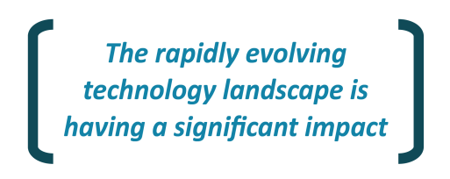The rapidly evolving digital landscape is creating as much cause for concern for existing businesses as is the opportunity inherent in new technologies. Technological disruption is happening at a rapid pace, transforming industries and the competitive landscape.

Chart 10: Technological change

Australia, by industry



Source: Manyika et al., ‘Harnessing automation for a future that works’, McKinsey Global Institute, January 2017.

Note: The central scenario is that by 2055, around half of all current work activities could be automated using currently available technology. This scenario is mapped onto current employment data.

The rapid rate of technological change and extent of disruption across the economy means that some investors consider it is difficult to know what to invest in next, as yields, businesses – even industries – can be wiped out. The stable revenue streams of the past are no longer considered stable.

* Contacts discussed that the lifespan of technology investment is now shorter so the timeframe for returns needs to be shorter. “Pay back periods have come right in.” Shorter payback periods are not just limited to investments in technology. In general, disruption across industries means that investors need to consider options for a good return over 3-5 years but after which the investment might be ‘dead’.
* One contact commented that the digital revolution is different to the internet arriving and the transformations required are hard. “It is very difficult for retailers to get ‘match fit’ for the arrival of major online competitors.”

There were different views on the impacts of automation in different industries, and whether this would increase or decrease investment.

* A few contacts discussed examples where automation as an efficiency measure could temporarily increase capital expenditure (Capex). One talked of varying levels of automation in warehousing operations, while another talked about increased automation in major agriculture operations. The potential for automation, and bespoke operations through technology such as 3D printing, to result in some manufacturing operations moving back onshore was pondered.
* Some banks talked about cost cutting in the industry including through digitisation and greater automation, for example in loan origination.

## Business strategies and risk appetite

Some businesses indicated strong investment intentions and strategies to expand and grow their businesses. Others indicated that business investment is increasingly being targeted at reducing costs and increasing operational efficiency.

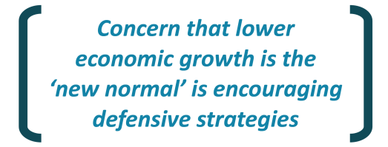Our consultations indicate that for some this is driven by a concern that the ‘new normal’ is an economy characterised by slower economic growth and fewer revenue growth opportunities. The recent economic activity appears to have encouraged defensive strategies from corporates to generate and maintain investor interest in holding their stock, including cost cutting. Cost control and operational efficiency is becoming as important as expansion to drive economic value-add with firms.

* A number of contacts discussed the trend towards consolidation and cost cutting in the banking sector. Re-investment strategies are much more technology focussed – shifting towards greater investment in operational expenditure (Opex) over capex because the returns are faster.
* The tough retail environment is resulting in price deflation with the competitive market forcing price compression while costs are rising. As a result, companies are pursuing margin recovery through increased efficiencies and higher productivity across operations.

Other defensive business strategies evident include aggressive capital management approaches such as increasing debt-to-equity ratios, increasing dividend payout ratios, share buybacks and expansion via mergers, acquisitions and other brownfield investment strategies.

* One contact suggested that uncertainty combined with less reliable economic data means that it is difficult to get a good aggregate picture of what is happening in the economy and often (eight times out of ten) results in a default to pay dividends rather than investing.

Dividend payments to shareholders are at historic highs and cash holdings are substantial (Chart 11). It is evident that businesses are currently deciding to hold more cash or return it to shareholders, which typically comes at the expense of new investment in the productive capacity of the economy.

Chart 11: Dividend payouts and deposits



Source: ABS cat. no. 5204.0, 5206.0 & 5232.0.

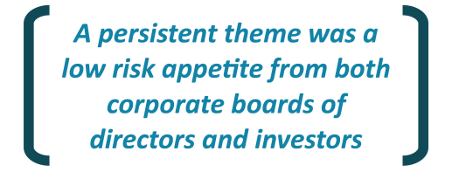A persistent theme from contacts was a low risk appetite from both corporate boards of directors and investors. Over time, investors have expressed a preference for solid, steady returns over potentially higher returns due to the associated risk of volatility with the latter. Other relevant factors identified by stakeholders as contributing to low risk defensive business strategies include:

* A number of examples of high-profile failed investments in Australia which were cited as having a strong negative impact on share price performance and executive careers;
* Greater scrutiny by regulators in the financial sector following the GFC, which has resulted in corporate governance requirements becoming more of a barrier to entrepreneurial investment and appropriately managing risk-taking; and
* The cultural appetite for risk which is an important determinant on whether people choose to grow a business. The potential for policy settings to impact this is discussed in the *Institutional Settings and Policies* section of this report on p.34-35.

Some stakeholders raised concerns that boards are increasingly becoming focused on operational detail (without necessarily having the required expertise) and leaving less to the discretion of management.

* One contact said too many companies have been captured by their management and Non‑Executive Directors, and that board decision-making and responsibilities are too frequently a compliance role, with no real strategic decisions.

There were mixed views on whether the requirement to have a majority of independent directors on the board of a company strikes an appropriate balance. Some considered that having more shareholder board members could be a welcome alignment of interest. Others noted that this could create a tension between the incentives for short-term profit and investment to grow profits over the longer term. It was however acknowledged that it is hard to generalise whether such incentives exist in publicly-listed companies and that short-term and long-term profits are not necessarily mutually exclusive.

More broadly, while many considerations need to be taken into account, there were some interesting general distinctions made by contacts between listed and non-listed companies. It was noted that operating non‑listed companies is considerably easier as there are not as much bureaucracy or reporting and auditing obligations. Decision-makers have more freedom as the company is not valued on the market every day, and there are less people in the decision‑making process (not driven by investor preferences). Nevertheless, stakeholders generally agreed that regulation and corporate governance is necessary and important in keeping corruption out of businesses and protecting investors’ interests.

## Uncertainty and firm behaviour

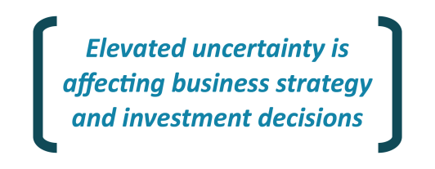There has been almost universal feedback that uncertainty has been elevated for the past decade and that this is impacting firm behaviour – both business strategy and investment decisions. As many fixed investments involve irreversible costs, uncertainty and risk around expected returns can weigh heavily on investment decisions. Despite the fact that long-lived investments are generally over multiple time periods that will see changes in business strategies, firms may postpone investment in periods of heightened economic and political uncertainty. This is a rational business decision.

Our consultations revealed a number of heightened sources of uncertainty for business in the current environment:

* The impact of technological innovations including disruption in the economy;
* Global economic and financial market uncertainty following the GFC;
* Geo-political uncertainty; and
* Domestic political uncertainty and policy stability and continuity at all levels of government.

Even with recent signs of transition from the mining sector to broader based domestic economic growth and a pickup in global activity, the outlook remains mixed. Heightened global political instability and the fracturing of a broad consensus about the benefits of free trade and investment flows, associated with a resurgence of protectionism rhetoric is worrying to business.

Years of economic uncertainty and slower growth have been identified as an impediment to investment. There is a strong view that coming out of the financial downturn, the psychological impacts described as the ‘scars’ of the GFC on business decision makers, are deeper and more extensive than we had originally expected. The GFC introduced new risk premia for advanced economies; that of an economic, financial or political shock which had for decades previously largely been the domain of emerging and frontier economies. Tail events, that is, low probability, high impact events, now weigh on the minds of business leaders and financial market participants. It was suggested that this is reducing the risk appetite for sections of the business community.

While Australian-based subsidiaries of foreign companies generally shared a view that political and policy uncertainty in Australia compares well to overseas experience, many businesses feel that it is currently elevated in Australia – this is explored in detail in the next section *Institutional Settings and Policies*.

Discussions indicate that it can be difficult to disentangle statements about general uncertainty from perspectives on the outlook for demand or risk appetites. However, it is important for government and policy-makers to try to understand the links and the impacts that these factors can have on business decision-making. As an example, the minimum expected return on potential investment projects required to gain managerial approval — known as the ‘hurdle rate’ — remains elevated despite current low interest rates and bond yields (Chart 12 and Chart 13).

Chart 12: Government bond yields



Source: Bloomberg.

Chart 13: Investment hurdle rates (nominal)



Source: NAB Quarterly Business Survey.

A lower average cost of capital should theoretically drive down hurdle rates. Some companies consulted suggested that in real world decision-making, real hurdle rates are not as important and are not as regularly reviewed as theoretical literature would suggest or assume. Others indicated that hurdle rates are reviewed every few years and had been modestly reduced recently. However, companies noted that boards are requiring more downside scenario planning which has a negative impact on the feasibility of investments. One contact commented that they do not tend to adjust hurdle rates for cyclical fluctuations and that it depends on the gearing assumptions (less likely to revise down if highly leveraged).

All contacts discussed their increased use of downside scenario planning relative to business decision making a decade ago, and noted that discount rates or hurdle rates cannot be considered in isolation of the business cases. This strong focus on downside risks seems to be adding a subjective project risk premium to investment assessments (Box 2).

|  |  |
| --- | --- |
|  | box 2: hurdle rates and Uncertainty |
|  | The hurdle rate is defined as the lowest required return for an investment project to go ahead. The hurdle rate consists in theory of the long-term funding rate for the business plus a premium that reflects the risk of the project. Alternatively, the hurdle rate can be viewed as the firm’s weighted average cost of capital (WACC), which is a blend of debt and equity costs, plus a premium for the undiversifiable element of the project risk.  In either case, theoretical models would imply that the sustained fall in debt funding costs across the yield curve over the past decade should, all else being equal, have put downward pressure on investment project hurdle rates. Evidence from survey data and consultations suggests that this is not the case. Hurdle rates have been ‘sticky’ and in some cases have not fallen at all despite an extended period of historically low interest rates and an expectation that future rates will remain lower than historical rates.  One explanation of steady hurdle rates in the presence of falling long-term funding costs is increased risk premiums, either embedded in the equity cost of capital or directly in the assessment of project specific risk.  An elevated equity risk premium may reflect a lower risk appetite on the part of investors. The elevated equity risk premium will cause the equity cost of capital that a firm faces to rise relative to the debt funding costs. As appears to be the case in the current environment this results in a much smaller decline (or no decline) in the WACC that firms face despite lower long-term interest rates.  Alternatively it could reflect that many businesses take the view that hurdle rates need to reflect a long-term assessment of the cost of capital and should not move in line with cyclical moves in economic activity and interest rates. This would suggest a gap between the business community and the financial markets who currently expect rates to remain lower in future than has historically been the case. It appears that hurdle rates are reviewed less frequently than the literature would suggest and often require the sign‑off of the board to make adjustments.  Hurdle rates can be impacted by increased risk around investment projects that lead to less confidence in cash flow projections that underpin the calculations. Uncertainty and downside risks were persistent themes in feedback from business and many contacts believed that the higher risks premiums reflect a range of economic, political and financial factors.  Contacts agree that the implication of this hurdle rate stickiness is less investment than would otherwise have been the case. |

## Ai Group survey of Chief Executive Officers

Our findings are consistent with a survey of CEOs that Australian Industry Group (Ai Group) recently conducted. Ai Group attended the roundtable consultations and kindly shared some early findings from its member survey which is due for release in late 2017 (Box 3).

|  |  |
| --- | --- |
|  | Box 3: business investment influences and decisions ─ Ai group survey results |
|  | According to a CEO survey conducted by Ai Group, businesses planning to **increase** business investment in 2017 are doing so for the following reasons:   * Expansion and innovation – in physical capital, research and development, and technology; and * Short payback periods justifying the investment.   The survey found the main reasons for businesses **decreasing** their investment spending in 2017 are:   * High hurdle rates for investment; * Cost reduction programs across all areas of business; and * Long payback periods not justifying the investment.   Ai Group noted that access to funding did not rate highly as a barrier to 2017, as it has in the past.  The priorities for 2017, in terms of types of investment that businesses prefer to make, are shown in chart 14.  Chart 14: First priority for 2017 investment,  weighted by industry sector    Source: Ai Group 2017 CEO Survey results. |

# Institutional settings and policies

|  |  |
| --- | --- |
|  | Key Points |
|  | All levels of government influence the business environment as they set the institutional frameworks in which businesses operate.  Predictable, stable and transparent business regulation and supervision, at all levels of government, is an important precondition for business investment.  Stakeholders raised significant concerns about policy and regulatory instability – the pace of regulatory change itself is an issue, not just the level of regulation.  Developments in government policy and regulations, notably at the intersection of State and Commonwealth roles and responsibilities, continue to remain a source of uncertainty for many participants. |

All levels of government influence the business environment as they set the institutional frameworks – being our institutions, laws, regulations and the taxation, fiscal, macroeconomic, planning, and occupational, health and safety policies. These frameworks set the context in which businesses operate and governments need to strike the right balance between desired public policy objectives whilst allowing businesses to thrive.

The strength and stability of institutional arrangements impact on firm behaviour including investment decisions and many stakeholders raised concerns about policy uncertainty. Investment decisions are forward-looking and investors would prefer to have a reasonable expectation around their risk-adjusted return if they are to put their next investment dollar into Australia. Businesses consider that while some of the sources of uncertainty are outside the control of governments, Australian governments should focus on reducing their contribution to uncertainty

* One contact commented that an export credit agency recently observed that Australia’s reputation as a high cost, low sovereign-risk investment destination was no longer axiomatic.
* Another commented that Australia is competing against the rest of the world for capital but now has a reputation for changing policy settings.

Businesses are concerned that even discussions around potential changes or sudden reviews of longstanding policies can create uncertainty that discourages investment. A list of examples of policy announcements, across all levels of government, that were described as sovereign risk by businesses consulted is in Box 4 below.

|  |  |
| --- | --- |
|  | box 4: sovereign risk |
|  | Businesses cited a number of policy announcements that could affect them adversely as being associated with sovereign risk. Some specifics included:   * The Petroleum Resource Rent Tax (PRRT) Review; * The Review of Stapled Structures; * Energy policy uncertainty related to emission reduction policies; * Changes to State based mining royalties; * Review and continued uncertainty around R&D Tax Incentive arrangements; * Introduction of the Bank Levy at the Commonwealth and State level; * Changes to the 457 Visa program – with particular concerns noted about and the lack of consultation ahead of the announcement and impact on specialist labour skills; * Introduction of the Australian Domestic Gas Security Mechanism; * The unilateral removal of the Limited Merits Review regime for electricity transmission investments; * Regulatory changes by both the Commonwealth (FIRB rules regarding the 50% cap for advanced off‑the‑plan sales) and State Governments that apply to residential apartment complexes under development which potentially limit whether foreign investors can purchase; and * Local government planning and zoning changes. For example, where sudden zoning changes for between different types of commercial land can trigger Fringe Benefits Tax implications. |

The political divide between the Commonwealth and State and Territory Governments and partisan politics were identified as contributing to instability and sovereign risk. Some businesses commented that there appeared to be less regard for election mandates than had historically been the case.

* One business said it is becoming a situation where “We just want what the other bloke doesn’t”.

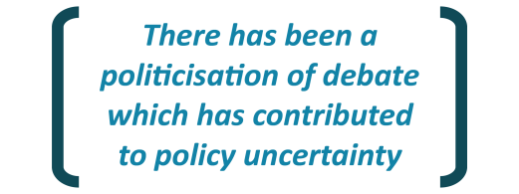Concern was raised that there has been a politicisation of debate which has contributed to policy uncertainty. One contact felt that previously companies worked with government and discussed reforms, but now it seems to be decision by inquiry – resulting in populist outcomes rather than sensible policy. A few companies raised concerns about the politicisation of well‑established review processes such as regulatory inquiries and the risks that these can create for investment.

* One company said that an ACCC inquiry underway had created regulatory uncertainty and stalled its investments in a particular business area pending completion of the inquiry.
* Another commented that companies may be less willing to undertake investments, even where these are unlikely to attract competitors, just from the potential risk of a politicised regulatory inquiry.

It was noted that there are ‘endless’ government reviews and inquiries underway, looking into overlapping issues without many tangible outcomes evident for businesses. The time that companies spend compiling submissions and participating in these processes is considered red-tape burden.

* For example, one industry association lodged 107 detailed submissions in 2016 alone in response to government inquiries and reviews, and was participating in more than 10 separate reviews at the time of this Review.

Despite the apparent consultation fatigue, stakeholders emphasised the importance of ensuring that when policy changes are required governments do this via an appropriate process – a process that involves adequate consultation and implementation on a timeframe that enables businesses to adjust.

* 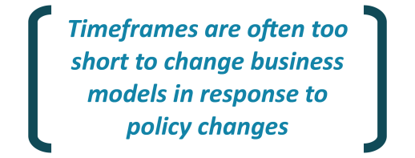One contact commented that the main challenge in recent years has been inadequate consultation and timeframes that are too short to change business models in response to policy changes – “We can’t change our business model overnight”.

The overall message was that genuine consultation for necessary policy/regulatory changes, and where industry views will actually be considered, are appreciated. Disingenuous consultations and reviews for purely political reasons are not well received.

## Regulation and red tape

|  |  |
| --- | --- |
|  | Key Points |
|  | There is widespread concern about the high level of red tape required to do business in Australia, and the high regulatory burden, in terms of the sheer volume of regulation and compliance costs.  The often piecemeal approach to regulation, and the cumulative burden it is having on businesses, was identified as a dis-incentive to investing in Australia.  Given the pervasiveness of our regulatory environment, governments should be ever vigilant to ensure an appropriate balance between intervention and cost is achieved.  A clear framework for making and managing regulation, rather than a single focus on red tape reduction, should be advocated across all levels of government.  A greater focus should be placed on evaluating the burden of regulatory changes after they are made, as well as before.  Selecting a small number of meaningful reform areas of regulation and significantly reducing the compliance burden in these could have meaningful impacts for industry. |

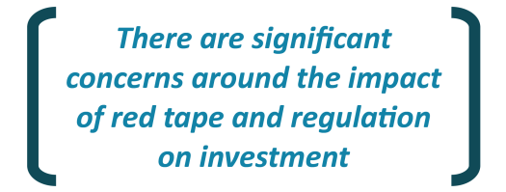In all of the roundtable discussions, concerns were raised about the red-tape cost of doing business in Australia and impact of the regulatory environment on the investment environment. It was noted that this may be contributing to declining competitiveness, with Australia’s ranking in the IMD competitiveness index falling outside the top 20 countries in 2017. Some stakeholders perceived that Australia was previously given latitude as a high-cost country as it was a well‑regulated economy but warned that “additional risk factors are starting to stack up on the wrong side of the equation”*.*

* One company commented that “there seems to be a smugness that certain industries won't relocate offshore but that if Australia becomes too expensive/complicated or industrial relations unravels it could push the limit”.
* Another company used their advanced manufacturing business as an example to explain that they base their investment strategy on where they can achieve the best returns within their footprint. While they have seen rapid growth of their Australian operations in past years and continue to manufacture in Australia, over 90 per cent of their products are exported. This company is a price taker, its business is truly portable and it is investing in Asia. This contact is concerned there is a lack of real-world experience in government and no long-term thinking. The siloed approach of different government agencies often precludes sensible decision‑making from a business perspective.

A high regulatory burden at all levels of government has been identified as an impediment to business investment. Companies indicated that ‘over-regulation’ or the cumulative burden of regulation on business is increasing, not decreasing, over time. Monitoring and compliance costs for regulation significantly add to business costs. Some businesses indicated that they have had to spend significant amounts of money implementing new systems and procedures due to extensive regulatory change.

* SMEs commented that they experience a disproportionately high regulatory burden as they do not have the same economies of scale that large companies do.
* One contact from an SME estimated that he has to spend roughly 25 per cent of his time dealing with bureaucracy (at all levels of government). For example, he had to deal with six different departments for approval to get a sign on a highway.
* Occupational Health and Safety (OHS) laws have specifically been identified as having a growing red tape burden over time, especially for SMEs. One contact commented that large construction companies often agree to onerous OHS requirements to win contracts on the basis they can push this regulatory burden down the line to smaller contractors.

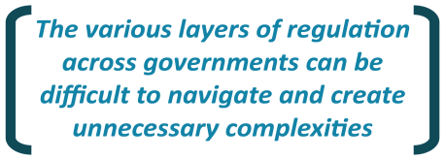It has been identified that while individual regulations may seem reasonable in any sector or jurisdiction, a piecemeal approach is often adopted and taken together such interventions are having significant cumulative ramifications and are lowering the incentive to invest in Australia. Exacerbating these issues, a number of businesses indicated that the various layers of regulation across governments could be difficult to navigate and create unnecessary complexities.

* OHS was raised as an example where there is complexity for companies operating in multiple jurisdictions that need to navigate different rules in different States.
* Some SMEs noted that while there have been numerous programs to reduce red tape, the outcomes have been perceived to be mere “window dressing”, with little inroads being made into “significant” or “tough” regulatory burdens.
* One contact commented that there was an effort to streamline environmental approvals with the one-stop-shop idea but it actually seems to have gotten worse.

Businesses consider that regulation and intervention are often the first resort for policy‑makers to deal with perceived market imperfections but these strategies risk undermining the incentives that drive businesses to invest and innovate in the first place.

* One business raised concern that some regulators are becoming overtly ideological about regulation, commenting “the arbitrate/negotiate framework is philosophical and does not work in reality”.

The slowness of some regulators to either make rules, or respond to concerns of stakeholders, was raised. Particular examples provided included high profile mergers which had taken a significant amount of time, delays in environmental approvals, and delays in local government approvals including planning and zoning.

Contacts discussed examples where efforts to reduce red tape have had significant positive benefits. For example, one said that hundreds of millions has been spent on expanding retail shopping centres in Western Australia since the State Government lifted previous regulatory restrictions.

The case study of a successful pilot of red tape reduction conducted in Parramatta (Box 5) demonstrates the gains that can be made through concerted efforts between industry and the Commonwealth, State and local levels of government.

|  |  |
| --- | --- |
|  | box 5: case study: red tape reduction pilot |
|  | The New South Wales Government recently undertook an “Easy to do Business” pilot project in the hospitality industry in Parramatta where previously, there were in excess of 50 pieces of regulation that applied to set up a hospitality business meaning that it could take up to 18 months to commence trading.  In an attempt to smooth the process, the Commonwealth and State agencies, local councils and industry bodies worked together to streamline the regulatory process by examining how many of the processes could be run in parallel. A review of the information requested under various regulations was conducted and it was found that many of the information requests were duplicated between processes. As a result a system was created to ask for information once only and share it between relevant regulators, whilst processes were run in tandem rather than consecutively. While red tape was not cut per se, it was instead sped up and made invisible.  This is an example of an efficient way of using systems and technology to relieve the regulatory burden on businesses. It has been shortlisted for the 2017 Prime Ministers Award for Innovation and the 2017 NSW Premiers Award. |

## Competition

|  |  |
| --- | --- |
|  | Key Points |
|  | Competition policy enables efficient businesses of all sizes to thrive and reduces unnecessary impediments to innovation. Regulatory settings need to enable and encourage effective competition.  SMEs provided examples where they consider that large firms with substantial market power are operating in ways that are anti-competitive.  Payment times by large suppliers were an area of concern and having working capital to support investment and growth is a significant challenge for SMEs.  Access to credit and the cost of debt financing was a concern for some SMEs but not at all for large businesses.  Competition policy should continue to develop and ensure that markets work in the long term interests of consumers, as well as encouraging innovation, entrepreneurship and the entry of new players. |

The regulatory environment has important implications for competition in the economy. Regulation can both enhance competition and impede it. Effective regulatory settings can encourage businesses to pursue efficiencies and reward businesses who innovate and provide the best services at the lowest cost. Businesses who take up innovation and new technologies in order to be more productive should not be dissuaded by government policies which protect inefficient businesses.

In our consultations, while many stakeholders confirmed that competition encourages business investment which in turn flows on to customer investment, there were some contrasting attitudes about whether it is necessary for businesses to embrace technological advances to survive. This could reflect insufficient competition in some parts of the Australian economy.

* There was unanimous agreement from SMEs that it is essential for them to keep up with technological change and to invest in technological advances because they “won’t exist” if they don’t “make the right decisions”.
* While SMEs consider that competition drives innovation, one commented their expectation is that technological changes would not do much to help level the playing field (in terms of competition with big market players) as these are too small around the edges.

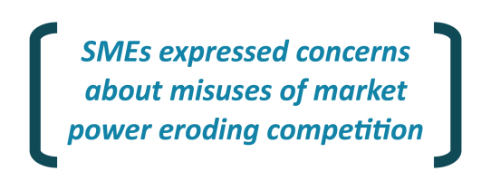Competition can be eroded by misuses of market power. Our consultations indicate that there is concern about this in the Australian economy. In particular, SMEs provided examples where they consider that large firms with substantial market power are operating in ways that are anti‑competitive. Some stakeholders discussed whether government is doing enough on the legal framework when it comes to big companies with market power. Contacts noted that businesses are generally not willing to go to the ACCC to complain due to confidentiality concerns despite relevant provisions in the law being in place.

* Some contacts suggested that at this stage rather than trying to fix the issue of competition in supermarkets, it might be better for governments to focus on other efforts to assist suppliers such as mandating fair contracting and payment facilities for small businesses. Waiting up to 60 days for invoices to be paid presents significant liquidity challenges for small businesses.

### Supplier payment times

Payment times by large suppliers were an area of significant concern. Having sufficient working capital for growth is the greatest challenge for SMEs and is considered a significant barrier to investment. Many SMEs commented that they experience a continuous squeeze on working capital and constrained cash flow, in part driven by delayed receipts of payments, especially by big companies including Government Business Enterprises.

* Contacts in Tasmania commented that at best, payments by big clients are received in 30‑60 days, but often 90-180 days for really big players. This problem is compounded by upfront outgoing payments being required by government and utilities for items such as: taxes; payments to the workers compensation schemes; and rates and energy.
* One business explained that generally SMEs cannot hold enough cash flow to be able to invest so they continually delay projects for a time when it is considered not too risky to invest – they are waiting for windfalls that provide a decent buffer against unanticipated costs.
* Contacts in Western Australia noted that the impact of the mining downturn on supply chains meant that larger companies have been squeezing smaller suppliers, with terms being extended to 90-120 days. The combination of working capital requirements for contacts with large miners and banks requiring debt repayment created extremely difficult conditions for mining service companies. Those who remain had conservative balance sheets leading into the downturn.

### Small business finance

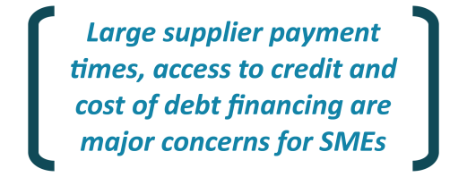Another major concern for some SMEs (and which can contribute to the working capital issue) is access to credit and the cost of financing. This was in contrast with large businesses consulted where access to and costs of financing were not seen as an impediment. Small business is reliant on banks and other lenders for financing, whereas big business has more diverse funding sources; notably direct access to capital markets and greater use of equity. This is borne out in the data which shows a smaller fall in small business borrowing rates than big business (Chart 15).

Chart 15: Business borrowing rates



Source: RBA, Bloomberg & Treasury.

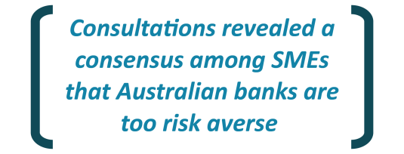There was a consensus among SMEs that Australian lenders are too risk averse when it comes to lending to SMEs. It was suggested that banks only lend against bricks and mortar and are reluctant to lend for investment in innovation or against cash flow. Some contacts cited the need to provide residential property as security on business loans as a potential impediment to investment.

Some SMEs consider that the cost of capital for SMEs in terms of price and covenants is prohibitive, and questioned whether banks might be more willing to lend to SMEs if they were not able to derive so much profit from the residential mortgage market. Some contacts raised questions about the level of competition in the financial market.

* Some banks consulted reported that demand for credit from small business has been lower than expected, and noted that small business loans tend to be more expensive reflecting the higher level of risk.
* Other stakeholders saw bank margins and returns on equity (ROE) for small business lending as unusually high and potentially an impediment to financing this segment.
* SME contacts raised questions about whether Australia’s macro-prudential settings are right and suggested that prudential requirements could be recalibrated to support business lending.
* Some contacts raised concerns that the recent APRA changes and associated tightening of lending practices has amplified financing challenges for SMEs. A few described this as a quasi‑credit squeeze.

A number of stakeholders commented that it is noteworthy that the lowest interest rates on record have not encouraged more business investment, pointing to how much capital has flowed into passive investment such as real estate rather than productive investment over the past decade. They asked if this is the best outcome for the country.

* One contact commented that lending for business is as strong as it has ever been. Australians are investing in residential property, not business. Confidence will fall when house prices fall.
* Another commented that there is little incentive to diversify investments because the returns in commercial property are superior and it’s much easier than running a business in other sectors given all of the regulation and costs associated with employees.

Some SMEs considered that overall, these financing problems point to a market failure. It was suggested governments could bridge the gap through a loan assistance scheme at commercial rates. However it was noted that one existing State loan guarantee arrangement has had very limited uptake to date.

* Stakeholders suggested that any such guarantee schemes need to be well-designed in order to present a good deal to SMEs relative to other market options such as peer-to-peer lending (which is expensive) and using the family home as security for an ordinary loan (which attracts better rates).

## Energy

|  |  |
| --- | --- |
|  | Key Points |
|  | Affordable and reliable energy is crucial for investment decisions by small and large businesses across Australia.  Signals for new long-term generation investments require a nationally agreed and widely supported policy framework.  The recent increase in gas and electricity prices, and the continued uncertainty around their outlook, requires concerted effort by State and Commonwealth Governments to deliver the reforms required for a reliable, affordable and sustainable energy market.  The rapid implementation of recommendations on energy security and the gas supply strategy from Dr Alan Finkel’s Independent Review into the Future Security of the National Electricity Market should remain a matter of priority. |

The energy sector was regularly raised by all groups consulted as an example where appropriate regulatory and policy settings were vital for investment decisions. It was noted that many of the factors currently impacting negatively in the Australian energy market were the result of inadequate policy and regulatory settings that had been slow to adapt to shifting circumstances. While many factors were outside of government’s hands, such as the international price of new technology, it was possible for governments at all levels to provide greater policy certainty.

* One industry contact articulated that the current regulatory settings were designed for an electricity market of the past. The market was previously about base load, intermediate and peak, but we have moved towards intermittent renewables and distributed power.
* Another commented that energy had not been on the radar while everything was working fine. However now the Australian economy is in a somewhat precarious position, and given the transition time required for investments in the sector, now is the time for politicians across the federation to come together to support a long-term policy solution.

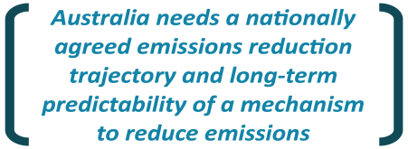Stakeholders were unanimous in their views that strong signals for new investments require a nationally agreed emissions reduction trajectory and long-term predictability of a mechanism to reduce emissions. Investments in the electricity sector are capital intensive and have long asset lives. The absence of a clear emissions reduction trajectory or a durable mechanism to guide the next wave of generation investment after the Renewable Energy Target closes in 2020 has resulted in significant uncertainty for electricity generation investment, which is stalling investment and putting upward pressure on electricity prices.

Stakeholders strongly emphasized that the urgent implementation of the recommendations made by Dr Alan Finkel’s Independent Review into the Future Security of the National Electricity Market (NEM) 2017 (Finkel Blueprint) is crucial to addressing investment uncertainty and delivering market rules that continue to deliver secure, reliable and affordable power. Stakeholders were of the view that the implementation of the Finkel Blueprint has to be durable to changes in government and must be coordinated at the national level to secure the support of all State and Territory Governments.

* Businesses noted that high electricity prices and concerns around reliability increasingly presented a barrier to future investments, and the perception of Australia as a favourable destination for international capital.
* A large number of contacts raised concerns about higher energy prices forcing businesses to “get by on really skinny margins” and threatening the viability of some businesses.
* Companies were concerned about the impact of high and rising electricity prices on consumer confidence and affecting demand for goods and services more broadly. One contact noted that “the rubber is still yet to hit the road”– as we are yet to actually feel the impact of higher bills.
* One contact commented that, if we were to unpack and extrapolate the underlying energy costs, we would find we are moving to a situation where fewer customers will be paying for the network assets, which will increase the cost of electricity for those who can least afford it and cannot afford to install their own generation or storage. It would be a regressive economic outcome.

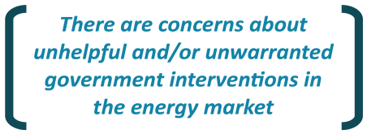Stakeholders understood that artificially increasing generation supply will not be the solution to lower prices in the medium‑term and could have long-lived negative consequences. There were references to the system in place prior to the forming of the NEM not being favourable. Businesses commented that many of the ideas floated as quick fix supply solutions do not stack up. Businesses expressed concern about what are considered to be unhelpful and/or unwarranted government interventions in the market. Specifically, concerns were raised about the Commonwealth Government’s Domestic Gas Security Mechanism and State gas exploration and extraction moratoriums.

Energy consumers in Western Australia raised concerns about high electricity costs but, unlike the NEM this is attributed to significant generation overcapacity associated with the capacity mechanism in their Wholesale Electricity Market (WEM). The WEM is currently transitioning to a rules framework that will require new generators to pay for their guaranteed use of network capacity, even when the network is congested. Stakeholders raised a concern that this change may make further investment in generation unviable. Some stakeholders in Western Australia noted that the Finkel Blueprint did not take into account the specific issues facing the WEM and remote grids in the State’s north.

## Taxation

|  |  |
| --- | --- |
|  | Key Points |
|  | Australia’s high corporate tax rate by international standards acts as a barrier to investment in Australia.  Large multinational companies not paying their ‘fair share’ of tax put other businesses at a competitive disadvantage – a level playing field is required.  Some SMEs consider payroll taxes act as a dis-incentive to expand employment and investment.  Given the long timeframes of many investments, the tax environment and policies should remain relatively stable and avoid creating impediments to new investment, particularly in terms of international competition. |

Many companies consulted indicated that Australia’s 30 per cent company tax rate imposes a large distortion on investment as it sets a higher rate of return hurdle for new investments in Australia than in other countries. Contacts noted that the gap has widened in recent years and is set to widen further.

* While most businesses indicated that they are pleased with the Commonwealth Government’s plan to lower corporate tax rates, there was concern from some contacts that the tax cuts for large companies may not achieve the stated purpose if these companies do not reinvest tax cuts due to the franking credit arrangements. One contact argued that not all companies should pay the same level of tax and suggested a turnover tax instead.
* Businesses that supported the corporate tax cuts generally believed that there is a need to go further to improve Australia’s competitiveness and to stimulate investment.

A concern around competitors in the form of multinational companies not paying their fair share of tax was raised as a disincentive for investment as it puts them at a disadvantage to start with.

Payroll taxes were identified as a significant concern, particularly for SMEs with a large number of employees in the services sector. These businesses considered that payroll tax creates perverse incentives for employing more people and growing the business.

* One contact described payroll tax as “a tax on business optimism”.

## Policies to support a transitioning economy

|  |  |
| --- | --- |
|  | Key Points |
|  | Governments can implement well-designed policies to support structural transitions in the economy.  Australia’s relatively risk averse culture is having a negative impact on our innovation capabilities.  Regulatory settings should continue to be reviewed to ensure they support an environment for innovation, but should strike a balance in protecting investors.  Businesses raised concerns they cannot access the required skills and knowledge to create measurable value from investments in digital and other technologies.  The Australian economy will continue to face the forces of technological change, ageing and globalisation, and the education and training system will need to evolve to meet those demands.  Investment in human capital and the ability for firms to access skilled and qualified employees (through the education system or relevant visas) requires constant attention.  Governments should continue to promote private sector participation in infrastructure projects and to focus efforts on making better use of existing infrastructure. |

Governments can implement well-designed policies to support industry to deal with the structural transitions in the economy. For example, the accelerating pace of technological change is causing structural shifts in some industry sectors and employment patterns. Governments should not impede these transitions. However, well-designed policies can help smooth the transition and assist business and the community more broadly to adapt. Such polices can help to ensure that productivity growth is realised.

### Innovation

Innovation is important in every industry as it has the potential for far reaching economic implications – keeping Australia competitive, boosting employment and maintaining living standards. While high commodity prices have helped drive growth in living standards over the past decade, fostering innovation and commercialising ideas will be a key driver of future jobs and growth.

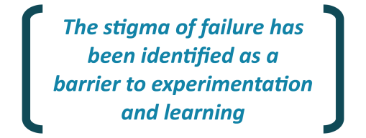Innovation capabilities are impacted by the risks that businesses are willing to take. Stakeholders discussed the difference between the risk appetite of people in Australia compared to places like Israel, and the stigma of failure was specifically identified as a barrier to experimentation and learning.

* One contact noted that their organisation tackles risk by identifying the harm that could happen and mitigate it by producing a set of regulations, which in turn actually reduces the flexibility of the business and therefore reduces the appetite for risk.

Some businesses commented that Australia has a similar legal framework to countries that do innovation well but that we have some significant cultural differences. Other businesses expressed concern that the current insolvency regime is too onerous and is dis‑incentivising risk taking. This is consistent with past consultation processes, where it has been raised in particular by small businesses. It was noted that regulatory settings should strike a balance in protecting investors while supporting an environment for innovation and that regulatory settings should continue to be reviewed and, where appropriate, international models should be considered.

|  |  |
| --- | --- |
|  | box 6: National innovation and science agenda |
|  | Given the positive relationship between innovation and productivity, the Commonwealth Government launched the NISA, a broad initiative aimed at promoting innovation in the economy through building talent and skills, improving access to capital and encouraging entrepreneurship.  The NISA initiatives are closely aligned with potential strategies to deal with issues raised by stakeholders consulted. For instance, to help redress the risk aversion culture towards a better balance the Commonwealth Governments has introduced laws that:   * introduces a safe harbour to encourage directors to seek advice earlier on how to restructure and save financially distressed, but viable companies; and * will make ipso facto clauses (that allow contracting parties to immediately terminate agreements with a company when an insolvency event occurs) unenforceable if the company is undertaking a formal restructure.   These changes are aimed at reducing the stigma associated with insolvency in order to redress the risk adverse culture in a measured approach.  Another key focus of NISA is equipping Australians with the skills they need for jobs in an increasingly knowledge-based economy, including programs to increase digital literacy, improve science, technology, engineering and mathematics (STEM) learning outcomes and encourage women to engage in STEM education and careers.  Under the NISA the Commonwealth Government has implemented a range of measures to improve access to finance, including new tax incentives for investors in early stage innovation companies, improved tax rules for venture capital and a new regulatory framework for crowd sourced equity funding for public companies. This new framework will be extended to proprietary companies. |

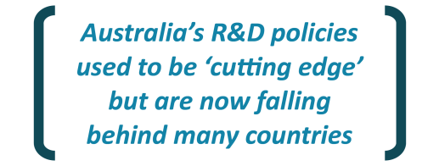Companies noted that Australia’s research and development (R&D) policies used to be ‘cutting edge’ but are now falling behind many countries. They expressed concern that funding is being scaled back whereas other countries are increasing it. One commented that R&D arrangements were stable for 15 years but have recently been changing on a regular basis.

Some SMEs raised concerns around Australia’s R&D tax incentives, noting that they can only benefit from the incentives if and when they are strongly cash flow positive. Contacts provided mixed views on grant schemes established by States since securing grants through these schemes requires cash co-contributions from applicants. They suggested revisiting eligibility criteria to better target such programs rather than removing these altogether where uptake is low or the scheme is not meeting the desired objectives.

* A few stakeholders commented that there needs to be more fostering of industry clustering and innovation hubs to build momentum in the transition to advanced manufacturing. There was an open question on governments’ role in assisting with this.

### Skills and the labour market

Businesses raised concerns that while digital and other technologies are being adopted across Australian industries, they cannot access the required skills and knowledge to create measurable value from them. This can be more challenging for small businesses, which typically need to see a strong case for the adoption of new technologies before committing money or resources.

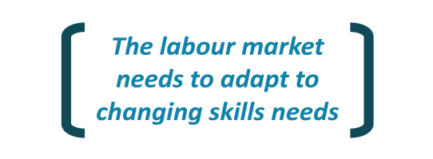Stakeholders agreed that the labour market needs to be flexible enough to adapt to changing skills needs and people will need to be able to reskill much more quickly to adapt to the changing economy. It was agreed that we are rapidly going to need employees with a different set of skills but that we are not well placed for this, for example there is already a lack of programming skills.

* One contact provided an example of a company in advanced manufacturing that was unable to fill a number of jobs because a large number of the applicants failed a basic maths assessment.

Some contacts considered that gaps and shortfalls across Australia’s education and training systems are an issue. It was noted that universities are responding by offering shorter, more general degrees. It is considered that the Vocational Education and Training (VET) sector will need to play a bigger role in the future. Some contacts suggested that there needs to be greater links between universities, the VET sector and training hubs. Others acknowledged that industry should be sending signals on skills needs to the education sector but that businesses themselves are still adapting to the fast pace of technological change and the impacts – such as the advancing of Artificial Intelligence.

Our consultations raised important questions about how the VET and university sector respond to the changing industry needs, as well as industry’s role in this through signalling. Concerns were raised about the rapid pace of technological change and likely impacts on industry, which highlights the importance of industry working together with the education sector to help smooth this transition.

Other questions raised include whether the VET sector could play a greater role in skilling the workforce and what is industry’s role in providing relevant technical and on-the-job training. Some of the feedback suggests that industry assumes that skilling of workforces is primarily a role for governments.

#### SMEs skills challenges

Our consultations revealed that attracting and retaining skilled labour and talented professionals can be even more challenging for SMEs. Contacts in Adelaide, Tasmania and the ACT commented that this is particularly challenging in smaller States.

* One contact in South Australia described this as the biggest barrier to their business expansion, noting that it’s hard to compete with large companies in other States. While locals consider that Adelaide, and South Australia more broadly, are generally considered a ‘dream’ place to do business and live, businesses indicated that attracting talent, particularly young people with technical skills (IT skills for example), is difficult even with a salary premium.
* Similarly a contact in Tasmania noted that it is hard to compete with large construction projects on the mainland and skilled workers are often lured to the bigger States.
* A contact in Canberra noted that while the ACT is home to five universities and a range of tertiary and training institutions, Canberra businesses continue to identify skills shortages as a key impediment to business investment in the region.
* Some small businesses suggested that they lack the time or resources to invest in upskilling themselves or their employees. One contact said the cost of training staff is around $40,000 to $60,000 per employee in their business so the investment in your labour force is a big part of your working capital.

#### Skilled visa program

Most stakeholders indicated strong support for the 457 visa scheme as a way of managing skills shortages – particularly for roles where the Australian workforce does not have the skills, with a number of examples across a range of industries provided.

* Contacts commented that changes to the 457 visa scheme limiting some visas to two years, including for CEOs and other key personnel risk closing off the option to fill genuine skills shortages. Many companies raised concern about the process by which the changes came about and the lack of consultation ahead of the announcement.
* Some stakeholders in Darwin raised concerns that the changes to the 457 visa program and the Work and Holiday and Working Holiday visas will disproportionately affect the NT given the high intake of migrant workers.

One stakeholder raised concern that there is too big a reliance on the 457 scheme and that Australians could easily fill the lower skilled jobs if businesses focussed on training Australian workers.

### Infrastructure

Transport infrastructure is an important enabler of productivity and efficiency and is a connector between people, goods and services and markets. A number of stakeholders in different regions noted the importance of being able to transport goods to market.

* Shipping related export market access challenges were identified in Adelaide (where there has been a dramatic reduction in available shipping slots due to less competition in global shipping) and Tasmania (where the direct shipping line ceased in 2010).
* There was strong support in Tasmania for the Bass Straight scheme which was described as the lifeline of the Tasmanian economy. Contacts suggested that it is hard to know whether to invest in production to expand exports if there is uncertainty about the scheme continuing.
* Land transport infrastructure challenges were also identified in South Australia. Given the small size of the local market, most of the products need to be exported interstate or overseas.
* Northern Territory contacts raised concerns about a lack of supporting infrastructure, noting that road and rail improvements were required to smooth supply chains to support the agriculture, tourism and commodities industries. The scale of most projects is such that they are less likely to get up through the Infrastructure Australia process. Project‑by‑project cost benefit ratios do not adequately take into account the holistic regional development benefits.

Stakeholders were unanimous in their views that we need more bipartisan support for major infrastructure projects in order to support business confidence. This is important for the Australian brand.

Businesses consider that there is strong investor appetite in the infrastructure sector, and no shortage of capital for good Greenfields investments. However, there remains a strong role for governments to play particularly with more investment in land transport infrastructure projects to alleviate congestion for business (transporting goods) and to enable greater labour mobility.

* One peak industry body considers that insufficient infrastructure is a major barrier to greater investment because it is critical for transporting goods to market and congestion caused by inadequate infrastructure adds to business costs.
* Another contact noted that transport is also an important for labour mobility, and suggested that the rail funding announced in the 2017-18 Federal Budget is good but that it needs to be brought forward from the out years to accelerate the productivity benefits this funding will provide “otherwise we will be waiting a decade before real progress”.
* Stakeholders also commented on the positive spillover benefits of public funding in infrastructure into the economy more broadly, with numerous citations of what some contacts described as the current ‘infrastructure boom’ in NSW.

Contacts suggested that governments should also look to improve procurement processes. One company noted the high bid costs associated with Public Private Partnerships (around 1‑3 per cent of project costs) and the need for governments to do more work around this. It was also noted that there are unintended complexities in government procurement processes.

# Appendix A: stakeholders consulted

Heads of Treasuries would like to thank the following businesses and organisations for their valuable input to this Review.

|  |
| --- |
| A. Noble & Son Limited |
| AGL Energy Limited |
| Ahrens Group Pty Ltd |
| Alinta Energy Pty Ltd |
| AMP Limited |
| Australian and New Zealand Banking Group Limited |
| Aurizon Holdings Limited |
| Australian Advanced Manufacturing Council |
| Australian Chamber of Commerce and Industry |
| Australian Council of Trade Unions |
| Australian Energy Council |
| Australian Industry Group |
| AustralianSuper Pty Ltd |
| AUSVEG Limited |
| Bentleys Finance SA |
| BHP Billiton Limited |
| Bickfords Australia Pty Ltd |
| Brisbane Airport Corporation Pty Ltd |
| Broadspectrum Limited |
| Business Council of Australia |
| Canberra Business Chamber |
| CBH Group Pty Ltd |
| Chamber of Commerce and Industry of Western Australia |
| Citigroup Pty Ltd |
| Commonwealth Bank of Australia |
| ConocoPhillips Australia Pty Ltd |
| Cook Medical Pty Ltd |
| Crown Resorts Limited |
| Energy Resources of Australia Limited |
| ERM Power Limited |
| Forico Pty Ltd |
| Hazell Bros Group Pty Ltd |
| Incat Tasmania Pty Ltd |
| Intelledox Pty Ltd |
| Landbridge Pty Ltd |
| Levett Engineering Pty Ltd |
| Macquarie Group Limited |
| Minerals Council of Australia Northern Territory |
| National Australia Bank Limited |
| The National Convention Centre Canberra |
| Nekon Pty Ltd |
| New Hope Group (Aust) Pty Ltd |
| Northern Territory Manufacturers Council |
| Origin Energy Limited |
| Pennicott Wilderness Journeys Pty Ltd |
| Philmac Pty Ltd |
| Port of Brisbane Pty Ltd |
| Precision Components Australia Pty Ltd |
| Property Council of Australia Limited |
| Qantas Airways Limited |
| QIC Limited |
| QSuper Limited |
| Scentre Group Limited |
| Seeley International Pty Ltd |
| Stornoway Pty Ltd |
| Suncorp Group Limited |
| Sydney Angels Incorporated |
| Telstra Corporation Limited |
| Transurban Limited |
| UBS Pty Ltd |
| Ultra Electronics Australia Pty Ltd |
| Victorian Funds Management Corporation |
| Virgin Australia Holdings Limited |
| Watpac Limited |
| Wesfarmers Limited |
| Western Power |
| Westpac Banking Corporation |
| Woodside Pty Ltd |
| Woolworths Limited |

1. Businesses generally referred to business investment in broad terms that included spending beyond what is captured in the official Australian Bureau of Statistics (ABS) data. For example, the ABS definition of private business investment does not include spending on human capital items such as education and training. It was clear from discussions with many small businesses that investment in their people was their primary investment – particularly for sole traders. [↑](#footnote-ref-2)
2. (See Campbell and Withers (2017) for a detailed discussion of the recent drivers of productivity growth,  
   [https://static.treasury.gov.au/uploads/sites/1/2017/08/p2017-t213722-Roundup\_Productivity\_trends\_and\_  
   structural\_change.pdf](https://static.treasury.gov.au/uploads/sites/1/2017/08/p2017-t213722-Roundup_Productivity_trends_and_structural_change.pdf)). [↑](#footnote-ref-3)