Shaping a Nation

Population growth and immigration over time

The Treasury

Department of Home Affairs

© Commonwealth of Australia 2018

ISBN 978-1-925504-68-2

This publication is available for your use under a [Creative Commons Attribution 3.0 Australia](http://creativecommons.org/licenses/by/3.0/au/deed.en) licence, with the exception of the Commonwealth Coat of Arms, the Treasury and Department of Home Affairs logo, photographs, images, signatures and where otherwise stated. The full licence terms are available from [http://creativecommons.org/  
licenses/by/3.0/au/legalcode](http://creativecommons.org/licenses/by/3.0/au/legalcode).

Creative Commons attribution licence 3.0 icon. 

Use of Treasury and Department of Home Affairs material under a [Creative Commons Attribution 3.0 Australia](http://creativecommons.org/licenses/by/3.0/au/deed.en) licence requires you to attribute the work (but not in any way that suggests that the Treasury or the Department of Home Affairs endorses you or your use of the work).

*Treasury and Department of Home Affairs* *material used ‘as supplied’.*

Provided you have not modified or transformed Treasury and Department of Home Affairs material in any way including, for example, by changing the Treasury and Department of Home Affairs text; calculating percentage changes; graphing or charting data; or deriving new statistics from published Treasury or Department of Home Affairs statistics — then the Treasury and the Department of Home Affairs prefers the following attribution:

*Source: The Australian Government the Treasury and the Department of Home Affairs.*

**Derivative** **material**

If you have modified or transformed Treasury and Department of Home Affairs material, or derived new material from those of the Treasury or the Department of Home Affairs in any way, then the Treasury and the Department of Home Affairs prefer the following attribution:

*Based on the Australian Government, the Treasury and Department of Home Affairs, data.*

**Use of the Coat of Arms**

The terms under which the Coat of Arms can be used are set out on the It’s an Honour website (see [www.itsanhonour.gov.au](http://www.itsanhonour.gov.au)).

**Other uses**

Enquiries regarding this licence and any other use of this document are welcome at:

Manager  
Editorial, Media and Speeches Unit  
The Treasury  
Langton Crescent   
Parkes ACT 2600  
Email: [medialiaison@treasury.gov.au](mailto:medialiaison@treasury.gov.au)

# Foreword

From the Secretaries of the Treasury and the Department of Home Affairs

Australia is a nation built on a foundation of migration. Our historically strong population growth is drawn from both natural increase and net overseas migration. Migration has made a significant contribution to our country, with almost 7 million out of Australia’s population of almost 25 million born overseas.

The Australian community has been enriched by the presence of migrant groups, who have brought diversity to our cities, suburbs and towns. The Italians settled in Melbourne’s Carlton, the Vietnamese built a community in Sydney’s Cabramatta, just as the Arabic-speaking community has formed in Sydney’s Lakemba. China, India and the Philippines now join England and New Zealand at the top of the list of countries of birth other than Australia. Generations of migrants have contributed to Australia’s rich cultural diversity – our nation is comprised of people with over 300 different ancestries, who speak more than 300 different languages, and practice over 100 religions.

Population growth has not happened uniformly across Australia, nor has each State or Territory’s population story been the same. All States and territories are united, however, in continuing to grow. Population growth has undoubtedly contributed to the extraordinary period of economic growth that Australia has experienced since the early 1990s. Migration has also played a role in our prosperity, with migrants delivering economic, social and fiscal benefits for Australia. Australia’s skill-focused migration program has increased the resources, skills and knowledge available in our economy, boosting opportunities for all Australians.

At the same time, a growing population heightens existing pressure on infrastructure, housing, transport networks and our environment—especially in major cities—and the distribution of population growth will be a key factor in shaping the future of regional centres. Treasury and the Department of Home Affairs have worked together to better understand the trends driving Australia’s growing population and the influence of migration on our economy and society. As this paper highlights, policy makers will need to think carefully about the steps that can be taken now to ensure Australia can continue to reap the benefits of migration and population growth.

This joint research, which has been undertaken by our Departments over the course of 2017, aims to inform discussion and debate. The comments and analysis in this paper are those of the Departments and do not represent or imply Australian Government policy. There is more work to be done and our two Departments will continue to focus on these issues. Included in this paper is a list of possible issues for further research.

We would like to thank Mirren Allica, Christopher Short, Jacinta Greenwell, Lucy Lu, Son Vu, Eugen Kovac and Susan Love for their work on this paper.

 

**John A. Fraser Michael Pezzullo  
Secretary Secretary  
The Treasury Department of Home Affairs**

Contents

Foreword iii

Executive Summary 1

Population and Immigration: Trends and Implications 2

1. Australia’s population: growth over the last century 2

2. Population components 5

3. Population trends across the States 6

4. Distribution of Australia’s population 9

5. Net overseas migration — a closer look 14

6. Relationship between migration and economic growth 22

7. Fiscal impact of migrants 32

8. Population growth and associated pressures 35

Conclusion 49

Treasury Research Institute — possible questions for further research 50

References 51

# Executive Summary

Population growth and population distribution affect most areas of public policy. This paper examines the benefits that population growth and migration bring to Australia, while remaining alive to the challenges brought by a larger population.

Australia has long stood out from other nations as a country shaped by strong population growth and migration. Population growth has increased in recent times but still remains lower than in the 1960s and 1970s. While births have been the main driver of population growth over the last century, there have been times when net overseas migration has contributed a larger share, including over the most recent decade or so.

Australia’s population growth has varied widely across the States and sub‑state regions. In general, however, Australia’s cities have grown strongly while population growth in regional areas has been more mixed. Over the last decade, migration has contributed particularly strongly to population growth in Sydney, Perth and Melbourne.

While migrants from the United Kingdom featured strongly in Australia’s early migration efforts and remain the largest group of overseas‑born residents, migrants from China, India and other Asian countries now also feature strongly. According to the 2016 Census, for the first time in Australia’s history, a greater proportion of people born overseas are now from Asia rather than from Europe. However, more of Australia’s residents still have European ancestry.

Australia’s migrants increasingly first enter the country on temporary visas before transitioning to permanent residency. Permanent migrants are also increasingly coming through skilled pathways, including employer sponsored pathways.

Migrants deliver an economic dividend for Australia due to current policy settings which favour migrants of working age who have skills to contribute to the economy. This leads to higher rates of workforce participation and likely productivity benefits. This, in turn, increases Australia’s GDP and GDP per person, with positive flow‑on effects for living standards.

As well as delivering an economic growth dividend, migration improves the Commonwealth’s fiscal position, since migrants are likely to contribute more to tax revenue than they claim in social services or other government support.

The positive effects of migration on economic growth and Australia’s fiscal position are well documented. However, the effects of migration and population growth more generally on the geographic distribution of Australia’s population are less well documented. High rates of population growth can heighten existing pressures on infrastructure, housing, and the environment. Without continuing action to find innovative solutions, high rates of growth may also intensify issues such as congestion and excessive waste production. To fully reap the benefits of immigration and population growth, Australia must continue to explore and address these issues.

# Population and Immigration: Trends and Implications

1. Australia’s population: growth over the last century

The story of Australia’s population over the last century is one shaped by baby booms and successive waves of migration. Australia’s population is now almost 25 million, having increased by almost five times over the last century. Over nearly five decades, Australia’s population growth rate has changed only slightly, although it has been high compared to population growth rates in most OECD countries (Figure 1). Canada and New Zealand – countries often considered similar to Australia – have also experienced high population growth rates, although not as high as Australia’s.

As at 2016, Australia had the sixth highest population growth rate in the OECD, the same ranking as in the 1960s. Population growth rates have slowed across many OECD countries. However, Australia’s population growth rate was higher in 2016 than it was at its low point during the 1990s, despite remaining lower than during the 1960s and 1970s (Figure 1).

Figure 1: Population growth rates across OECD countries



Note: Australia had the sixth highest growth rate in the OECD in 2016 but the fourth highest, on average, over the 2010s.

Source: World Bank 2017, authors’ calculations.

Australia’s population has had periods of faster growth and slower growth over the past century. As Australia emerged from World War I, the population grew rapidly, and continued to do so during the 1920s. Population growth then slowed to its lowest point during the Great Depression of the 1930s, falling to just 0.7 per cent in 1935.

The highest population growth occurred after World War II, from 1946 to 1970, during which time annual population growth rates averaged 2.2 per cent. After a relatively slow growth period over the 1980s and 1990s, Australia’s population growth rate increased again in the mid‑2000s before peaking in 2008 (Figure 2).

Figure 2: Australia’s population growth over the last century

|  |  |
| --- | --- |
| Population (level) | Growth rate |
|  |  |

Note: The break in the right hand side chart reflects a series break in 1971. Series breaks also occurred in 1922, 1925, and 2006. Series breaks can limit the comparability of data over time.

Source: Australian Bureau of Statistics (ABS) 2014a & ABS 2017a.

Australia’s population growth is determined by two components: natural increase and net overseas migration (NOM). Natural increase measures the excess of births over deaths where births and deaths are determined by the fertility rate and life expectancy respectively. NOM is the difference between the annual intake of immigrants into Australia and the outflow of emigrants departing Australia. It is primarily determined by Australia’s migration programs for permanent residence together with the annual changes in arrivals and departures of migrants on temporary visas.

Changes to these two elements — natural increase and NOM — affect both the size and the structure of the population. Natural increase is largely outside government control, in contrast to NOM which is heavily influenced by government policy.

The relative contribution of natural increase and NOM to population growth has changed over time. As shown in Figure 3, NOM has fluctuated from year to year, rising and falling with policy changes and economic conditions. In contrast, natural increase has remained relatively steady, although it has decreased slowly over time.

From the start of the 20th century until 1948, natural increase almost single‑handedly drove Australia’s population growth. NOM then increased markedly and contributed more than half of Australia’s population growth during brief periods in the 1950s, 1960s and 1980s, as well as during the last decade or so. NOM underwent a step increase in the mid-2000s and this, combined with a slowing rate of natural increase, meant that NOM has contributed 59 per cent of Australia’s population growth over the last decade. However, the increase in NOM in the mid-2000s may not be as large as it first appears.

From 2007, the ABS broadened the definition of NOM. Instead of an Australian resident for NOM purposes being defined as someone who had been in Australia for at least 12 months, a resident was redefined as someone who had been in Australia for at least 12 out of the past 16 months. While this new definition of a resident was officially adopted in 2007, the ABS measured NOM using both methods from December 2003 to September 2006. ABS analysis found that the new method produced NOM levels that were 25 per cent higher on average than the old method (ABS 2017b).

If this relationship between the two definitional methods holds more broadly, a 25 per cent adjustment could be made to NOM prior to 2007 (see Figure 3). Once this adjustment is made, the increase in NOM from the mid‑2000s onwards is less pronounced, although it is still higher on average compared to the previous three decades.

Figure 3: Components of Australia’s population growth



Source: ABS 2014a & ABS 2017a, authors’ calculations.

Relatively higher NOM since the mid‑2000s is, in large part, explained by changes in the number of international students and New Zealanders. International student numbers increased by almost 86 per cent from 2006 to 2009 (Home Affairs 2017), after new pathways to permanent residency through the skilled migration program were opened in 2005 (Australian National Audit Office 2011).

During 2009 and 2010, a number of measures were introduced to improve the integrity of student visas. This, combined with appreciations in the dollar and negative publicity around the safety of students, may explain the 21 per cent drop in student numbers between 2009 and 2013. Student numbers have again increased since 2013, with upwards impacts on NOM.

The number of New Zealanders in Australia grew by more than 41 per cent between 2007 and 2012. The largest single year increase occurred from 2007 to 2008, with an almost 14 per cent increase in the number of New Zealanders. The number of New Zealanders in Australia has continued to climb since 2013, albeit at a slower pace. The combined impact of high student numbers and significant growth in New Zealanders help explain the large NOM peak in 2008 (Home Affairs 2017).

1. Population components
   1. Natural increase has slowed over time

#### Fertility has been lower over the last four decades

Figure 4 shows the average number of babies an Australian woman might expect to have over her lifetime. This fell from 3.1 babies per woman in 1921 to 2.1 babies per woman in 1935. Fertility rates then increased during the ‘baby boom’ years, reaching a high of 3.5 babies per woman in 1961 and averaging 3.1 babies per woman over the period 1946 to 1972. Since then, fertility rates have been trending down and dropped to 1.7 in 2001, the lowest level seen in the last century (PC 2010).

Figure 4: Fertility



Source: ABS 2014a & ABS 2016a.

#### Life expectancy has increased steadily over time

As Figure 5 shows, life expectancy has risen steadily over time. Life expectancy at birth for both Australian males and females remains amongst the highest in the world — in 2015, life expectancy at birth was 80.4 years for men and 84.5 years for women, up from 55.2 years for men and 58.8 years for women in the period 1901‑1910. The combination of high life expectancy and a declining fertility rate is a key reason for population ageing in Australia, discussed in detail in Section 6.4.

Figure 5: Male and female life expectancies



Source: ABS 2014a & ABS 2016b.

* 1. Net overseas migration has varied over time

Changes in natural increase are relatively straightforward since they involve changes to the same variable — the number of Australian-born residents. However, NOM is more variable, fluctuating over time with changes in policy, economic conditions and global movements of people. For this reason, NOM is covered in detail in Section 5.

1. Population trends across the States

Population trends have differed widely across the States and Territories (‘the States’) (Figure 6).

Figure 6: Change in population by State, 1982 to 2016



Source: ABS 2017a.

As the most populous States, New South Wales (NSW) and Victoria’s population changes have most closely mirrored changes at the national level. Since 1993 for Victoria and 2004 for NSW, the trend has been for population to grow at an increasing rate, notwithstanding some fluctuations such as the slower growth experienced around 2010. The Australian Capital Territory (ACT) has also experienced strong growth. Despite only having a small population base, the ACT’s growth rate was the strongest on average of all the States between 2011 and 2016.

Queensland and Western Australia (WA) saw large increases in population during the mining boom, while South Australia (SA) also saw smaller increases. Annual population growth in these States is now more in line with long‑term trends.

Both Tasmania and the Northern Territory (NT) have experienced fluctuations in population growth over time. Currently, population growth appears to be picking up in Tasmania, while in the NT, it remains slow.

The influence of the various population components — natural increase, NOM, and net interstate migration (NIM) — vary across the States.

* 1. Population trends are highly variable across the States

|  |  |  |
| --- | --- | --- |
|  | | NSW’s population growth has been driven by natural increase and NOM. Both natural increase and NOM have been higher on average over the last decade than during previous decades but NOM has been particularly high.  NSW has consistently had a net outflow of people to other States, but this outflow has lessened in the last decade presumably as some of the mining boom flows reverse. |
|  | | Victoria is growing strongly. Annual population growth was 17 times higher in 2016 than it was at its low point in 1993. Victoria now has the highest annual population growth of any State, outpacing NSW since 2011.  Victoria is also the only State where all three population components — natural increase, NOM and NIM – are currently positive and, over the period 2010 to 2016, growing at an increasing rate. |
|  | | Queensland is the only State where all three population components have been consistently positive over the last 30 years.  Despite this, annual growth in all three components has slowed since the mid‑2000swith a consequential slowing of Queensland’s population growth.  NIM has historically been high, particularly compared to other States, but has tailed off over the last decade.  NOM increased markedly from the mid‑1990s, but has since come off the highs of the late 2000s. Natural increase has been higher since the mid‑2000s than during previous decades shown, despite slowing slightly in recent years. | |

3.1 Population trends are highly variable across the States (continued)

|  |  |
| --- | --- |
|  | WA’s population growth, like Queensland’s, appears to be closer to trend following high population growth during the mining boom. Since WA’s trend population growth was even lower than Queensland’s, falls in WA’s growth have been even more marked.  Natural increase has not slowed much but annual NOM growth has slowed to be more than 70 per cent lower in 2016 than at its 2008 peak. NIM has never been a big component of WA’s population change but is now negative. |
|  | The predominant change to SA’s population story is an increase in NOM, which despite levelling off is still higher than in previous decades. In 2016, the NOM share of SA’s population growth was the highest of any State.  Natural increase in SA, like in Tasmania, is now lower than it was in the early 80s.  Apart from three years, NIM has been negative over the period shown, due to a net outflow of people. |
|  | Tasmania’s population growth decreased from 2008 to 2015, but in 2016 a swing from negative to positive NIM, in addition to a slight uptick in natural increase, saw population growth increase.  NIM has been the most volatile component of Tasmania’s population growth. From 1992 to 2001, and again from 2011 to 2015, NIM was negative and relatively large compared to the offsetting positive impact of NOM and natural increase. |

1. Distribution of Australia’s population[1]

Population trends have not only varied across the States, but the variation has been even more significant at the sub‑state level. Australia’s capital cities, with the exception of Adelaide and Hobart, have experienced particularly strong growth. Between 1996 and 2016, the population across Australia’s capital cities grew by 37 per cent on average. Growth in regional areas was lower at 24 per cent on average, although this average masks significant variation from 80 per cent growth on the Gold Coast to negative 5.6 per cent in far west NSW. Higher growth, on average, in Australia’s capital cities compared to regional Australia has meant that by 2016, 67 per cent of the population lived in capital cities, compared to 65 per cent in 1996.

* 1. Population growth is concentrated in capital cities

Australia is, and has been for most of its history, a highly urbanised country (BITRE 2014). However, the proportion of people concentrated in cities, and particularly capital cities, is larger now than at any time in history. In 1911, the eight capital cities accounted for nearly 40 per cent of the population; by 1944 more than half of the population, and by 1996 almost two‑thirds (ABS 2014a).

Between 1996 and 2016, Australia’s population increased by more than 6 million people, with capital cities accounting for 75 per cent of this increase. In total, Australia’s capital cities grew by 4.2 million people, with 31 per cent of that growth occurring in Melbourne, 26 per cent in Sydney, 17 per cent in Brisbane, 15 per cent in Perth, and 11 per cent across the remaining capital cities (Figure 7).

Figure 7: Regional and metropolitan population growth, 1996‑2016

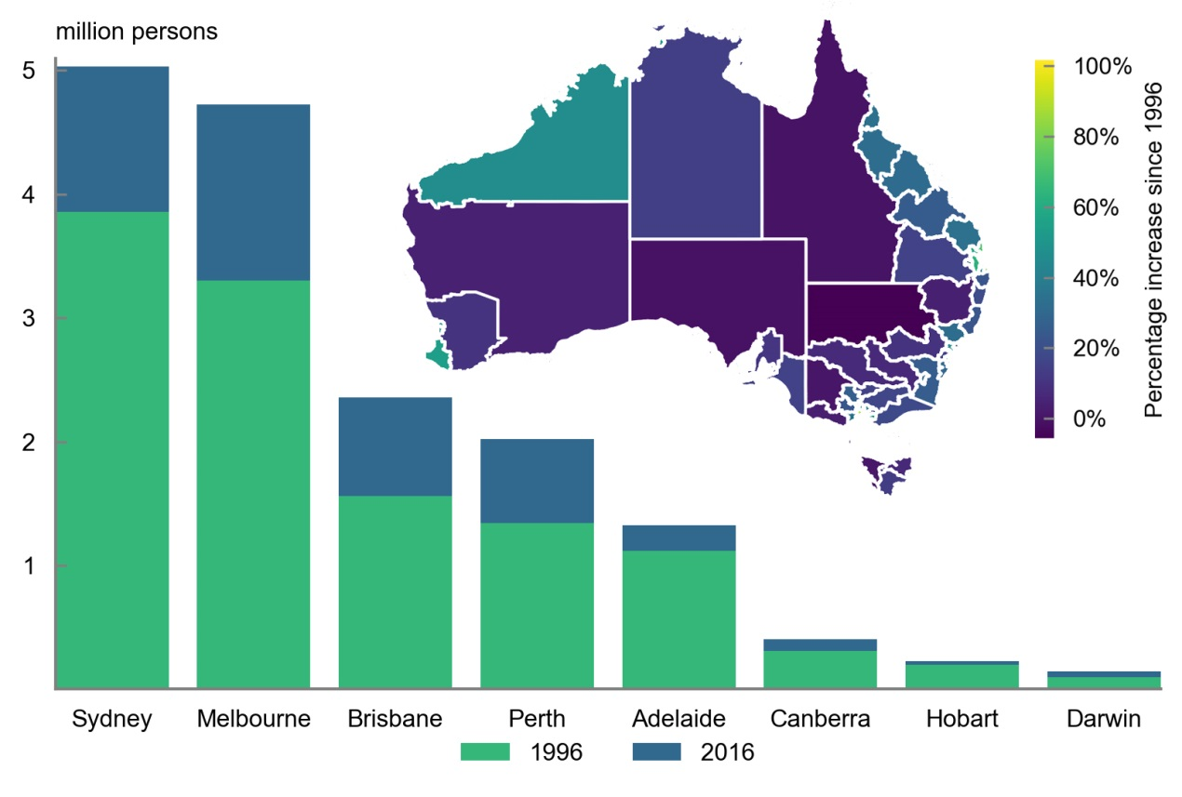

Source: ABS 2017d & ABS 2017e, authors’ calculations.

Melbourne’s West experienced the largest population increase, with the population rising from 410,000 to 766,000. Melbourne’s South‑East and Inner-City, then Perth’s North‑West, South‑East, and South‑West respectively experienced the next largest increases.

In percentage terms, Perth’s Mandurah topped the list by more than doubling in size. Brisbane’s Moreton Bay South and Melbourne’s West represented the next biggest increases (Figure 8). Melbourne and Perth’s population growth was the least uniform of the capitals, while Adelaide experienced relatively more uniform population growth (Figure 9). For Sydney, the largest percentage increase in population occurred in Parramatta, which increased by close to 40 per cent.

Figure 8: Population increases across selected capital cities, 1996‑2016

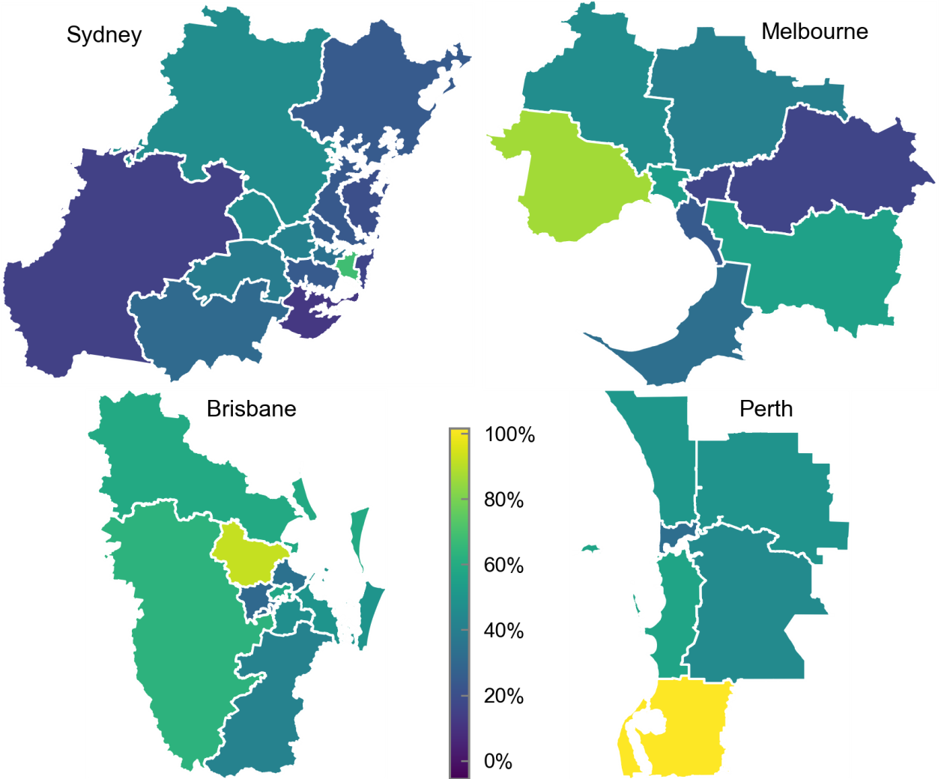

Source: ABS 2017d & ABS 2017e, authors’ calculations.

Figure 9: Population growth rates across Australian capital cities, 1996‑2016



Note: The number of SA4 regions for each capital city is: Sydney 15, Melbourne 9, Brisbane 9, Perth 6, Adelaide 4, Others 1.

Source: ABS 2017d & ABS 2017e, authors’ calculations.

* 1. Contrasting growth within regional Australia and capital cities

Across the regions, growth was most variable in Queensland, and least variable in Tasmania (Figure 10). The Gold Coast and the Sunshine Coast in Queensland experienced the largest population increases across the regions, both in absolute and percentage terms. The Far West & Orana region of NSW recorded the largest decline, falling 5.6 per cent (Figure 7).

Figure 10: Population growth rates across the States, 1996‑2016



Note: The number of SA4 regions for each State is: NSW 13, Victoria 8, Queensland 9, WA 4, SA 3, Tasmania 3 and NT 1.

Source: ABS 2017d & ABS 2017e, authors’ calculations.

Of the 42 sub‑state areas in regional Australia, 15 exceeded the average regional population growth rate of 24 per cent from 1996 to 2016. Some of the regions, such as the Southern Highlands & Shoalhaven in Table 1 below, are attractive destinations for retirees and this has been one of the drivers of strong population growth. Other regions, such as Geelong and the Hunter Valley, have also benefitted from being liveable locations close to Melbourne and Sydney.

Table 1: Growth rates across the States, 1996‑2016

|  |  |  |
| --- | --- | --- |
| Region name | State | Per cent |
| Gold Coast | QLD | 80 |
| Sunshine Coast | QLD | 71 |
| Bunbury | WA | 54 |
| WA Outback North | WA | 47 |
| Geelong | VIC | 35 |
| Cairns | QLD | 34 |
| Wide Bay | QLD | 34 |
| Townsville | QLD | 32 |
| Hunter Valley (exc Newcastle) | NSW | 32 |
| Mackay - Isaac - Whitsunday | QLD | 31 |
| Toowoomba | QLD | 31 |
| Southern Highlands & Shoalhaven | NSW | 29 |
| Bendigo | VIC | 26 |
| NSW Capital Region | NSW | 25 |
| Central Queensland | QLD | 25 |

Source: ABS 2017d & ABS 2017e, authors’ calculations.

* 1. Capital cities have continued to attract migrants

In 2016, 83 per cent of the overseas‑born population were living in capital cities, almost unchanged from 81 per cent in 1996. This compares with 61 per cent of the Australian‑born population, up from 60 per cent in 1996.

The percentage of the population born overseas varies. Almost 40 per cent of the populations of Sydney, Perth and Melbourne were born overseas, compared to only 15 per cent of the population in Hobart (Table 2).

Table 2: Migrant share of capital city populations, 2016

|  |  |  |  |  |  |  |  |
| --- | --- | --- | --- | --- | --- | --- | --- |
| Sydney | Perth | Melbourne | Darwin | Brisbane | Adelaide | Canberra | Hobart |
| 39 % | 39 % | 36 % | 29 % | 28 % | 28 % | 28 % | 15 % |

Source: ABS 2017e, ABS 2017f & ABS2017g, authors’ calculations.

Between 1996 and 2016, migration accounted for 54 per cent of the increase in the Australian population, but there was considerable variability across the capitals (Table 3). In Sydney, migrants contributed nearly two‑thirds of the increase in the population. This relatively high share is due, in part, to the net internal migration away from Sydney discussed earlier. In parts of Sydney, such as Ryde, Parramatta, the Inner-West, North Sydney & Hornsby, and the Eastern Suburbs, migrants accounted for more than 70 per cent of the increase in population.

In Melbourne’s Inner-East, migrants accounted for 100 per cent of the population growth (due to Australian‑born residents arriving and leaving the area in equal numbers). Migrants accounted for just over 60 per cent of population growth in Melbourne’s South-East. In the seven remaining regions within Melbourne, migrants accounted for only around 50 per cent or less of growth. In Perth and Brisbane, the contribution of migration to population growth was more evenly distributed across the geographic spread of those cities.

Table 3: Migrant contribution to population growth by capital city, 1996 to 2016

|  |  |  |  |  |  |  |  |
| --- | --- | --- | --- | --- | --- | --- | --- |
| Sydney | Perth | Melbourne | Darwin | Canberra | Adelaide | Brisbane | Hobart |
| 63 % | 50 % | 50 % | 42 % | 44 % | 42 % | 41 % | 32 % |

Source: ABS2017a, authors’ calculations.

Outside the capital cities, migrants contributed 26 per cent of the population growth in regional Australia (Figure 11). Migrants contributed more than 50 per cent of the population growth in a number of regions including New England and the Riverina in NSW, Warrnambool and the north west of Victoria together with the wheat belt and the resource rich southern part of the outback in WA. Migrants were also important contributors to population growth in regional Tasmania, although the relatively high proportional contribution reflects almost nil to little increase in the Australian born populations in regional Tasmania. In Queensland, migrants contributed 30 per cent of the population increase in Toowoomba and Cairns, and around a quarter or more in central Queensland, the Sunshine Coast and the Darling Downs. The only exception to an increasing migrant population was in outback SA where the migrant population fell 20 per cent even as the total population declined by less than 1 per cent.

Figure 11: Migrant contribution to population growth, 1996-2016

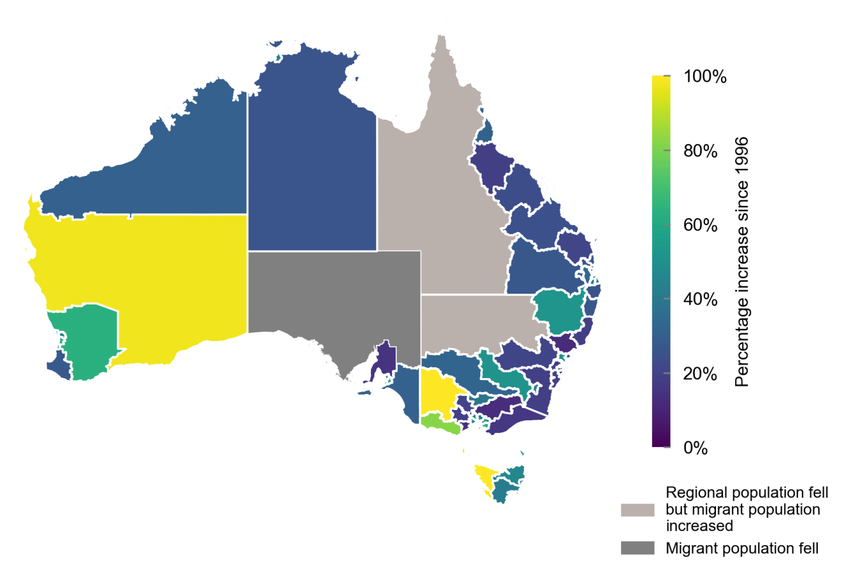

Source: ABS 2017d, ABS 2017e, ABS 2017f & ABS 2017g, authors’ calculations.

* 1. The migrant mix varies across Australia

Residents from the United Kingdom[2] remain Australia’s largest group of overseas-born residents, accounting for 5 per cent of the population in 2016. However, their number as a proportion of the population has been falling for a long time. In 1996, residents born in the United Kingdom accounted for 15 per cent of the population in Perth, 7 per cent in Brisbane and 6 per cent in both Sydney and Melbourne. By 2016, those shares had fallen to 12, 5 and 4 per cent respectively (Figure 12).

Figure 12: The migrant mix varies across capital cities

|  |  |
| --- | --- |
|  |  |
|  | |
|  |  |

Source: ABS 2017d, ABS 2017e, ABS 2017f & ABS 2017g, authors’ calculations.

By contrast, in 2016 people born in China accounted for just over 2 per cent of the national population, 5 per cent of Sydney’s population, 4 per cent of Melbourne’s population, but only 1 to 2 per cent of the populations of Adelaide, Brisbane, Perth and Hobart. Residents born in India accounted for 2 per cent of the national population in 2016, and are more evenly distributed across capital cities. Indian-born residents account for around 3 to 4 per cent of the population in Perth, Sydney and Melbourne, and around 2 per cent in Brisbane and Adelaide. A discussion of changes in Australia’s migrant mix over the last century is in Section 5.1.

1. Net overseas migration — a closer look

Net overseas migration includes both migrants coming to Australia from overseas as well as people leaving Australia. Since more people have generally arrived in Australia than left Australia, NOM has mostly been positive over time.

Migration has played an important role in Australia’s population growth over the last century at both a State and national level. It has also changed the composition of Australia’s population, with 28 per cent of people born overseas and 49 per cent of people either born overseas or with a parent born overseas.

Migrants have transformed Australian society, contributing to a rich array of art, literature, drama, music, fashion, sport and cuisine as well as underpinning economic growth through their contribution to the workforce and Australian businesses.

* 1. Migration to Australia has changed over time

By the time of Federation in 1901, Australia had a population of 3.8 million people, 23 per cent of whom were migrants (ABS 2014a). Overwhelmingly, this population was derived from the United Kingdom, Ireland and the countries of North‑West Europe. Migrants from these countries, together with New Zealanders, accounted for 90 per cent of the overseas‑born population in 1901 (Figure 13).

Figure 13: Country or region of birth for the 1901 overseas‑born population



Source: ABS 2017c.

Australia’s early immigration policies were highly selective and were strongly based around the principles of a ‘White Australia’. Antagonism towards non‑British migrants led to the development of federal policy in 1901 that aimed to keep Australia as ‘white’ as possible. In particular, the relatively small flows of Chinese who came looking for gold and the indentured labourers from the Pacific Islands who worked mainly on Queensland’s sugar plantations were seen as a threat to wages and employment, particularly at a time of economic depression and severe drought (Megalogenis 2015).

In response, several pieces of legislation were created largely to restrict the inflow of ‘coloured migrants’. One of the key mechanisms to achieve this was the introduction of a dictation test which could be in any European language, not necessarily English, at the discretion of officials (Jupp ed. 2001). Non‑European migrants were only allowed to enter Australia on a temporary basis under a strict permit. From 1901 to 1908, Australia lost more people to emigration than it received through immigration, and by 1911 the number of overseas‑born residents was 12 per cent lower than it had been in 1901.

Migration levels ebbed and flowed during the following four decades, with war and economic downturns affecting migrant numbers. Whilst the population doubled to 7.6 million by 1947, the share of overseas‑born residents fell to less than 10 per cent. This reflected increasing fertility levels but a relatively low intake of migrants.

In 1944, Prime Minister John Curtin committed to increase immigration once the war ended for both national security purposes and to support anticipated post‑war labour shortages. The Government established a policy that Australia must ‘populate or perish’ with a population growth target of approximately 2 per cent per year — 1 per cent by natural increase and 1 per cent through migration (Smith et al. 2011).

However, tensions existed between the notion of a ‘White Australia’ and the need for higher levels of immigration. As a result, the number of migrants fell significantly short of the planned intake. The Australian Government established various schemes to bring in migrants from the displaced persons camps in Europe, in addition to entering into agreements with a number of European countries and the United States on assisted migration schemes. As a result, migration from non‑British countries represented two-thirds of Australia’s immigration intake over the post-war period.

Following a review in 1966, Australia, like Canada and the United States, began dismantling its race‑based immigration policies. It was not until the 1970s, however, that the White Australia policy was formally abandoned. In its place, Australia introduced a points‑based system that gave weight to factors such as family ties, occupation, education, and language skills. The 1970s and 1980s also saw the arrival of refugees following the Vietnam War. By 1985, 70,000 refugees from Southeast Asia, mostly Vietnam, had settled in Australia. These changes served to welcome a greater variety of migrants and resulted in an increase in the number of non‑European arrivals.

While skilled migrants had long played a part in Australia’s migration programs, the focus on skills was formalised and expanded by the Howard Government in 1996, as a way of ameliorating the ageing of Australia’s population. Further changes were introduced in the late 2000s to prioritise employer-sponsored individuals. Since migrants arriving through employer sponsorship have a job offer prior to arrival in the country, these changes have helped boost the labour market outcomes of recent migrant cohorts (Cully 2011a). Together, these reforms have formed the basis of Australia’s current migration arrangements. Australia’s programs for permanent and temporary migration are discussed in more detail in Section 5.2.

In 2016, migrants from Australia’s top five migrant source countries accounted for 46 per cent of overseas‑born residents (see Figure 14). By contrast, in 1901, the top five migrant source countries accounted for 92 per cent of overseas‑born residents. As a share of the population, residents born in the United Kingdom accounted for 18 per cent of the population in 1901 and now account for just under 5 per cent, although they remain Australia’s largest group of overseas‑born residents.

Figure 14: Top five overseas countries of birth for Australian residents



Source: ABS 2014a & ABS 2017g, authors’ calculations.

The last 20 years in particular have seen significant shifts in Australia’s migrant mix (Table 4). The 2016 Census shows that Australian residents born in Asian nations now outnumber those born in Europe. Recent migrants from Asian nations have brought Indonesia, South Korea, Singapore, and Thailand into the list of top 20 migrant source countries. These have replaced Croatia, Malta, Poland, and Serbia – countries associated with the European migrant waves of the 1950s – in the top 20 list.

Table 4: Top 20 source countries for migrants, 1996 and 2016 (ABS 2017c)

|  |  |  |  |  |  |  |
| --- | --- | --- | --- | --- | --- | --- |
| Rank | 1996 | | | 2016 | | |
| Country | Population (‘000) | Share (%) | Country | Population (‘000s) | Share (%) |
| 1 | UK & Ireland | 1,218 | 6.7 | UK & Ireland | 1,284 | 5.3 |
| 2 | New Zealand | 312 | 1.7 | New Zealand | 607 | 2.5 |
| 3 | Italy | 250 | 1.4 | China | 526 | 2.2 |
| 4 | Vietnam | 159 | 0.9 | India | 469 | 1.9 |
| 5 | Greece | 138 | 0.8 | Philippines | 246 | 1.0 |
| 6 | Germany | 122 | 0.7 | Vietnam | 237 | 1.0 |
| 7 | China | 119 | 0.7 | Italy | 195 | 0.8 |
| 8 | Philippines | 105 | 0.6 | South Africa | 181 | 0.8 |
| 9 | Netherlands | 96 | 0.5 | Malaysia | 166 | 0.7 |
| 10 | Malaysia | 83 | 0.5 | Germany | 124 | 0.5 |
| 11 | India | 80 | 0.4 | Sri Lanka | 118 | 0.5 |
| 12 | Lebanon | 78 | 0.4 | Greece | 117 | 0.5 |
| 13 | Hong Kong | 76 | 0.4 | South Korea | 107 | 0.4 |
| 14 | Poland | 72 | 0.4 | USA | 104 | 0.4 |
| 15 | South Africa | 62 | 0.3 | Hong Kong | 97 | 0.4 |
| 16 | Croatia | 58 | 0.3 | Lebanon | 93 | 0.4 |
| 17 | USA | 56 | 0.3 | Indonesia | 84 | 0.3 |
| 18 | Malta | 56 | 0.3 | Netherlands | 83 | 0.3 |
| 19 | Sri Lanka | 54 | 0.3 | Singapore | 73 | 0.3 |
| 20 | Serbia | 50 | 0.3 | Thailand | 72 | 0.3 |

* 1. Current migration programs include a mix of permanent and temporary arrivals

#### Permanent migration has increasingly focused on skills

Australia currently has two distinct programs for permanent migrants — the Permanent Migration Program that includes a skill stream and a family stream, and the Refugee and Humanitarian Program. The Australian Government controls the level of permanent migration by setting the annual intake for both programs.

The skill stream of the Permanent Migration Program includes skilled migrants together with their family members. In 2016‑17, almost 39 per cent of skilled migrants were employer sponsored, almost 55 per cent arrived independently with qualifications on the skilled occupation lists, and almost 6 per cent came through business innovation streams. State‑specific and Regional Migration had an outcome of 29.5 per cent; these visas are included in various Skill Stream categories.

In 2016‑17, over 85 per cent of family stream migrants were the partners of Australian residents, and over 13 per cent were parents.

Following the Howard Government’s decision to focus the Permanent Migration Program on skilled migration and away from family reunion, the skilled intake has increased more than five‑fold to 129,000 in 2015‑16. By comparison, the family intake remains 20 per cent below the peak levels that occurred in the late 1980s. Two decades ago, skilled migrants and their families accounted for around 30 to 40 per cent of the Permanent Migration Program. They now account for nearly 70 per cent of the intake (Figure 15). The Permanent Migration Program has been set at 190,000 migrants per year for the last six years.

Figure 15: Evolution of Australia’s permanent migration intake



Source: Department of Immigration and Border Protection (DIBP) 2016a & unpublished Home Affairs data.

#### The stock of temporary migrants has increased over time

In addition to permanent migrants, there are nearly 1.6 million temporary migrants in Australia. Temporary migrants primarily include students, working holiday makers, temporary skilled migrants, and New Zealanders living in Australia.[3]

Australia’s temporary visa program is largely an uncapped program. The vast majority of temporary migrants (nearly 90 per cent) have visas that provide the right to work. This includes migrants who are primarily in Australia for other reasons (such as students and working holiday makers, for whom work rights are limited). The number of those arriving on temporary visas for which the primary purpose is work has been responsive to general labour market conditions, whilst the export focused international student program has moved in line with factors such as global economic conditions and exchange rate changes.

New Zealanders account for 40 per cent of the stock of temporary migrants, and more than a quarter are international students. Workers on 457 temporary skilled visas[4] account for around 10 per cent of the stock and working holiday makers a further 8 per cent (Figure 16). Since  
2000–01, more temporary migrants have generally arrived than departed each year, with the stock increasing by an average of over 50,000 people per year over the period.

Figure 16: Stock of temporary migrants



Source: Unpublished Home Affairs data.

Over the period 2007-08 to 2011-12, the stock of New Zealanders, working holiday makers and 457 visa holders increased strongly (by 24, 53 and 18 per cent respectively). By contrast, international student numbers fell by 3 per cent (and were down almost 21 per cent by the end of the period compared to the peak in 2008-09).

Since late 2012, the pace of growth in the stock of some of these visa holders has ceased or reversed. The number of New Zealanders residing in Australia has increased only 3 per cent in total since 2011‑12. The stock of 457 visa holders has fallen 17 per cent since the peak in 2013‑14, and the stock of working holiday makers has declined 16 per cent since 2012‑13. In contrast, the stock of international students has increased 46 per cent on the back of increasing global demand for education services and a lower exchange rate relative to earlier this decade.

* 1. Some temporary migrants become permanent

Various waves of reforms, from the introduction of the points test in the 1970s to the increased focus on skills in the 1990s and the prioritisation of employer‑sponsored individuals in the 2000s have increasingly required migrants to prove their commitment and skills before they are granted permanent residency. This has resulted in those migrants granted permanent residency having average skill levels and productivity higher than the non‑migrant workforce, on average (Hawthorne 2011; Gregory 2014; Parham et al. 2015).

These days, almost half of the individuals granted permanent residency are already in Australia on a temporary visa. The pathway through temporary visa categories to permanent residence is highly varied, with more than 5,500 different pathways identified. Nonetheless, of those who become permanent residents, nearly 55 per cent transition across just one or two temporary visa categories prior to obtaining a permanent visa within four years (Figure 17).

Figure 17: Transitions across visa classes, 2000‑01 to 2013‑14

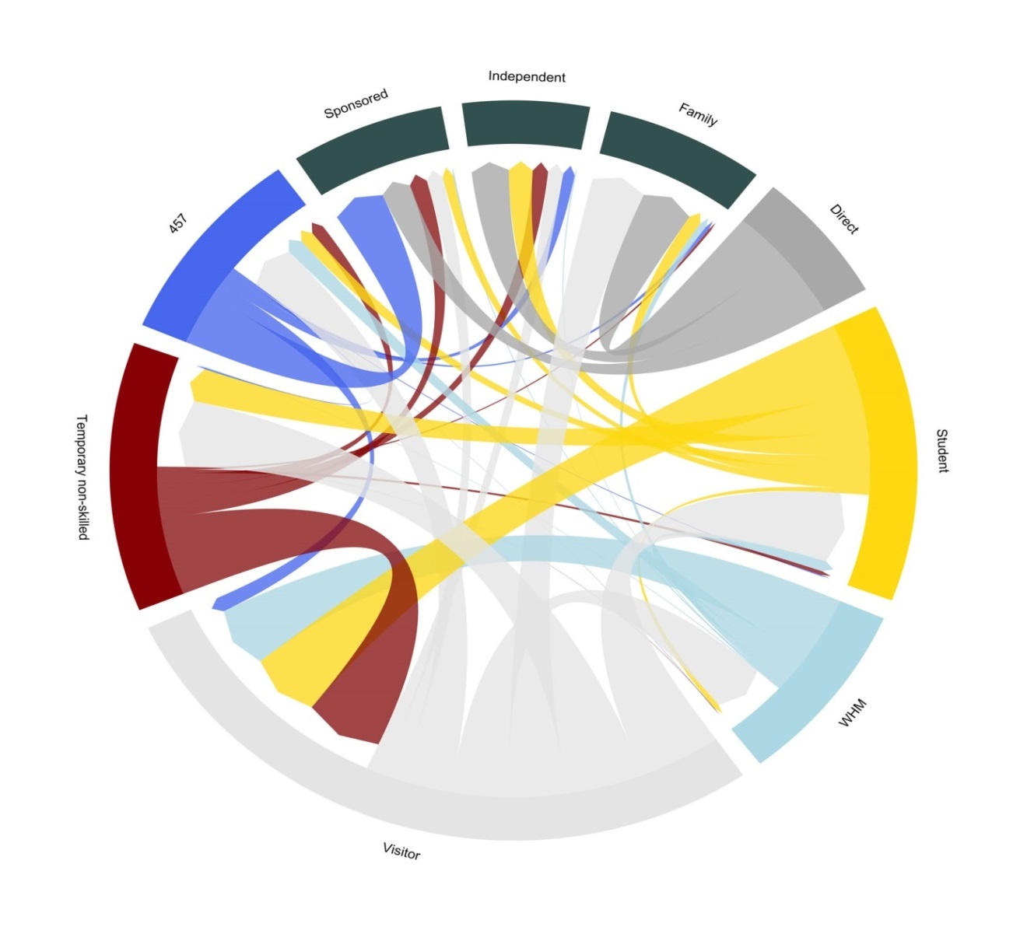

Source: unpublished Home Affairs data, authors’ calculations.

More than a decade ago, former international students were the largest source of permanent skilled migrants. However, expanded opportunities from the late 2000s for employers to sponsor temporary and permanent workers has enabled a demand‑driven approach to selecting relevant workforce skills. This has resulted in the most common pathway to permanent residency since 2007‑08 including a period on a 457 visa.

Of the 946,000 individuals who were employed on a 457 visa between 2000‑01 and 2013‑14, 55 per cent eventually transitioned to permanent residence (Figure 18). For those who transitioned to permanent residence, 25 per cent did so within around one and a half years, and 75 per cent did so within three and three quarter years.

Figure 18: 457 visa transitions

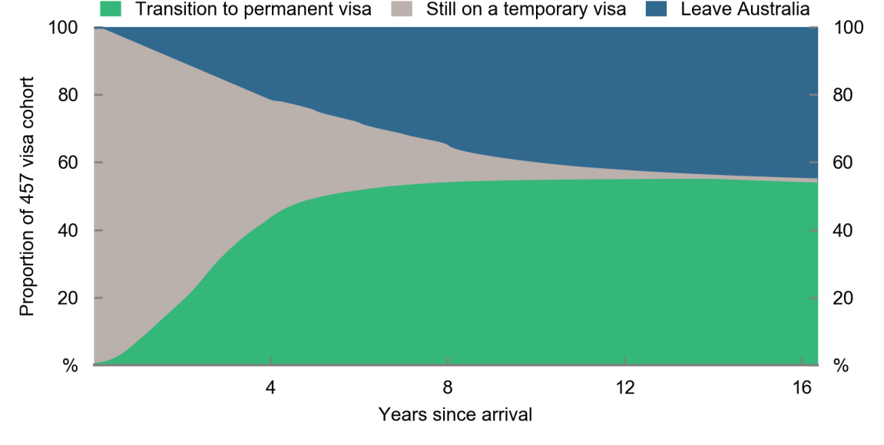

Note: This may also have involved working in Australia under visa arrangements other than a 457 visa.

Source: unpublished Home Affairs data, authors’ calculations.

A much smaller share of those arriving as international students eventually transition to permanent residence (Figure 19). Of the 1.6 million individuals examined between 2000‑01 and 2013‑14, 16 per cent eventually transitioned to permanent residence. Reflecting the time involved in studying, students take longer to make this transition than 457 visa holders. For those who transition to permanent residence, 25 per cent do so within two and a half years, and 75 per cent within just under five and a half years.

Figure 19: Student visa transitions

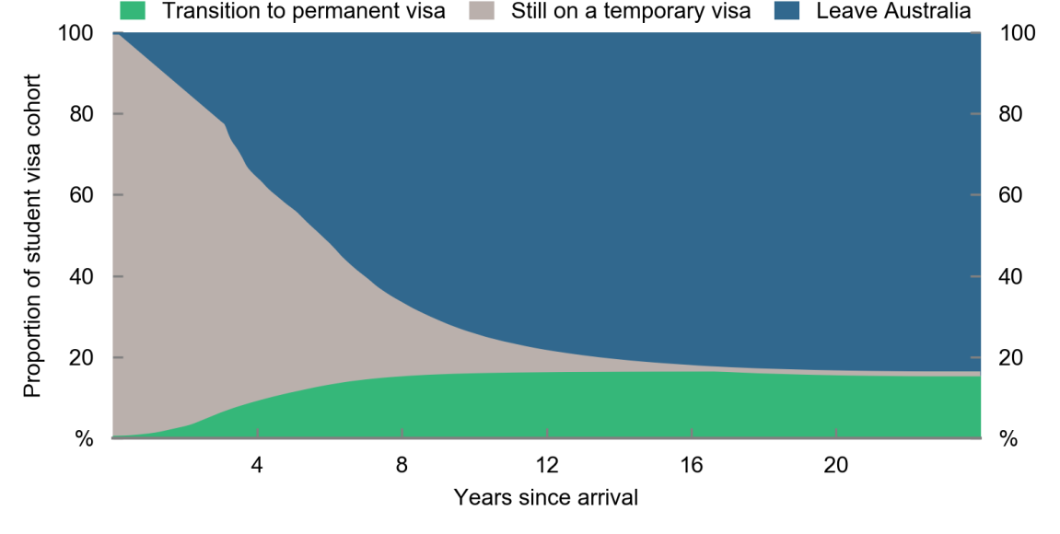

Source: Unpublished Home Affairs data, authors’ calculations.

The time taken for 457 visa holders to transition to permanent residence has reduced over time. This is likely due to increased opportunities for employer sponsorship to permanent residence, with 457 visa holders accounting for more than 75 per cent of the increase in permanent employer sponsored residents between 2000‑01 and 2007‑08.

The time taken for students to transition to permanent residence did not decrease much between 2000‑01 and 2013‑14, perhaps reflecting an increased requirement for students to demonstrate their labour market capabilities through workforce participation. This has made the transition more difficult and less direct. Students have increasingly had to look towards 457 visas and then employer sponsored pathways to permanent residence.

* 1. The supply of migrants is not assured

Due to the important role that a skilled workforce has in contributing to economic growth, policymakers around the world increasingly compete to attract the best and brightest in the ‘global competition to attract high skilled migrants’ (Boeri et al. eds. 2012). Although the global pool of highly skilled people expressing a desire to migrate is increasing, Australia faces considerable competition in attracting these migrants.

Governments set the number of migrants allowed into a country as well as the selection criteria to choose between prospective migrants. However, the factors that drive the supply of prospective migrants are generally outside the influence of migration policy. These factors include economic, social and cultural forces, such as whether there are opportunities available for prospective migrants to meet professional, personal and family goals. These considerations therefore go beyond financial opportunities, to include factors such as a tolerant and safe society, environment and lifestyle amenities, and the social safety net in the country (Papademetriou & Sumption 2013).

Countries in the OECD are currently the preferred destination for the vast majority of skilled migrants. In the decade to 2010, the net increase in university educated migrants arriving in the United States, Canada, Australia or countries within the European Union was 12.8 million. Less than 1‑in‑9 (11 per cent) came to Australia. This pales in comparison to the almost 7‑in‑9 (76 per cent) of university educated migrants who went to the United States. Of a further 19.4 million prospective migrants with a university education, less than 1‑in‑5 (18 per cent) nominated Australia as their most preferred destination (Docquier & Machado 2016).

1. Relationship between migration and economic growth
   1. Migration and economic conditions have moved together

Since World War II, economic growth in Australia has been relatively stable. Recent decades have been especially noteworthy, as the economy has recorded 26 years of uninterrupted economic growth — a remarkable feat considering the rest of the world’s advanced economies experienced deep recessions following the Global Financial Crisis of 2008. NOM has moved roughly in line with economic conditions — rising during periods of strong economic activity and falling during periods of economic weakness, including recessions (Figure 20).

Migration was strong during the immediate post‑war growth period of the 1950s and 1960s. Net inflows reduced during the 1970s when unemployment was high, and increased again in the 1980s before retracting during the early 1990s recession.

Australia experienced persistent strong growth in real incomes over the 2000s as the terms of trade increased to historically high levels. Migration rose over this period as a share of the population, peaking during the Global Financial Crisis in 2008. Since then, migration has remained above historical levels.

Figure 20: Real GDP growth and net overseas migration over time



Note: NOM contains a number of series breaks. For a full description see Phillips, Klapdor, & Simon‑Davies 2010.

Source: Butlin 1977; Australian Treasury 2001; ABS 2014a; ABS 2017a; ABS 2016c; Phillips, Klapdor & Simon‑Davies 2010.

In Figure 20, peaks in economic activity have often slightly preceded peaks in NOM. This suggests that Australia takes in larger numbers of migrants when economic conditions are strong and fewer migrants when conditions are weak.

There is considerable evidence pointing to the role of migrants in sustaining or fostering strong economic growth over the longer term. The 2015 *Intergenerational Report* (Australian Government 2015) estimated that, over the 40 years to 2015, population factors contributed almost 18 per cent of the 1.7 per cent annual average growth in GDP per person. This was mainly due to the growth in the working age share of the population. This suggests that migration helped the economy successfully weather the Global Financial Crisis and the slow global growth and poor economic conditions that followed.

GDP per person provides a better measure of living standards than total GDP. However, steady positive movements in total GDP also bring benefits in their own right by creating a stable and positive macroeconomic environment. Such an environment increases the level of certainty that people and businesses have in making decisions and improves efficiency in the allocation of resources across the economy.

Migrants have contributed to both Australia’s total GDP and GDP per person. Just like total GDP, GDP per person has been rising over time (Figure 21).

Figure 21: Real gross domestic product per person, indexed at 1959-60 levels



Source: ABS 2014a, ABS 2017a & ABS 2017h.

Migrants, particularly skill stream migrants who account for around 70 per cent of Australia’s migrant intake, contribute to GDP per person in a number of ways. They offset Australia’s ageing population, improve labour force participation and productivity, and help businesses to source skills that are difficult to develop at short notice.

Unemployment among skilled migrants is low. The unemployment rate of the skill stream (including both primary and secondary applicants) is comparable to unemployment rates in the general population after migrants have been in Australia for only 18 months (DIBP 2016c).

Skill stream migrants are also estimated to contribute more to government revenue through taxation than they receive through government services and benefits. Even migrants in the family stream, who are not brought into Australia for their skills, are estimated to have a positive fiscal impact over their lifetimes, provided that they arrive relatively early in their working life.

In addition, the increased diversity that migrants bring is likely to play an important role in helping Australian businesses to innovate in the face of intensified global competition and technological change.

In some ways, migration mirrors trade in the benefits it can bring to an economy. In general, migrants can bring with them productive skills and preferences for goods and services that are different to those of the local born population. These differences can generate wealth that would otherwise not exist by enabling specialisation of activity and international trade in goods and services. In contrast to international trade, migration realises these benefits onshore rather than across borders. However, the gains from migration would be greater than the gain from international trade in goods and services when the migrant has access to more opportunities or resources in Australia than in their home country.

In the Australian context, the Productivity Commission (2016) estimated that GDP per person would be around 7 per cent higher in 2060 under a business as usual case compared to a zero NOM scenario, or an average of 0.15 per cent higher growth each year. Consistent with the Productivity Commission’s finding, the IMF estimates that Australia’s current migration program will add between ½ and 1 percentage points to annual average GDP growth over the period 2020 to 2050 through its effect of limiting the economic impact of Australia’s ageing population (IMF 2017).

Another IMF study (Jaumotte, Koloskova & Saxena 2016) found that the benefits from migration seem to be shared across the population, although the study grouped the bottom 90 per cent of income earners and found that this cohort and the top 10 per cent of income earners both benefitted. Moreover, both high and low skilled migrants can contribute to increased GDP per capita. For lower‑skilled migrants, this is particularly the case if there is a complementarity with native‑born skills. Such complementarities are more likely in fast-ageing societies with rising education levels (like Australia), where shortages are bound to occur in certain parts of the economy, in particular in non‑tradable low skilled services, for which imports cannot substitute.

* 1. Migrants affect economic growth through several mechanisms

Migration contributes to the economy in a number of ways. These can be thought of as contributions through the demand side of the economy, and the supply side of the economy. On the demand side, permanent migrants increase overall consumption in the economy by enlarging the pool of consumers, encouraging personal and business capital flows, and requiring government services. Temporary migrants can increase exports, including education exports. On the supply side, migration adds to the supply of goods and services through the 3Ps — population, participation and productivity.

Say’s Law suggests that, over time, the supply of goods and services will grow by enough to meet the demand for goods and services. On the one hand, migrants work and participate in the local labour market. On the other hand, migrants consume and spend on locally produced goods and services, which in turn increases demand for all factors of production, including land, capital and labour.

* 1. Migrants have demand‑side impacts on GDP

#### Migrants add to consumption in a similar way to Australian‑born consumers

Migration leads to a larger population, which leads to increased consumption. To the extent that the increased demand is for domestically produced goods and services, the additional consumption will increase GDP.

In Australia, there is little difference in overall spending patterns for Australian‑born and migrant households. In 2009‑10, average weekly expenditure for the Australian‑born population was $1,242, compared with $1,225 for migrant households (ABS 2015, cited in Productivity Commission 2016). This suggests that while migrants increase GDP through increased consumption, they are unlikely to affect GDP per capita through this mechanism alone because they spend similar amounts to the Australian‑born population.

#### Migrants may lead to increased capital flows

Mainstream economic growth theory suggests that labour and capital are complementary inputs to production. For example, workers are able to produce more when they have the right tools and equipment to assist them. Everything else being equal, a larger workforce should increase the returns to capital, which should in turn encourage further investment.

Another potential benefit of migration is the extent to which migrants attract capital inflows into Australia from their countries of origin. There is evidence internationally that migration can lead to increased foreign capital inflows. Burchardi, Chaney and Hassan (2016) found that migrants in the US have had a positive long‑term effect on the ability of firms to engage in foreign direct investment (both inward and outward) with migrants’ countries of origin. For Australia, the available evidence suggests that there is a small but positive link. The Productivity Commission examined migrant populations in 28 OECD countries and found that a 1 per cent increase in the number of migrants can lead to around a 0.15 per cent increase in capital inflows from a migrant’s country of birth (Dolman 2008).

A final consideration is whether migrants increase the supply of funds available for domestic investment. There is no evidence that migrants increase domestic savings on a per person basis, in the short‑run. For example, the Productivity Commission (2016) noted that overseas‑born people on average at a single point in time have less wealth and savings than Australian‑born people. One explanation for the wealth gap is the increasing levels of remittances sent by migrants to their home countries in recent years. The Productivity Commission noted that this increase was likely the result of increasing migration flows, the appreciation of the Australian dollar and the increase in immigrants from countries with large remittance flows including China, India, the Philippines and Vietnam.

#### Migrants have a positive fiscal impact as they consume less in government services than they contribute to tax revenue

While an increased population will generally demand additional government services, higher levels of migration are likely to be associated with lower per person spending on social services (for example, health, aged care, transfers, and education). This is because migrants are predominantly of working age. This makes them more likely to contribute to tax revenue and less likely to claim social services. A more detailed discussion of the fiscal impact of migrants is in Section 7.

#### Temporary migrants have been a large contributor to exports

Expenditure by foreign residents who are in Australia for less than 12 months is counted as exports. In addition, expenditure by non‑resident students on education tuition fees, course material and other goods and services are also counted as exports (with certain exemptions). Education export volumes in Australia have more than doubled in real terms over the past 15 years. In 2016, education was Australia’s third largest export industry. In 2016‑17, education export values were at their highest level at $28.0 billion, accounting for 7.5 per cent of total exports.

* 1. Migrants have supply‑side impacts on GDP

As mentioned, migrants can affect the supply side of the economy through the 3Ps — population, participation, and productivity. In the 3Ps framework, an increase to the population will increase GDP. If this additional population is composed of people primarily of working age, it will also lead to higher GDP per person through an increased participation rate. GDP per person will also increase if the increased population is relatively more productive.

#### Migrants increase the population

As discussed in previous sections, migrants currently account for just over half of Australia’s population growth. Population growth has a large impact on virgin GDP but will not necessarily increase GDP or gross national income (GNI) per person. This is because the increased output or income is shared across a larger population. Migrants can have positive impacts on GDP or GNI per person when their characteristics differ significantly from those of the existing population.

#### Migrants have helped improve Australia’s labour force participation rate

After trending upward for almost three decades, Australia’s labour force participation rate declined from the early 2010s through to 2016 (Figure 22). This decline coincided with a large cohort of baby boomers reaching retirement, which weighed on Australia’s participation rate. Yet evidence shows that migrants, particularly skilled migrants, have helped curb the ageing of the population by boosting the labour force. Without the contribution from migrants, all else being equal, Australia’s participation rate would be lower than at present.

Figure 22: Australia’s labour force participation rate



Note: 12 month centred moving average.

Source: ABS 2017i.

Australia’s population is steadily ageing. The share of working age (15 to 64 year old) people in the population peaked in 2009 at 67.5 per cent, falling to 65.9 per cent in 2016. After the working age population share in a country peaks, per capita economic growth slows as income is spread over a rising share of those not in the labour force.

The share of working age people is expected to continue to fall since young people (those aged less than 15) who will make up the future labour force accounted for 18.9 per cent of the population in 2016, compared to 28.7 per cent in 1971. While population ageing is therefore already apparent today, the full effects will not be felt for some generations (Figure 23).

Figure 23: Population share by age group



Source: ABS 2017a, authors’ calculations.

Migrants to Australia are younger on average than the resident population — around 84 per cent of migrants arriving in 2015‑16 were aged under 40 years, compared to only 54 per cent of the resident population. Younger age groups tend to have higher participation rates than older age groups, and, in this way, migration can improve Australia’s labour force participation rate. The impact of migration on participation can be seen by decomposing changes in participation over the period 2000 to 2016 (Krueger 2016; Hotchkiss 2009; Cully 2011b).

Between 2000 and 2016, the labour force participation rate increased 1.4 percentage points in total (see bottom right figure in Table 5). This increase was the combined effect of changes in Australia’s **demographic composition** and the **population’s propensity to participate**.

Table 5: Decomposition of changes to the participation rate, 2000–2016

|  |  |  |  |  |  |  |  |
| --- | --- | --- | --- | --- | --- | --- | --- |
|  | Australian‑born | |  | Overseas‑born | |  |  |
|  | Males | Females | Total | Males | Females | Total | Total All |
| Change in demographic composition | | | |  | | | |
| 15‑19 years | ‑0.3 | ‑0.4 | ‑0.7 | 0.0 | 0.0 | 0.0 | ‑0.7 |
| 20‑24 years | ‑0.1 | ‑0.2 | ‑0.3 | 0.1 | 0.1 | 0.3 | 0.0 |
| 25‑34 years | ‑1.3 | ‑1.0 | ‑2.4 | 0.9 | 0.6 | 1.6 | ‑0.8 |
| 35‑44 years | ‑1.4 | ‑1.1 | ‑2.4 | ‑0.1 | 0.0 | ‑0.1 | ‑2.5 |
| 45‑54 years | ‑0.4 | ‑0.2 | ‑0.5 | ‑0.3 | ‑0.1 | ‑0.4 | ‑0.9 |
| 55‑64 years | 0.7 | 0.4 | 1.1 | 0.0 | 0.1 | 0.2 | 1.3 |
| 65 + years | 0.1 | 0.0 | 0.1 | 0.1 | 0.0 | 0.1 | 0.2 |
| Total | ‑2.6 | ‑2.4 | ‑5.0 | 0.8 | 0.8 | 1.6 | ‑3.4 |
|  |  |  |  |  |  |  |  |
| Change in propensity to participate | | | |  | | | |
| 15‑19 years | ‑0.3 | ‑0.1 | ‑0.4 | 0.0 | 0.0 | 0.0 | ‑0.4 |
| 20‑24 years | ‑0.2 | 0.0 | ‑0.1 | 0.0 | ‑0.1 | ‑0.1 | ‑0.2 |
| 25‑34 years | 0.0 | 0.4 | 0.4 | 0.0 | 0.2 | 0.2 | 0.6 |
| 35‑44 years | 0.0 | 0.3 | 0.3 | 0.1 | 0.1 | 0.2 | 0.5 |
| 45‑54 years | 0.0 | 0.4 | 0.4 | 0.1 | 0.3 | 0.3 | 0.7 |
| 55‑64 years | 0.4 | 1.1 | 1.6 | 0.3 | 0.6 | 0.9 | 2.5 |
| 65 + years | 0.3 | 0.4 | 0.7 | 0.3 | 0.2 | 0.5 | 1.2 |
| Total | 0.3 | 2.6 | 2.9 | 0.7 | 1.3 | 2.0 | 4.9 |
| Total change | ‑2.3 | 0.2 | ‑2.1 | 1.5 | 2.1 | 3.6 | 1.4 |

Note: The bottom right hand figure is the overall change to the participation rate from 2000 to 2016. All other figures are the percentage point contribution to that 1.4 percentage point change, separated into changes in population composition and the propensity to participate in the labour force (by age cohort, gender and country of birth). Note figures may not add due to rounding.

Source: ABS 2017j, authors’ modelling.

The change in Australia’s **demographic composition** largely reflects the ageing of the population. Since the Australian‑born population is ageing rapidly, the Australian‑born population represented a drag on the participation rate to 2016 (deducting 5 percentage points from the 2000 participation rate and representing the largest single factor impacting on participation). The impact of younger, working age migrants entering the country added 1.6 percentage points. While this was insufficient to entirely offset the ageing Australian‑born population, it helped ameliorate the negative demographic impact of the Australian‑born. This resulted in the overall impact from demographic changes being a 3.4 percentage point drag on labour force participation. By slowing the ageing of the population, migration allows the economy and society time to adjust. The additional time allows Australia to provision for a society where fewer people are working and delivering income tax revenue, but increasingly drawing on government services.

Along with changes in the composition of the population, the other factor impacting on Australia’s participation rate is the **population’s propensity to participate**. Overall, the propensity to participate increased between 2000 and 2016, driven by both Australian‑born and overseas‑born females. Male participation increased slightly due to small increases in participation for older males. Australian‑born women increased their participation more than overseas‑born women (2.6 and 1.3 percentage points respectively). Nevertheless, overseas‑born women, when combined with overseas‑born men, still added 2 percentage points to the participation rate due to an increased propensity to participate.

The overall change arising from the combined effect of changes in population composition and propensity to participate is highly illustrative of the benefits of migrants on participation. While the Australian‑born population lowered the participation rate by 2.1 percentage points, the overseas‑born more than made up for this negative effect, adding 3.6 percentage points to the labour force participation rate (Figure 24).

In the absence of migrants, all else being equal, the participation rate, instead of increasing 1.4 percentage points over the period to 2016, would have fallen 2.1 percentage points relative to 2000. In fact, in the absence of migration, Australia’s workforce would begin shrinking in absolute terms by 2020 (United Nations 2017). This would have far reaching effects including significantly lower GDP and GDP per person than would otherwise be the case.

Figure 24: Contributions to changes in the labour force participation rate,  
2000 to 2016



Source: ABS 2017j, authors’ modelling.

Australian‑born labour force participation rates are currently higher than overseas‑born participation rates, although this gap has narrowed. Migrants who arrived from 1987 have, on average, higher participation rates than both the Australian‑born population and migrant cohorts who have been in Australia for some time (Figure 25). This reflects the focus of Australia’s immigration program on skilled migration – primary applicants entering through the skill stream have participation rates exceeding 95 per cent and their partners have participation rates exceeding 74 per cent (DIBP 2016c), compared to the Australian‑born participation rate of just under 68 per cent (ABS 2017j).

Figure 25: Labour force participation rates by year of arrival



Note: 2016 arrivals are arrivals to July 2016.

Source: Unpublished ABS 2016 labour force data.

Both temporary and permanent migrants supplement Australia’s workforce, increase the labour force participation rate, and reduce the impact of ageing. Temporary migrants deliver a bigger fiscal benefit since they come to Australia in their prime working years and are not eligible for the majority of government services. However, Australia could not rely on temporary migrants alone. The supply of temporary migrants is currently demand‑driven and much of that demand is fuelled by the prospect of long‑term permanent residency. Permanent migration therefore remains a key component of the migration mix in order to support Australia’s labour force and offset the impact of the ageing population.

#### Productivity is the most important mechanism for sustainable income growth

Although participation in the labour force is an important contributor to economic growth, productivity growth is the most important mechanism for sustainable economic growth and growth in incomes.

There is a large body of literature on the link between increased human capital and skill levels and increased productivity. As mentioned previously, Australia’s immigration arrangements prioritise skilled migrants, with around 70 per cent of permanent migrants arriving through this stream. Parham et al. (2015) found that skills in immigrant labour input had grown more rapidly than those of Australian‑born labour, with a resulting positive impact on productivity. Parham et al. estimated that migrants accounted for 0.17 of a percentage point of annual labour productivity growth between 2006 and 2011. This represents about 7 per cent of the average rate of labour productivity growth of 2.4 per cent a year over the period 1994-95 to 2007-08. Parham et al.’s findings are consistent with international evidence, with the IMF finding that highly skilled migration increases productivity per worker through innovation and diversity of skills, and low and medium skilled migration complements the skills of native-born workers (Jaumotte, Koloskova & Saxena 2016).

Wages are sometimes used as a proxy for the direct productivity benefits of migrants. Underlying this is the theory that workers would only be able to demand wage increases if they were adding value in the form of additional productivity to the firm. Parham et al. (2015) find that migrants earned a 6 per cent wage premium over the Australian‑born due to their propensity to work on average in more skilled jobs. Section 7 contains a more detailed discussion of migrant incomes.

While these estimates take into account the direct human capital effect of skills and work experience, they do not account for the indirect spillover effects associated with migrants’ impacts on firms or the broader economy. Positive spillover effects are thought to occur because migrants are different from the resident population. Research examining the benefits of cultural diversity on business operations has found a positive relationship between having diverse staff members and the performance of multinational corporations. A diversified workforce is likely to have different skills and mindsets, which in turn are positively correlated with business, technological and cultural innovation. This is particularly the case at the firm level, with firms with migrant owners or partners more likely to introduce new products or processes (Qian, Acs & Stough 2013; Niebuhr 2010; Saxenian 2002). Culturally diverse staff members, particularly migrant workers, may also have international connections aiding the flow of labour, goods, and services between Australia and their nation of cultural heritage.

In fact, migration likely encourages a number of flows, many of which have positive impacts on productivity. The geographic mobility of labour that occurs through migration is one of the major mechanisms for diffusion of knowledge and experience across countries (Döring & Schnellenbach [2006](https://link.springer.com/article/10.1186/2193-9039-2-18#CR13)). This may support organisations to take up new technologies and improve processes by bringing a fresh perspective, and applying international best practice (PC 2016).

Migrants often bring with them a taste for the products of their homelands which can spark new product markets and industries. Personal links to their homelands can also be responsible for increasing business exposure to competitive pressures by facilitating trade and entrepreneurial activity and overcoming language barriers (PC 2016).

Lastly, migrants may positively impact on productivity through their contribution to agglomeration. Agglomeration refers to the benefits that arise when households and firms cluster together. This can result in increased knowledge sharing, labour pooling, and input sharing, with resulting positive impacts on productivity (Helsley & Strange 2002). Agglomeration occurs regardless of migration as the benefits of economic activity and community connections draw both migrants and the Australian‑born alike. Agglomeration is also increasingly being driven by the shift to a services based economy, with around half of all jobs growth in Sydney and Melbourne occurring within a two kilometre radius of the city centre (Daley 2017). However, migrants have undoubtedly contributed to agglomeration and the productivity benefits this brings, due to their tendency to settle in Australia’s major cities.

1. Fiscal impact of migrants

One approach to assessing the fiscal impact of migrants is to examine their level of income. Migrants with higher levels of income have a more positive impact on the Australian Government’s fiscal position than those with lower levels of income.

Almost 11 per cent of working age migrants, compared to just over 7 per cent of Australians, earn no income. The slightly higher figure for migrants likely reflects the time it takes to acclimatise to a new country and labour market. The income of migrants grows with additional time in Australia, with substantial improvements in incomes over the first three years. Between six and 18 months after arrival, migrants show income increases four times that of the average yearly wage increase (DIBP 2016c): 1.8 times for family stream partner visa migrants; 4.1 times for skill stream primary applicant migrants and 4.6 times for their migrating spouse.[5]

Once migrants settle into the labour force and start earning income, in aggregate, they earn very similar amounts to the Australian‑born[6]. This varies across migrant cohorts, however. Migrants who arrived following the increased focus on skilled migration (post‑1996) perform better on average than the Australian‑born, while older cohorts of migrants perform worse on average than the Australian‑born (Figure 26). Skilled migrants who have been the focus of Australia’s modern migration program earn significantly higher incomes. Forty-two per cent of skill stream primary applicants earned over $1,250 per week (the top 30 per cent of incomes), whereas this applied to only 20 per cent of the Australian‑born. This is not to say that migrants earn more than non‑migrants in the same job, but rather that they tend to work in more skilled jobs on average, which is consistent with the findings of Parham et al. (2015).

Figure 26: Weekly income distributions for the Australian‑born and overseas‑born



Source: ABS 2014b & ABS 2016d.

Looking more broadly across both migrant incomes and expenses, migrants are estimated to have a positive fiscal impact since they are predominantly of working age when they arrive. This means that they arrive in Australia at a time in their lives when their taxable income is usually highest and usage of government services such as health, education and aged care is usually lowest (Figure 27). While higher expenses are incurred when these migrants age (assuming that they remain in Australia), most migrants arrive after childhood and therefore child care and education expenses associated with early life are generally incurred by the migrant’s home country.

Moreover, new migrants normally have several decades in Australia before they reach retirement age. Cumulative fiscal benefits are estimated to grow for around 30 years after migrants arrive, before being partly eroded by age‑related expenditure. This means that current arrivals are bringing a welcome fiscal boost at a time when Australia is facing heightened fiscal pressures due to the ageing of the population.

Figure 27: Government spending and taxable income by age of the population



Source: Productivity Commission 2016.

An assessment of the fiscal impact on the Commonwealth’s Budget of the 2014‑15 migrant cohort estimated a net positive impact over the migrants’ lifetimes (Deloitte Access Economics & DIBP 2016) (Figure 28). The magnitude of this impact varies by visa type:

* 457 visa holders were estimated to deliver a large positive net fiscal impact ($3.9 billion). 457 visa holders are generally working in Australia for a period of up to seven years and incur none of the expenditures associated with youth or old age. They are also not eligible for many government services. After seven years, 457 visa holders have generally either left the country (52 per cent) or become permanent residents (48 per cent).
* Permanent skill stream migrants were also estimated to deliver a large positive net fiscal impact ($6.9 billion). The net contribution of secondary applicants in the skill stream (that is, family members, predominantly partners) was negative, in part because the early period after arrival often involves establishing a family and more gradual entry into the labour market. However, the small negative impact of secondary applicants was more than outweighed by the large positive impact delivered by the primary applicants.
* Permanent family stream migrants were also estimated to deliver a net positive fiscal contribution ($1.6 billion). Around 80 per cent of the 2014‑15 family stream were partners of Australian residents. Their estimated positive fiscal contribution was partially offset by the negative fiscal impact of parents, who accounted for 14 per cent of the 2014‑15 family stream.
* Humanitarian migrants were estimated to have a net negative fiscal impact (-$2.7 billion). More than one‑third of this is associated with resettlement costs incurred in the first five years including language and skills development. The continuing small net negative fiscal impact of humanitarian migrants on average is a function of lower wages leading to tax revenues that are insufficient to offset the cost of social services.

Figure 28: Lifetime projected fiscal impacts of 2014‑15 migrant cohort

|  |  |  |  |  |  |  |  |  |  |  |  |  |  |  |  |  |  |  |  |  |  |  |  |  |  |  |  |  |  |  |  |  |  |
| --- | --- | --- | --- | --- | --- | --- | --- | --- | --- | --- | --- | --- | --- | --- | --- | --- | --- | --- | --- | --- | --- | --- | --- | --- | --- | --- | --- | --- | --- | --- | --- | --- | --- |
|  | |  |  | | --- | --- | | Total net fiscal impact | | |  | $(billion) | | Skilled — primary | 9.8 | | Skilled — secondary | ‑2.8 | | Skilled — total | 6.9 | |  |  | | Family — partner | 3.3 | | Family — parents | ‑1.2 | | Family — other | ‑0.6 | | Family — total | 1.6 | |  |  | | Humanitarian — total | ‑2.7 | |  |  | | 457 skilled temporary — total | 3.9 | |  |  | | Permanent programme + 457 | 9.7 | |

Note: Up to 2064‑65, end of life costs are included for some, but not all of the 2014‑15 cohort.

Source: Unpublished Deloitte Access Economics 2016 data.

Together, the 2014‑15 cohorts of the Permanent Migration Program, the Humanitarian Program and the 457 temporary skilled visa program are projected to contribute a net fiscal benefit of $9.7 billion over 50 years.

1. Population growth and associated pressures
   1. Population growth heightens the need to address existing challenges

Population growth — and the distribution and composition of the population — has a range of economic, environmental, infrastructure and social consequences. This is especially true for Australia’s major cities where growth has been concentrated.

Issues such as congestion and pollution are not new. These issues have concerned policy makers for decades and are the result of a range of legacy issues (such as environmental practices or town planning decisions) in addition to population growth. These issues would continue to be relevant for Australia even in the face of zero population growth. However, population growth tends to heighten existing challenges.

It is worth noting that the effects of population growth are not one‑sided: although more people can create more problems, more people are also available to help solve them. This is because population growth results in more consumers, workers and employers. However, the costs and the benefits of population growth and immigration may not always align, which may result in distributional or compositional effects. To continue to reap the benefits of immigration and population growth, it is important to address the costs through a continued focus on existing challenges.

Below is an account of Treasury’s Melbourne Office’s consultations on population, followed by a brief discussion of some of the key challenges that are impacting Australia and the interaction of population growth and immigration with these issues.

|  |
| --- |
| Melbourne office consultations on population  Treasury’s Melbourne Office has been investigating population growth in Victoria. Victoria’s economy is currently benefitting from strong population growth in that State, but growth presents ongoing challenges for urban planning, transport and infrastructure.  Treasury has consulted with construction and urban infrastructure companies, academics, demographers, think tanks and State and Local governments. Treasury also undertook suburban and regional consultations in Casey, Ballarat, Bendigo and Geelong.  One of the themes that has emerged from the consultations is that population growth is supporting economic activity in Victoria. High population growth, including through migration, has boosted real gross State product, which grew by 3.3 per cent over 2015‑16. The government sector in Victoria has benefitted from the revenues generated by a strong housing sector, payroll tax and GST. Last financial year, the Victorian Government revised revenue projections up by 8.1 per cent (Victorian Government 2017).  In the last five years, health, education and professional services were the sectors that added the most jobs (ABS 2017k). However, employment growth is broad‑based and keeping pace with additional workers from overseas and interstate. Migration has played a key role in supporting economic activity, particularly in the services and construction sectors, as Australia’s economy has transitioned from the mining boom.  Economic activity is concentrated in inner Melbourne, but the suburbs and the regions have a role to play. While most of Victoria’s economic output is concentrated in inner Melbourne, the CBD has also been a key beneficiary of urban infrastructure investment. More than 80 per cent of jobs are located outside inner Melbourne (ABS 2017j). Some stakeholders noted that governments have a strategic role to play in seeding new areas of business activity by relocating government agencies to locations well‑connected by public transport, such as Footscray or Box Hill.  So why is population growing so rapidly in Victoria? Many people Treasury consulted suggested that Melbourne, as one of the two major international cities in Australia, is a drawcard for both overseas and interstate migrants given its deep labour market and comparatively affordable outer urban housing. Compared to Sydney, office space is cheaper, and the cost of land and construction is often lower. Developers are trying to keep pace with residential building on the outer fringe, where most of the population growth is occurring.  Infrastructure was a pressure point raised in consultations as it can sometimes lag behind population growth. This includes new growth areas having little access to transport infrastructure but also extends to social infrastructure – housing often arrives in greenfield areas before hospitals and schools. Around 800,000 people travel to Melbourne’s CBD each day (City of Melbourne 2017). Work by the Grattan Institute reveals that congestion in Melbourne is as bad as in Sydney, and can be worse for hybrid trips that involve getting on and off major arteries (Terrill et al. 2017). Most of the organisations Treasury has consulted have indicated that public transport has an important role to play in addressing this issue.  Catering for population growth is not just about building new infrastructure. It is also important to utilise latent capacity in existing infrastructure. For example, the Victorian Government provides free train travel for people arriving at their destination before 7.15 am. This action has reduced passenger counts in peak periods, and saved the Government from purchasing the additional trains that would otherwise have been needed (Victorian Government 2010). |

* 1. Job growth has accompanied a growing population

Notwithstanding fluctuations in the economic cycle, employment growth generally occurs in line with population growth. This is because, as mentioned in Section 6.2, an increasing population demands an increasing amount of goods and services, thus spurring job creation to meet these increased needs. This is supported by the data – over the last 30 years, the working age population has grown by 49 per cent but the percentage of employed persons has increased over time and is now over 7 percentage points higher than 30 years ago (ABS 2017i).

Migration has been critical to growth in the Australian workforce in recent years. Recent migrants accounted for two-thirds (64.5 per cent) of the approximately 850,000 net jobs created over the past five years (Figure 29). For full‑time employment, the impact is even more pronounced, with recent migrants accounting for 72.4 per cent of new jobs created.

Figure 29: Contribution to employment growth by Australian‑born  
and overseas‑born



Source: ABS 2017j, authors’ modelling.

Growth in the resident workforce has been declining since 2006 due to lower fertility rates in recent decades and the consequential ageing of the population (as discussed in Section 6.4). In the absence of migration, growth in the workforce would have been lower, all other things being equal, which would have acted as a drag on economic growth. Instead, migrants contributed to employment growth.

This is not to say that migrants are replacing Australian workers. Breunig, Deutscher and To (2016) found that the labour market outcomes (wages, weekly hours, participation rate and employment rate) of the incumbent labour market had been neither helped nor harmed by migration over the period 2000 to 2011. In fact, the study found almost no evidence that outcomes for those born in Australia have been harmed by immigration. The most statistically significant associations were with stronger labour market outcomes for the Australian‑born. This is likely explained by the fact that migrants are generally seen as complements to the Australian‑born labour force. Some migrants also do not participate in the labour force or have limited work rights (for example, long‑term visitors, students and working holiday makers) but still consume goods and services and therefore still add to job creation.

#### Available research suggests no distributional labour market effects from immigration

Australia’s large inflows of international students and working holiday makers, together with factors like changes in industry structure and automation, potentially increase the level of competition in the lower‑skilled end of the labour market. Some argue that because they often undertake low‑skilled work, young people are at the greatest risk of being replaced (CFMEU, cited in PC 2016). Others point to the role of working holiday makers as complements to the Australian‑born labour force (ACCI, cited in PC 2016), particularly in undertaking work that is sometimes shunned by Australians, such as cleaning or fruit picking.

The Productivity Commission initially expressed concern in their 2015 draft report on the *Migrant Intake into Australia* that high temporary migrant flows might be associated with youth unemployment (PC 2015). Subsequent work that was included in the Productivity Commission’s final report showed that increases in migrant labour were occurring at the high‑skill end of the labour market and not in low‑skilled occupations where it might be expected that displacement would occur (PC 2016). However, the Productivity Commission noted that further research would be valuable. Breunig, Deutscher and To’s 2016 study built on the Productivity Commission’s work and found migrant labour had no effect on Australian workers across a range of skill levels (from those who had not completed secondary school to university graduates). This included no effect on youth or low‑skilled cohorts.

Sinning et al. (cited in PC 2016) analysed Australian Census data from 1996, 2001 and 2006 and found that migration had no adverse effects across the regions either, with no effect on unemployment rates or median incomes over these time periods.

* 1. Increased housing stock must accompany a higher population

There has been much commentary in recent times on the availability and price of housing and the role that population growth and migration have played. While migrants contribute to population growth and therefore add to the demand for housing, individually, migrants appear to have a similar effect on the housing market as the Australian‑born population. When they are young and childless, both the Australian‑born and the overseas‑born are less likely to own their own home or live in a detached house. As they age and start their own families, both the Australian‑born and the overseas‑born are more likely to seek to own their own home and buy detached housing (Capuano 2016).

On average, increasing real dwelling prices have been a feature of Australia’s housing market for several decades (Table 6). The cumulative effect of increases in dwelling prices above inflation has meant that dwelling prices are high compared to average incomes – for example, in Sydney, dwelling prices are 8.4 times incomes on average (CoreLogic 2016).

Table 6: Nominal and real house prices over time

|  |  |  |  |  |
| --- | --- | --- | --- | --- |
|  | 1980s | 1990s | 2000s | 2010s |
| Nominal average annual house price growth | 12.4 % | 3.3 % | 7.7 % | 5.3 % |
| Real average annual house price growth | 4.0 % | 0.8 % | 4.5 % | 3.0 % |

Source: Unpublished CoreLogic 2017 data.

On average across Australia, dwelling prices have increased markedly between 2012 and 2017. The average increase across Australia is reflective of high dwelling price increases in Sydney but also in Melbourne. Dwelling price movements in other areas have been more muted, with dwelling price rises being much lower in Brisbane and declining in Perth (Figure 30).

Figure 30: Through‑the‑year dwelling price growth rates

|  |  |
| --- | --- |
|  |  |

Source: Unpublished CoreLogic 2017 data.

Just like the prices of other assets, dwelling prices adjust to balance supply and demand, increasing when demand exceeds supply and decreasing when supply exceeds demand, though short‑run supply is not always immediately responsive to increasing prices. Increases in dwelling prices over an extended period, such as have occurred in Sydney and Melbourne between 2012 and 2017, may suggest that demand has outstripped supply in areas where this has occurred.

Kohler and Van der Merwe (2015) attribute the demand increases to high population growth, falling household sizes, the low interest rate environment, tax concessions for housing wealth, and increased access to credit. They argue that there are lags in the ability of supply to respond to demand increases due to geographical constraints, the time needed for construction, and rigidities in planning and zoning policies.

Kohler and Van der Merwe point to population growth as being the main factor driving housing demand and price growth since the mid‑2000s, since both natural increase and immigration increased more strongly over the current decade compared to the previous decade. In contrast, Stapledon (2016) found that low interest rates and financial deregulation were the key drivers of house prices in the period 1991 to 2016.

ABS data suggests that Australia’s population growth, adjusted for dwelling size, underwent a step increase in the mid‑2000s and has continued growing at this higher rate (ABS 2017a). However, as discussed in Section 1, the step increase in growth in the mid‑2000s is potentially overstated due to the change in the definition of NOM. Nevertheless, even after accounting for the definitional change there was a small step increase in population growth in the mid‑2000s.

This population increase occurred in parallel to a period of subdued residential construction activity. This led to a state of pent‑up demand on average across the national housing market, as the ratio of dwelling completions to population changes fell to record lows (Figure 31).

Figure 31: Ratio of dwelling completions to population change, Australia

Note: The ratio is of completions to population change, both calculated as 6 quarter moving averages.  
The 100 mark is the long-term average of the ratio. Readings above (below) 100 indicate periods of relatively higher (lower) residential building activity compared to population growth.

Source: ABS 2017a & ABS 2017l, authors’ calculations.

In NSW and Victoria, population growth has been strong relative to growth in dwelling supply, and the ratio of completions to changes in population has been below long-term averages (Figure 32). Over the past decade, population growth has risen more strongly in Victoria than NSW but has been better matched by supply increases. The rate of population growth in Victoria has more than tripled over the period since 1982, while the rate of population growth has doubled in NSW. Further, most States experienced a drop in building activity leading into the Global Financial Crisis but the drop in NSW was more pronounced compared to trend than the drops in other States. This soft building market in NSW in the mid‑2000s and the lagging supply response could explain why Sydney house prices have increased so markedly in recent times compared to the rest of Australia.

Commencements in NSW and Victoria have increased strongly over recent years. In NSW, various studies have pointed to geographical constraints limiting supply in Sydney. However, the large increase in dwelling commencements in the last four years indicates that these are not insurmountable and that population growth can be accommodated, albeit with some lags. Nevertheless, supply lags can push up prices, and it may take time before supply increases make up for low completions in previous years.

Elsewhere in the country, dwelling completions have outpaced population growth in Queensland and WA since late 2014. Both Queensland and WA, in contrast to NSW and Victoria, are above their long‑term completion to population ratios. This reflects strong building activity in both States but slowing population increases as the mining boom inflows to these States reverse. These different regional patterns perhaps explain why dwelling prices have diverged over recent years, with strong price growth in Sydney and Melbourne, relatively modest price growth in Queensland, and price declines in Perth since around 2014.

Figure 32: Ratios of dwelling completions to population change by State

|  |  |
| --- | --- |
|  |  |
|  |  |

Note: The ratio is of completions to population change, both calculated as 6 quarter moving averages.  
The 100 mark is the long-term average of the ratio. Readings above (below) 100 indicate periods of relatively higher (lower) residential building activity compared to population growth.

Source: ABS 2017a & ABS 2017l, authors’ calculations.

The divergence between States highlights the heterogeneous nature of the housing market, where regional, suburb, and even street trends affect supply and demand, and hence influence price movements. That said, housing market trends are also reflective of broader economic and financial conditions in each State.

Another factor influencing demand and supply is the housing mix (Figure 33). As at 2016, 71 per cent of people lived in detached houses, but only 64 per cent of dwelling completions were for such houses. Reflecting the pattern of the last two decades, in NSW, the difference is more pronounced. 65 per cent of the NSW population is currently living in detached houses but only 43 per cent of new dwelling completions are for such houses. This may partly explain why prices for detached houses have risen more strongly than prices for units and apartments.

Figure 33: Dwelling completions, housing mix for NSW and Victoria

|  |  |
| --- | --- |
|  |  |

Source: ABS 2017l, authors’ calculations.

It is useful to distinguish the impact of population growth and immigration from the impact of foreign investment in residential property. Foreign investment overlaps with immigration in that foreign investment includes investment by migrants on temporary visas (excepting New Zealanders). A 2016 Treasury paper (Wokker & Swieringa 2016) which looked at data from July 2010 to March 2015 found that foreign demand increased dwelling prices by between $80 and $122 in Melbourne and Sydney in each quarter. This is modest when compared to the average quarterly increase in dwelling prices of $12,800 in Australia’s two largest cities during the period.

* 1. A growing population emphasises the importance of infrastructure planning, investment and demand management

A growing population requires accompanying infrastructure — new infrastructure to service new suburbs and better use of current infrastructure to accommodate more people in existing suburbs.

Australia’s expenditure on infrastructure as a percentage of GDP is relatively high compared to expenditure in other advanced economies (Figure 34). While total investment has risen over time, public investment has remained relatively steady, consistent with trends across the OECD for greater private provision of infrastructure (Coombs & Roberts 2007). Australia has prioritised investment in new infrastructure, with most expenditure going towards new projects. By contrast, expenditure on maintenance of existing infrastructure is quite low by international standards (Terrill, Emslie & Coates 2016).

Figure 34: Total inland infrastructure investment of advanced economies  
(per cent of GDP)



Note: Inland infrastructure includes road, rail, inland waterways, maritime ports and airports and takes account of all sources of financing, both public and private.

Source: OECD 2017.

While concerns are often expressed about population‑induced infrastructure pressure in Australian cities, there are a number of benefits to population growth occurring in our cities. Australia’s cities are often better placed than regional areas to plan and invest in major infrastructure as they have been required to do this for decades to accommodate population growth. For instance, an additional 1.7 million people have been accommodated in Sydney and an additional 1.9 million people have been accommodated in Melbourne over the last 30 years (ABS 1988 & ABS 2017d).

A larger population in Australian cities may provide additional impetus for private investment in infrastructure or result in a project’s benefit‑cost ratio increasing. This is because a higher population in the same geographical space increases the number of people that would benefit from a project and may therefore make a previously unprofitable infrastructure project viable.

However, even if population growth makes new infrastructure desirable or profitable, one of the key difficulties will be retrofitting our cities to accommodate infrastructure more appropriate to a larger population. To date, one of the ways that Australia has dealt with population growth has been to increase urban sprawl. By way of example, Melbourne’s footprint is six times the size of London’s despite having half its population; Brisbane has 20 times the footprint of New York City with only one quarter of its population (Delbosc 2015).

A consequence of urban sprawl has been a decline in the number of households that can easily access their job by car or public transport. For example, a worker who lives in the centre of Melbourne can access 90 per cent of jobs in the metropolitan area by car within 45 minutes, compared to workers in outer suburban growth areas where just 10 per cent of all metropolitan jobs can be reached within a 45 minute drive (Kelly et al. 2013). This has economic and liveability implications for households that cannot afford to move to areas that have better accessibility to jobs.

Infrastructure Australia summed this up in its 2015 infrastructure audit as:

…experiences of transport networks failing to keep pace with demand, water quality standards being uneven, energy costs being too high, telecommunication services being outdated, or freight corridors being neglected are now so common that they necessitate a strategic response.

Better use of existing infrastructure will help to address these pressures. Reforms to the structure of markets and the way we pay for infrastructure can extract more value from existing infrastructure. In addition, planning for the right infrastructure and delivering it as efficiently as possible at the right time will also be important.

Long-term infrastructure planning is an important means of lowering the cost of new infrastructure. Planning the right infrastructure early, timing its delivery to meet demand and ensuring it is fit for purpose enhances economic opportunity and saves money. For example, identifying and protecting infrastructure corridors reduces the future costs of delivering infrastructure using expensive tunnels.

While population growth is increasing existing pressures, Australia’s infrastructure is performing relatively well given the challenges of the Australian environment. These pressures should not only be addressed by new infrastructure. They should also include better use of existing infrastructure.

The scope of this paper does not allow a discussion of each type of infrastructure (for example, transport, communications, water infrastructure, hospitals, schools, etc.). However, in many cases, infrastructure supply and demand are not driven by population growth. For instance, expenditure on hospitals has been driven by increasing quality in the delivery of services, often due to technological advancements. The effect of population growth on expenditure or demand for such services is dwarfed compared to these factors. This is not to say that population growth has no impact but, rather, to say that it is often not the key factor driving growth in demand or expenditure.

* 1. Waste management must continue to be addressed

Since 2007, waste to landfill has decreased despite waste generation growing. Between 2006–07 and 2010–11, Australia’s generation of waste grew from around 44 megatonnes to around 48 megatonnes per year—an increase of just over 9 per cent while population increased by just over 7 per cent.

Despite an overall increase in waste generation, Australia’s total disposal tonnage decreased from about 21.5 megatonnes to about 19.5 megatonnes (about 9.5 per cent) between 2006–07 and  
2010–11. This decrease reflects increased efforts to recycle a broader range of materials. The quantity of waste generated per person in Australian jurisdictions varies, but shows a general increase that correlates with income per person and with the level of urbanisation (Coleman 2017).

Here again, population does not appear to be the driving factor. Instead, factors such as government policies, changes in community expectations, and new technologies are compensating for the negative effects of a higher population. Nevertheless, waste disposal is likely to become more challenging, and potentially more expensive, over time as landfill resources close to population bases are exhausted.

* 1. Solutions to congestion and air pollution must accompany a growing population

#### Air pollution

Air quality in Australia is generally good to very good. Levels of carbon monoxide, lead, nitrogen dioxide and sulphur dioxide are generally well below the relevant standards, and continue to decrease in most locations.

While periods of poor air quality continue to occur in some locations across Australia, many of these are not related to population growth or density but rather to the continuation of polluting practices, such as smelting facilities in Mount Isa and Port Pirie or the use of wood heaters in Launceston and Armidale. More widespread exceedance of the standards has also occurred from bushfires, smog and dust storms that contribute to high levels of particulate matter.

Motor vehicles are the main diffuse source of air pollution in urban areas. The tightening of vehicle emissions standards has led to a decrease in emissions. As a result, non‑tailpipe particle emissions such as brake and tyre wear are projected to become an increasing proportion of total vehicle emissions in the future (Keywood, Hibberd & Emmerson 2017).

#### Traffic congestion

Congestion is a significant liveability issue in our major cities. Car use was relatively low during the 1920s and 1930s but has increased consistently since the 1940s. Total passenger travel in Australian cities has grown almost ten-fold over the last 70 years (BITRE 2015). This has resulted in high levels of congestion, particularly in Sydney and Melbourne.

Terrill et al. (2017) looked at 300 separate driving routes in Melbourne and Sydney. Melbourne had congestion levels just as bad as Sydney, despite having a lower population. Delays vary dramatically across the two cities, in some places being quite moderate and in others quite severe, but in general, delays were the most significant for trips into the CBD. Terrill et al. found that a trip to the CBD in morning peak hour will take a commuter in Melbourne 70 per cent longer on average than it does in free flowing traffic, while in Sydney it takes about 60 per cent longer on average. Sydney CBD commuters from Hurstville in the South and Balgowlah in the North face some of the worst delays in Sydney. Drivers into Melbourne’s CBD from Heidelberg, Kew and Doncaster in the North‑East faced the longest delays.

Austroads (2016) found similar results. In Sydney and Melbourne, road users need to allow an average of 50 per cent more time than during free flow to complete their journeys during peak hours, when average speeds are as low as 29 km/hr and 34 km/hr respectively. Brisbane (52 km/hr) and Perth (58km/hr) perform better. Adelaide has the slowest average travel speed, but higher reliability, reflecting a road network with fewer motorways. Darwin and Hobart have low levels of congestion, with Canberra the best performing city overall, achieving average speeds over 60 km/hr. Despite these findings, Austroads found that Australian cities perform broadly in line with international comparator cities such as Hamburg, Seattle and San Francisco on the three key measures of average speed, travel time delay and reliability.

Vehicle kilometres per person peaked in 2004-05 and have continued to decline since. Available literature suggests this trend may be driven by a social shift for some travel to be replaced with modern communication technologies; a preference for travel modes more compatible with mobile phone use such as public transport; and younger people delaying (or even refraining from) getting a driver’s licence (Goodwin 2012). Disruptive innovations such as car sharing services also potentially make car ownership less attractive for some groups. While it is possible that the trend for lower vehicle kilometres per person may reverse, if the trend continues it will help alleviate some of the impacts of population growth on congestion. Nevertheless, road network congestion is expected to continue to rise, particularly in Sydney and Melbourne (BITRE 2015). This points to a likely increase in congestion costs and a possible role for traffic management measures to help moderate some of these impacts.

* 1. Australians largely continue to support a multicultural nation

A socially cohesive society is ‘one that works towards the wellbeing of all its members, fights exclusion and marginalisation, creates a sense of belonging, promotes trust, and offers its members the opportunity of upward mobility’ (OECD 2011). In particular, immigration policy needs to be sensitive to its social cohesion impact so that it maintains public support and remains a useful tool with which to respond to the country’s economic imperatives.

#### Surveys of social cohesion continue to show positive results

Australia is one of the most culturally diverse and socially cohesive nations in the world (Markus 2016a). Since 2007, the Scanlon Foundation has conducted nine detailed national surveys, together with a further seven local area and sub‑national surveys, on social cohesion, immigration and population issues. These surveys have consistently found that Australia is a stable, highly cohesive society. Australians tend to be supportive of immigration and the benefits it has brought to the Australian economy.

However, there are also some contrasting views, with relatively high levels of negativity towards Muslims and an increase in the proportion of people experiencing discrimination on the basis of skin colour, ethnicity or religion.

Nonetheless, a key finding of the 2016 Scanlon Foundation survey was that concerns about immigration remain low: 34 per cent of respondents considered that the immigration intake was ‘too high’, which is the lowest percentage ever recorded in the Scanlon surveys and consistent with the findings of recent ANU, Lowy Institute and Roy Morgan polls (Markus 2016b). The survey also showed high levels of support (80 per cent) for refugees resettled under the Humanitarian Program. Further, there was a high level of agreement with the proposition that ‘multiculturalism has been good for Australia’ – a consistent finding over time. Australians generally report high levels of life satisfaction and a sense of belonging and pride in Australia and the Australian way of life  
(Dandy & Pe‑Pua 2013).

#### A number of factors influence public views on immigration

##### Economy

Although community support for immigration has been consistently high over the past 15 years — even as migration levels have increased — the performance of the Australian economy, and particularly the unemployment rate, appears to influence community attitudes towards migration levels (Figure 35).

Figure 35: Concerns over migration rise and fall with unemployment levels

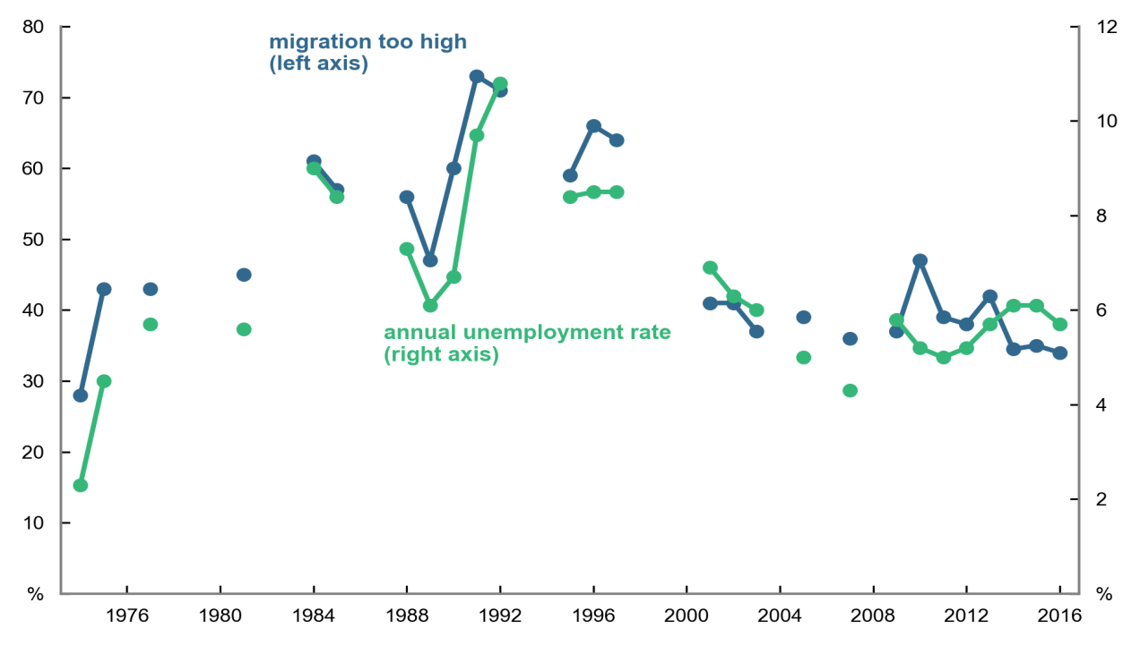

Note: Breaks in this chart represent non‑continuous data sources.

Source: Markus 2016b (drawing on the Scanlon Foundation surveys and earlier social surveys).

##### Local factors

Migrants are largely drawn to settle in large metropolitan areas where there are more job opportunities and where their family members and co‑ethnic communities are already settled. This can be beneficial if jobs are available and communities are supportive, as community and social networks can assist in orientation, adapting to local market conditions and finding employment. However, ethnic co‑location can be less positive if the local areas are of low socio‑economic status and high unemployment. While pockets of such disadvantage coupled with high migrant populations do exist, Australia has to date avoided the isolated migrant communities that exist in many other countries.

Scanlon Foundation surveys of selected Local government areas have consistently found lower levels of social cohesion in regions with both a high immigrant concentration and low socio‑economic status. This is reflected in survey findings on trust, sense of safety, experience of discrimination, political participation and involvement in voluntary work. A relatively high proportion of ‘long-term’ (third‑generation or longer) Australians in these areas indicate dissatisfaction with their neighbourhoods (Markus 2012). However, it has been argued that it is *segregation* that reduces trust, rather than *diversity* in itself, and that diverse but integrated neighbourhoods (whose members have diverse social networks) actually have higher levels of trust (Uslaner 2012). Studies have shown that more diverse communities are, in general, more accepting of difference (Allport 1954; Christ et al. 2014).

Among skilled migrants, highest priority is given to those seeking to migrate to a regional area (PC 2016). This policy is designed to address skill shortages in regional Australia and has helped attract skilled migrants to areas where they are needed (Wright et al. 2016). However, retaining skilled migrants, just like retaining skilled Australian‑born residents, in regional and remote locations remains a challenge. Many migrants move to larger cities once their visa requirements for permanent residency are met (Taylor, Bell & Gerritsen 2014).

Regional settlement locations have proved successful over time, in particular for Humanitarian Program entrants with no direct family or community links in Australia. This is particularly the case where there are employment opportunities, sufficient support services and the local community is welcoming.

##### Settlement services

Effective settlement services and multicultural policies have assisted migrants to gain employment, learn English if needed, improve their skills, and participate in the community. This helps migrants, their families, and the broader Australian society.

Australia’s focus on skilled migration means that primary skill stream migrants are often well‑equipped to settle into Australian life and quickly begin contributing to the economy. Other cohorts, such as family stream migrants, secondary visa holders and humanitarian entrants, are not selected on an economic basis, generally require more assistance, and take longer to become economic contributors.

However, these cohorts contribute to positive settlement outcomes in other ways. For example, families bring a youthful demographic balance to the general population; humanitarian entrants have high rates of entrepreneurship; and second generation migrants have outcomes equal or superior to the children of the Australian‑born population, particularly in terms of educational achievement. 2012 data from the Program for International Student Assessment shows that in Australia, first generation immigrant students perform as well as non-immigrant students in computer-based problem solving, and outperform non-immigrant students in mathematics and reading. Second generation immigrant students go on to outperform non-immigrant students in all three areas (OECD 2015).

International indicators of migrant integration (OECD & European Union 2015; Barcelona Centre for International Affairs & Migration Policy Group 2015) confirm that Australia performs favourably in both migrant settlement policies and outcomes relative to many other OECD countries. The Productivity Commission (2016) has noted that settlement services in Australia are generally commendable and have supported the settlement and integration of new immigrants. The Productivity Commission has also noted that Australia’s current immigration system works well by international standards, despite scope for improvement.

* 1. More research on population pressures would be beneficial

Section 8 only briefly touches on issues such as employment, housing, infrastructure, and social cohesion. There is a wealth of literature and research on each of these topics which helps inform understanding of these issues. This paper is not intended to cover these topics in detail but to provide an illustration of the possible implications of population growth and immigration alongside other material.

The Treasury and the Department of Home Affairs would be interested to see further work on the implications of population growth and immigration. With this in mind, Treasury Research Institute questions have been included at the end of the paper to encourage further exploration of these complex issues.

# Conclusion

The history of Australia is the history of its population. In particular, Australia has been shaped by successive waves of migration.

Following World War II, Australia opened its doors, and in the name of nation building, or ‘populate or perish’, welcomed in the first major wave of migrants, many from the war-torn countries of Europe. Over time, the focus of migration shifted, and instead of targeting a growing population, the goal became to support a growing economy. In the mid‑1990s, the migration program was significantly expanded and the focus on attracting highly skilled migrants was strengthened. Since that time, migration has comprised more than half of Australia’s population growth, similar to some of the previous peaks in migration in the 1940s, 1960s and 1980s.

Migration has, in many ways, shaped Australia’s culture and economy.

Australia’s focus on skilled migration has demonstrated positive effects for economic growth, because our migrants on average lift potential GDP and GDP per capita through all of the three Ps of population, participation and productivity. In particular, migration has played an important role in ameliorating and delaying the adverse effects of our ageing population. Further, migrants generate jobs and economic opportunities for the population more broadly, because they lift aggregate demand through consumption and investment. Temporary migrants also lift our exports, particularly in the education sector.

The movement of people (migration) mirrors trade in goods and services in the benefits it can bring to an economy. In general, migrants bring with them productive skills and preferences for goods and services that are different to those of the local-born population. These differences generate wealth that would otherwise not exist by enabling specialisation. In contrast to international trade, migration realises these benefits onshore rather than being conducted across borders. As such, the gains from migration will be greater than the gains from international trade in goods and services when the migrant has access to more opportunities or resources in Australian than in their home country.

A bigger population brings challenges, in the form of congestion, pressure on the environment, and additional demand in key markets like housing. These pressures exist regardless of migration, but a growing population exacerbates existing pressures, particularly if policy and planning efforts by Commonwealth, State and Local Governments do not keep pace.

Migration has also shaped the nature of our society, with 49 per cent of Australia’s population either a migrant or the child of a migrant. Australians have consistently shown high levels of support for migration, and the benefits it has brought.

Treasury and the Department of Home Affairs would welcome further analysis of the issues considered in this paper. Suggestions of topics that would benefit from further research have been included on the following page.

# Treasury Research Institute — possible questions for further research

This paper has considered the trends and implications of Australia’s population growth over the last century. Looking forward, it will be important to continue to deepen our understanding of the contribution of immigration to population growth, the distribution of the population and of migrants, and the opportunities and challenges that population growth and immigration will present to governments and policy makers.

The following are some areas of particular interest to Treasury and the Department of Home Affairs, but do not represent an exhaustive list of issues that would benefit from further research.

* What are the benefits and challenges associated with population growth?
  + What might the effect of a larger population be on the distribution of wages and incomes?
  + Are there other challenges of a larger population that governments should explore?
* Are the current patterns of spatial distribution of population in Australia sustainable?
  + If not, what levers are available to Government to alter the spatial distribution of the Australian population, and how should these be used?
  + What would be the efficacy and implications of using these levers?
  + How will structural, demographic and technological change alter existing trends?
* What is the role of migrants in filling skill gaps and complementing the Australian‑born labour force, including in emerging industries likely to undergo significant growth such as the care workforce?

# References

Australian Bureau of Statistics (ABS) 1988, *Census of Population and Housing, 1986*, cat. no. 2102.0, Canberra.

ABS 2014a, *Australian Historical Population Statistics, 2014*, cat. no.3105.0.65.001, Canberra.

ABS 2014b, *Microdata: Australian Census and Migrants Integrated Dataset, 2011*, cat. no. 3417.0.55.001, Canberra.

ABS 2016a, *Births, Australia, 2015*,cat. no. 3301.0, Canberra*.*

ABS 2016b, *Life Tables, States, Territories and Australia, 2013‑2015*, cat. no. 3302.0.55.001, Canberra.

ABS 2016c, *Australian System of National Accounts, 2015-16*, cat. no. 5204.0, Canberra.

ABS 2016d, *Counting Persons, Place of Usual Residence: Total Personal Income (Weekly)*, 2011 Census TableBuilder, Canberra.

ABS 2017a, *Australian Demographic Statistics*, cat. no. 3101.0, Canberra.

ABS 2017b, *Migration, Australia, 2015-16 – Technical Note: ‘12/16 Month Rule’ Methodology for Calculating Net Overseas Migration from September Quarter 2006 Onwards*,cat. no. 3412.0, Canberra.

ABS 2017c, *Migration, Australia, 2015-16*, cat. no. 3412.0, Canberra.

ABS 2017d, *Regional Population Growth, Australia, 2016,* cat. no. 3218.0, Canberra.

ABS 2017e, *Estimated Resident Population by SA2 and Above (ASGS 2011)*, 1991-2016, data extract from ABS.Stat, Canberra.

ABS 2017f, *1996 Census Data - customised report*,Canberra.

ABS 2017g, *Counting Persons, Place of Usual Residence by Country of Birth*,2016 Census TableBuilder, Canberra.

ABS 2017h, *Australian National Accounts: National Income, Expenditure and Product*, cat. no. 5206.0, Canberra.

ABS 2017i, *Labour Force, Australia*, cat. no. 6202.0, Canberra.

ABS 2017j, *Labour Force, Australia, Detailed – Electronic Delivery*, cat. no. 6291.0.55.001, Canberra.

ABS 2017k, *Labour Force, Australia, Detailed, Quarterly,* cat. no. 6291.0.55.003, Canberra.

ABS 2017l, *Building Activity, Australia*,cat. no. 8752.0, Canberra.

Allport, GW 1954, *The Nature of Prejudice,* Perseus Books, Cambridge, MA.

Australian Government 2015, *2015 Intergenerational Report – Australia in 2055*, report, Canberra.

Australian National Audit Office 2011, *Management of Student Visas*, ANAO audit report  
no. 46 2010-11, Canberra.

Australian Treasury 2001, ‘Australia’s Century Since Federation at a Glance’*,* Australian Treasury *Economic Roundup*, Centenary Edition, Canberra.

Austroads 2016, *Congestion and Reliability Review: Full Report*, Austroads research report AP‑R534‑16, Sydney.

Barcelona Centre for International Affairs & Migration Policy Group 2015, *Migrant Integration Policy Index 2015*, available at <http://www.mipex.eu/>.

Boeri, T, Brücker, H, Docquier, F & Rapoport, H (eds.) 2012, *Brain Drain and Brain Gain: The Global Competition to Attract High‑Skilled Migrants*, Oxford University Press, Oxford.

Breunig, R, Deutscher, N, and To, HT 2016, ‘The Relationship between Immigration to Australia and the Labour Market Outcomes of Australian-Born Workers’, Technical Supplement A to the Productivity Commission Inquiry Report *Migrant Intake into Australia*, Canberra.

Burchardi, KB, Chaney, T, and Hassan, TA, 2016, *Migrants, Ancestors, and Investments*, National Bureau of Economic Research working paper no. 21847, Cambridge, MA.

Bureau of Infrastructure, Transport and Regional Economics (BITRE) 2014, *The Evolution of Australian Towns,* Report 136, Canberra.

BITRE 2015, *Traffic and Congestion Cost Trends for Australian Capital Cities*, information sheet 74, Canberra.

Butlin, MW 1977, *A Preliminary Annual Database 1900/01 to 1973/74*, Reserve Bank of Australia research discussion paper 7701, Sydney.

Capuano, G 2016, ‘Are Australia’s Migrants Home Owners?’, *Blog .id: The Population Experts*, available at <http://blog.id.com.au/2016/population/demographic-trends/are-australias-migrants-home-owners/>.

Christ, O, Schmid, K, Lolliot, S, Swart, H, Stolle, D, Tausch, N, Al Ramiah, A, Wagner, U, Vertovec,  
S & Hewstone, M 2014, ‘Contextual Effect of Positive Intergroup Contact on Outgroup Prejudice’, *Proceedings of the National Academy of Sciences of the United States of America*, vol. 111, no. 11.

City of Melbourne 2017, *Daily Population Estimates and Forecasts: 2017 Update*, report, Melbourne.

Coleman, S 2017, *Australia State of the Environment 2016: Built Environment*, independent report to the Australian Government Minister for the Environment and Energy, Australian Government Department of the Environment and Energy, Canberra.

Coombs, G & Roberts, C 2007, ‘Trends in Infrastructure’, Australian Treasury *Economic Roundup*, Summer 2007 Edition,Canberra.

CoreLogic 2016, *Housing Affordability Report: December 2016*, Sydney.

Cully, M 2011a, ‘Skilled Migration Selection Policies: Recent Australian Reforms’, *Migration Policy Practice*, vol. 1, no. 1, pp. 4–7.

Cully, M 2011b, ‘How Much do Migrants Account for the Unexpected Rise in the Labour Force Participation Rate in Australia over the Past Decade?’, paper presented at the 2011 *Australian Conference of Economists*, available at: [https://www.border.gov.au/ReportsandPublications/  
Documents/research/migrants-account-unexpected-rise-labour-force-rate-aus-2000-2010.pdf](https://www.border.gov.au/ReportsandPublications/Documents/research/migrants-account-unexpected-rise-labour-force-rate-aus-2000-2010.pdf).

Daley, J 2017, *Productivity and Geography: Presentation to* *Productivity Commission Conference*, Grattan Institute, Melbourne.

Dandy, J & Pe‑Pua, R 2013, *Research into the Current and Emerging Drivers for Social Cohesion, Social Division and Conflict in Multicultural Australia*, report for Joint Commonwealth, State and Territory Research Advisory Committee, Canberra.

Delbosc, A 2015, ‘Public Transport is Always Greener on the Other Side’, *The Conversation*, 10 August, available at <https://theconversation.com/public-transport-is-always-greener-on-the-other-side-44307>.

Deloitte Access Economics & Department of Immigration and Border Protection (DIBP) 2016, unpublished data and modelling.

DIBP 2016a, ‘Migration Programme Statistics’*, DIBP: Research and Statistics*, available at <https://www.border.gov.au/about/reports-publications/research-statistics/statistics/live-in-australia/migration-programme>.

DIBP 2016b, ‘Temporary Entrants in Australia (Stock Data) Statistics’, *DIBP: Research and Statistics*, available at <https://www.border.gov.au/about/reports-publications/research-statistics/statistics/live-in-australia/temporary-entrants-in-australia>.

DIBP 2016c, *The Continuous Survey of Australia’s Migrants,* multiple releases, reports by the Australian Government Department of Immigration and Citizenship/Department of Immigration and Border Protection, Canberra.

Home Affairs 2017, unpublished data.

Docquier, F & Machado, J 2016, ‘Global Competition for Attracting Talents and the World Economy’, *The World Economy*, vol. 39, no. 4, pp. 530-542.

Dolman, B 2008, *Migration, Trade and Investment*, Productivity Commission working paper, Canberra.

Döring, T & Schnellenbach, J [2006](https://link.springer.com/article/10.1186/2193-9039-2-18#CR13), ‘What do We Know about Geographical Knowledge Spillovers and Regional Growth?: A Survey of the Literature’, *Regional Studies*, vol. 40, no. 3, pp. 375-395.

Goodwin, P 2012, ‘Peak Travel, Peak Car and the Future of Mobility: Evidence, Unresolved Issues, Policy Implications and a Research Agenda’, *International Transport Forum Discussion Papers,* no. 2012-13, OECD Publishing, Paris.

Gregory, RG 2014, *The Two‑Step Australian Immigration Policy and its Impact on Immigrant Employment Outcomes*, German Institute for the Study of Labor discussion paper no. 8061, Bonn.

Hawthorne, L 2011, *Competing for Skills: Migration Policies and Trends in New Zealand and Australia*, report prepared for the New Zealand Department of Labour, Wellington.

Helsley, RW & Strange, WC 2002, ‘Innovation and Input Sharing’, *Journal of Urban Economics*, vol. 51, no. 1, pp. 25-45.

Hotchkiss, JL 2009, ‘Changes in the Aggregate Labor Force Participation Rate’, *Federal Reserve Bank of Atlanta* *Economic Review*, vol. 94, no. 4, pp. 1-6.

International Monetary Fund (IMF) 2017, ‘Regional Economic Outlook: Asia and Pacific’, *World Economic and Financial Surveys*, Washington DC.

Infrastructure Australia 2015, *Australian Infrastructure Audit: Our Infrastructure Challenges*, report, Canberra.

Jaumotte, F, Koloskova, K & Saxena S 2016, *Impact of Migration on Income Levels in Advanced Economies*, International Monetary Fund, Washington DC.

Jupp, J (ed.) 2001, *The Australian People: An Encyclopaedia of the Nation, its People and their Origins*, 2nd edn, Cambridge University Press, United Kingdom.

Kelly, JF, Mares, P, Harrison, C, O’Toole, M & Hunter, J 2013, *Productive Cities: Opportunities in a Changing Economy*, Grattan Institute report no. 2013-5, Melbourne.

Keywood, MD, Hibberd, MF & Emmerson, KM 2017, *Australia State of the Environment 2016: Atmosphere*, independent report to the Australian Government Minister for the Environment and Energy, Australian Government Department of the Environment and Energy, Canberra.

Kohler, M & Van der Merwe, M 2015, ‘Long-run Trends in Housing Price Growth’, *Reserve Bank of Australia Bulletin*, September Quarter 2015, Canberra.

Krueger, AB 2016, ‘Where Have All the Workers Gone?’, paper presented at the *Boston Federal Reserve Bank’s 60th Economic Conference*, available at <https://www.bostonfed.org/-/media/Documents/economic/...2016/Alan-B-Krueger.pdf>.

Markus, A 2012, *Mapping Social Cohesion – The Scanlon Foundation Surveys Neighbourhoods Report: Areas of Immigrant Concentration 2012*, Scanlon Foundation report, Monash University, Caulfield.

Markus, A 2016a, *Australians Today: The Australia@2015 Scanlon Foundation Survey*, Scanlon Foundation report, Monash University, Caulfield.

Markus, A 2016b, *Mapping Social Cohesion: The Scanlon Foundation Surveys 2016*, Scanlon Foundation report, Monash University, Caulfield.

Megalogenis, G 2015, *Australia’s Second Chance: What Our History Tells Us About Our Future*, Penguin, United Kingdom.

Niebuhr, A 2010, ‘Migration and Innovation: Does Cultural Diversity Matter for Regional R&D Activity?’, *Papers in Regional Science*,vol. 89, no. 3, pp. 563-585.

Organisation for Economic Cooperation and Development (OECD) 2011, *Perspectives on Global Development 2012: Social Cohesion in a Shifting World*, OECD Publishing, Paris.

OECD 2015, *Helping Immigrant Students to Succeed at School – and Beyond*, OECD Publishing, Paris.

OECD 2017, ‘Infrastructure Investment’, *OECD Data*, available at <https://data.oecd.org/transport/infrastructure-investment.htm>.

OECD & European Union 2015, *Indicators of Immigrant Integration 2015: Settling In*, OECD Publishing, Paris.

Papademetriou, D & Sumption, M 2013, *Attracting and Selecting from the Global Talent Pool: Policy Challenges*, Migration Policy Institute, Washington DC.

Parham, D, To, H, Ratna, N, Regan, S & Grafton, Q 2015, *Migration and Productivity in Australia*, Crawford School of Public Policy, Australian National University, Canberra.

Phillips, J, Klapdor, M, & Simon‑Davies, J 2010, *Migration to Australia Since Federation: A Guide to the Statistics*, Department of Parliamentary Services background note, Canberra.

Productivity Commission (PC) 2010, *Population and Migration: Understanding the Numbers*, research paper, Canberra.

PC 2015, *Migrant Intake into Australia: Draft Report*, draft inquiry report no. 77, [Canberra](https://www.pc.gov.au/inquiries/completed/migrant-intake/draft/migrant-intake-draft.pdf).

PC 2016, *Migrant Intake into Australia*, inquiry report no. 77, [Canberra](http://www.pc.gov.au/inquiries/completed/migrant-intake/report/migrant-intake-report.pdf).

Qian, H, Acs Z, & Stough, R 2013, ‘Regional Systems of Entrepreneurship: The Nexus of Human Capital, Knowledge and New Firm Formation’, *Journal of Economic Geography*, vol. 13, no.4,  
pp. 559-587.

Saxenian, A 2002, *Brain Circulation: How High Skill Immigration Makes Everyone Better Off*, Brookings Institute, Washington DC.

Smith, D, Wykes, J, Jayarajah, S & Fabijanic, T 2011, *Citizenship in Australia*, report by the Australian Government Department of Immigration and Citizenship, [Canberra](https://www.border.gov.au/ReportsandPublications/Documents/research/citizenship-in-australia-2011.pdf).

Stapledon, N 2016, ‘The Inexorable Rise in House Prices in Australia Since 1970: Unique or Not?’, *The Australian Economic Review*, vol. 49, no. 3, pp. 317-327.

Taylor, AJ, Bell, L, & Gerritsen, R 2014, ‘Benefits of Skilled Migration Programs for Regional Australia: Perspectives from Northern Territory’, *Journal of Economic and Social Policy*, vol. 16, no. 1.

Terrill, M, Batrouney, H, Etherington, S & Parsonage, H 2017, *Stuck in Traffic? Road Congestion in Sydney and Melbourne*, Grattan Institute report no. 2017‑10, Melbourne.

Terrill, M, Emslie, O & Coates, B 2016, *Roads to Riches: Better Transport Investment,* Grattan Institute report no. 2016‑5, Melbourne.

United Nations 2017, Department of Economic and Social Affairs, Population Division, World Population Prospects: The 2017 Revision, Volume II: Demographic Profiles.

Uslaner, EM 2012, *Segregation and Mistrust: Diversity, Isolation, and Social Cohesion,* Cambridge University Press, United Kingdom.

Victorian Government 2010, *Submission to the Legislative Council Select Committee on Train Services*, Victorian Government Department of Transport, [Melbourne](https://www.parliament.vic.gov.au/images/stories/documents/council/Select_Committees/Trains/Presentations/Myki_Pres.pdf).

Victorian Government 2017, ‘Strategy and Outlook Budget Paper No. 2’*, Victorian Budget 2017-18: Getting on With the Job*, [Melbourne](http://budgetfiles201617.budget.vic.gov.au/2016-17+State+Budget+-+BP2+Strategy+and+Outlook.pdf).

Wokker, C & Swieringa, J 2016, *Foreign Investment and Residential Property Price Growth*, Australian Treasury working paper, [Canberra](https://static.treasury.gov.au/uploads/sites/1/2017/06/TWP_FI_Residential_Property_Price_Growth.pdf).

World Bank 2017, ‘Population, Total’, *World Bank Open Data*, available at <https://data.worldbank.org/indicator/SP.POP.TOTL>.

Wright, CF, Clibborn, S, Piper, N & Cini, N 2016, *Economic Migration and Australia in the 21st Century*, Lowy Institute, Sydney.

1. This section considers population changes at the Statistical Area 4 (SA4) level. SA4 areas are the largest geographical sub‑state areas defined by the ABS. The analysis of capital cities uses the ABS Greater Capital City Statistical Area definitions.
2. References to the United Kingdom in Section 4.4 and Section 5 include all countries within the United Kingdom along with the Republic of Ireland for purposes of grouping culturally similar countries.
3. There are also around 300,000 people in Australia on visitor visas, most of whom are not counted as temporary residents and therefore do not contribute to NOM.
4. In April 2017, the Australian Government announced that the 457 visa would be abolished and replaced with a new temporary visa that targets critical skill shortages.
5. Income growth is based on median full-time earnings of migrants, compared to the wage price index for December quarter 2014 to December quarter 2015 of 2.2 per cent.
6. According to the 2011 Census (ABS 2016d), of those aged 15 years and over:

   32 per cent of overseas-born and 31 per cent of Australian-born earned $1 - $399 per week;

   22 per cent of overseas‑born and 25 per cent of Australian‑born earned $400 - $799 per week;

   34 per cent of overseas‑born and 37 per cent of Australian‑born earned $800+ per week; and

   the remainder earned nil or a negative income.