INFORMATION NOTE
Accumulation of superannuation across a lifetime
This is the third in a series of information notes to showcase results of Treasury’s new dynamic microsimulation Model of Australian Retirement Incomes and Assets (MARIA).
This note analyses how Australian median superannuation balances are expected to change over time.
We project superannuation balances over the next forty years for Australians of different incomes and ages. The analysis shows that superannuation balances are projected to increase for all Australians, and that younger Australians and higher income Australians will benefit most from the maturing superannuation system.

A maturing superannuation system is projected to lead to increased median superannuation balances for all ages | About MARIA  The Model of Australian Retirement Incomes and Assets (MARIA) is a long-term dynamic microsimulation model of Australia’s retirement income system. It simulates the characteristics of each individual for every year for which the model is run, based on their characteristics in the previous year. This method produces a lifepath for each individual and thereby seeks to capture the diversity of Australian lifetimes and how they are expected to change in the future. The dynamic aspect is crucial for modelling Australia’s retirement income system as the characteristics of future retirees are likely to differ from current retirees as the superannuation system matures.  There are a range of circumstances that can affect the retirement incomes of individuals. These include: their family composition including whether they have a partner; how much time they spend in the workforce and how much they get paid; how much they save for their retirement; if they own a home and the impact of disability or illness. Simulating detailed distributions of retirement income and assets in the long-term requires predicting all of these factors for each of the individuals in MARIA.  MARIA begins with 2013-14 base data which captures the Australian population aged 25 and over at a set point in time. The model is run on a representative sample of this complete data set. MARIA then uses Treasury analysis and projections – the ‘input parameters’ – to model the lifepaths (including employment status, superannuation contributions and balance) of these individuals from working life to retirement and death. Each year, new records are introduced to represent new 25 year olds in the population. While income from work and the accumulation of superannuation of superannuation is modelled in detail, at present, MARIA imputes savings outside superannuation (including home ownership) at the point of retirement based on characteristics including age, education level, work experience and superannuation balance.  MARIA’s long-run assumptions for indexation and economic growth are important to interpreting the analysis in this information note. MARIA assumes long-run inflation growth is 2 ½ per cent, by nominal Gross Domestic Product (GDP) growth is around 5 ¼ per cent and wages growth is around 4 per cent.  Investment returns, fees, insurance and drawdown assumptions are based on historical data. Investment returns before fees are assumed to be 7 ½ per cent in the accumulation phase and 6 ½ per cent in the retirement phase. This reflects a shift to a more conservative investment strategy post retirement. Annual fees are calculated as $74 (indexed to Average Weekly Earnings (AWE)) plus 0.85 per cent of the account balance, and insurance premiums are $214 (indexed to AWE). Drawdowns assumptions are based on observed drawdown rates for individuals from tax administration data.  MARIA projects defined contribution accounts, including voluntary contributions made to these accounts, at an individual level. The model does not model superannuation funds themselves, or any assets held by funds to support defined benefits or for regulatory capital purposes.  Modelling in MARIA is undertaken in nominal dollars. The choice of most useful deflator to present modelling results in today’s dollars depends on the context of use. The analysis in this paper seeks to compare the impact of a maturing superannuation system on different age cohorts, and for this reason nominal estimates have been deflated by AWE to 2019 dollars. This ensures differences in outcomes reflect differences in policy or income distribution rather than productivity growth. In other situations deflating outcomes by GDP or the CPI would be more useful.  All dates for MARIA output years are financial years ending in the year stated e.g. 2020 represents 2019-20.  A maturing superannuation system will lead to increased median superannuation balances for all age groups  The Government first introduced Australia’s mandatory superannuation system in 1992, to help Australians support their retirement with superannuation contributions over their working life. The Superannuation Guarantee rate (mandatory superannuation contributions rate) has increased from the initial 3 per cent of employees’ wage to 9.5 per cent today. It is legislated to gradually increase to 12 per cent between 2021 and 2025.  The superannuation system is ‘maturing’ over time as Australians spend more of their working life with mandatory superannuation (and with higher Superannuation Guarantee rates).  MARIA can be used to assess how superannuation balances of the Australian population will grow as the system matures over their lifetimes. Chart 1 shows the projected median superannuation balances of different age groups over the next forty years.  Chart 1: Median superannuation balances from 2020 to 2060, by age group (2019 dollars, AWE deflated)  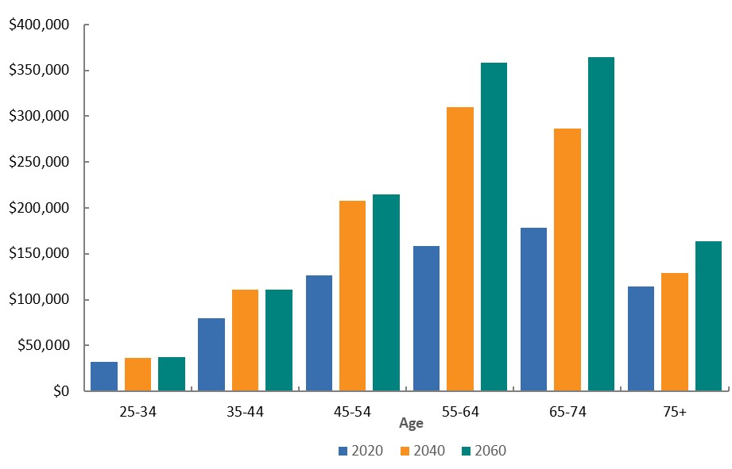  Superannuation balances are typically accumulated throughout working life, peaking near retirement and then drawn down as income in later life. This trend is clear in Chart 1 above.  Chart 1 also shows that all age groups are projected to have higher balances in the future, but that the balances of older age groups will increase more than younger age groups. While the balances for 55-64 and 65-74 age groups will more than double from 2020 to 2060, 25-34 year olds’ balances will be only 15 per cent higher after the same period.  Those aged under 35 today have already spent most of their working life in a superannuation system with a superannuation guarantee rate of at least 9 per cent. However, those aged 55 and over today have spent at least some part of their career without a mandatory superannuation system. The median balance of people in older age groups will rise significantly as those 55 and over in 2060 will have contributed to superannuation all of their working life.  Furthermore, over their lifetimes, people in younger age groups will experience the benefits of compound returns on their early career earnings, helping them to accumulate higher balances than the older population today.
Future generations are projected to have higher balances than current generations | A closer look at outcomes for different age cohorts  We can also use MARIA to examine how retirement income outcomes will change for individuals born in different age cohorts.  Chart 2 compares superannuation balances of individuals who are born in different decades to show how balances are projected to change over time. Median superannuation balances are projected to increase across all age cohorts up to age 65 before decreasing. By comparing balances at a certain age, we can see that those born in more recently (displayed in the lighter shades) will have higher balances than those born less recently (displayed in darker shades). For example, the median balance of the age cohort born in 1970 peaks at around $326,000 at age 65 while the median balance of the age cohort born in 1990 peaks at around $446,000.  Chart 2: Superannuation balances over lifetime by birth year (2019 dollars, AWE deflated)  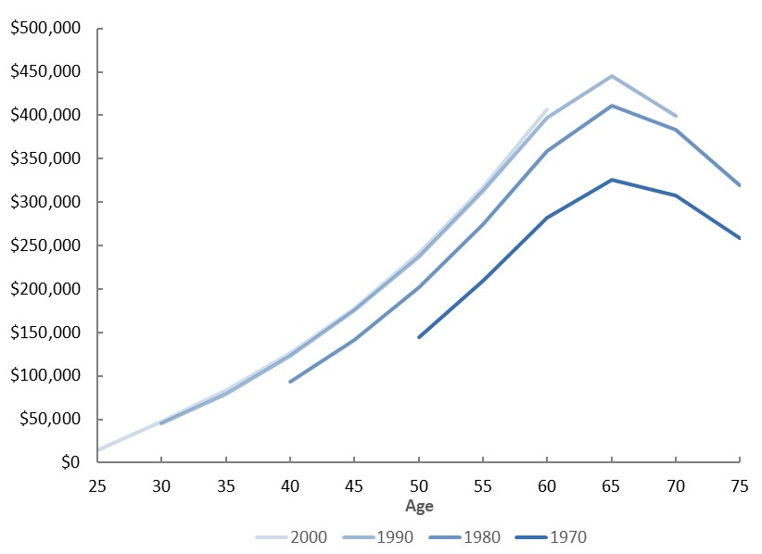  Again, over time, balances at older ages are expected to increase more than balances at younger ages. 65 year olds born in 1990 are projected to have balances around $120,000 higher than 65 year olds born in 1970, while 50 year olds born in 1990 are projected to have balances around $93,500 higher than 50 year olds born in 1970. These results highlight the maturing superannuation system’s boost to balances over the next forty years.
 | The balances of higher income Australians will grow more than lower income Australians
The superannuation balances of high income Australians are generally projected to increase more than those of low income Australians | Finally, we can use MARIA to project how balances will change for low and high income individuals born in different decades.  Chart 3 shows low and high income individuals in different birth cohorts for selected ages from 30 to 75, using percentile of superannuation balance to proxy for lifetime earnings. The 10th percentile (green) is used as a proxy for low income earners, while the 90th percentile (orange) is used as a proxy for high income earners.  Chart 3: Superannuation balances over lifetime for low and high income individuals (2019 dollars, AWE deflated)  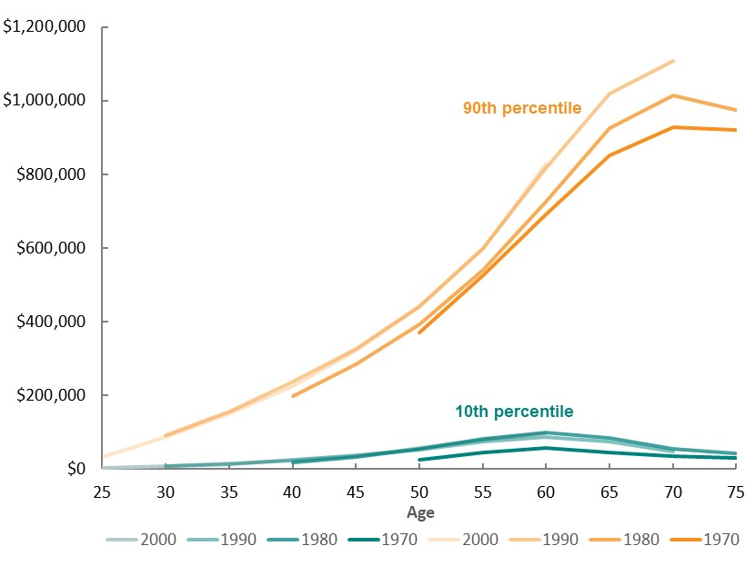  The gap in contributions between low and high earning cohorts accumulates over a lifetime, resulting in an increasing gap in balances as the cohorts age.  On average across birth cohorts, the balance of a high earning 40 year old is nine times higher than that of a low earning 40 year old, while a high earning 70 year old has a balance 21 times higher than a low earning 70 year old. The median balances of low earning cohorts decline at an earlier age (age 60) than those in high earning cohorts (age 70). This indicates that low earnings cohorts are more likely to have to draw down higher proportions of their balances to support their consumption needs in retirement.  In dollar terms, the gap between low and high earning individuals is projected to grow in the future at ages 40 and over. The gap is rising from around $180,000 for today’s 40 year olds (born in 1980) to around $200,000 for 40 year olds in thirty years’ time (born in 2010). The gap for 70 year olds is projected to rise from around $847,000 for today’s 70 year olds (born in 1950) to around $959,000 for 70 year olds in thirty years’ time (born in 1980).  The growth in the gap between low and high earning Australians may be driven by more recent birth cohorts benefitting from higher levels of compulsory superannuation early in careers, and the subsequent compound earnings on these contributions. Additionally, any fixed account management fees and insurance premiums have a proportionally greater impact on low balance superannuation accounts than higher balance superannuation accounts.  However, the gap is expected to stabilise as they system matures. The 2000 and 2010 birth cohorts are expected to have near identical distribution of balances across their life paths, as both will enter the workforce with the superannuation guarantee system mature.  Summary  - MARIA provides useful insights on how the distribution of superannuation balances will change over the next forty years.  - People aged under 35 today have benefited from a largely mature superannuation system for their entire working career. Over their life, people aged under 35 today will accumulate much higher balances than those aged 55 and over today. However, increases to balances are projected to be larger for those born between 1970 and 1990 than for those born after 1990.  - Over the next forty years, the gap between the superannuation balances of low and high earning individuals is projected to grow at all ages 40 and over. This may be because, over a lifetime, the superannuation system boosts the balances of high income young people more than the balances of low income young people.

The views expressed in this note are those of The Treasury and do not necessarily reflect those of the Australian Government. This note was prepared by Elliot Lavers, Mark Bott, Katarina Trinh and Jacob Stone in Revenue Group.
MARIA simulates a range of life events each year for each individual in the model to project people’s income and assets in retirement.
For more detail on the modelling methodology used in MARIA, see http://research.treasury.gov.au/treasury-working-paper/2017-02/.
The impact of a maturing system on superannuation balances at retirement is covered in more detail in in the Information Note: ‘Superannuation balances at retirement’ http://research.treasury.gov.au/treasurys-two-cents/superannuation-balances-retirement.

