INFORMATION NOTE
The superannuation system in aggregate
This is the fourth in a series of information notes to showcase the results of Treasury’s new dynamic microsimulation Model of Australian Retirement Incomes and Assets (MARIA).
This note shows MARIA projections of total superannuation balances over time, which is a measure of the size of the superannuation system.
The total value of superannuation balances is projected to continue to grow relative to the size of the economy. This is primarily driven by fund earnings continuing to grow relative to the size of the economy. While superannuation contributions currently exceed drawdowns, this gap is projected to close in the future as more people who have benefited from a full career with compulsory superannuation move into retirement.
Despite an ageing population, a maturing superannuation system means Age Pension expenditure remains stable over the long-term.
 |  | About MARIA
The Model of Australian Retirement Incomes and Assets (MARIA) is a long-term dynamic microsimulation model of Australia’s retirement income system. It simulates the characteristics of each individual for every year for which the model is run, based on their characteristics in the previous year. This method produces a lifepath for each individual and thereby seeks to capture the diversity of Australian lifetimes and how they are expected to change in the future. The dynamic aspect is crucial for modelling Australia’s retirement income system as the characteristics of future retirees are likely to differ from current retirees as the superannuation system matures.
There are a range of circumstances that can affect the retirement incomes of individuals. These include: their family composition including whether they have a partner; how much time they spend in the workforce and how much they get paid; how much they save for their retirement; if they own a home and the impact of disability or illness. Simulating detailed distributions of retirement income and assets in the long-term requires predicting all of these factors for each of the individuals in MARIA.
MARIA begins with 2013-14 base data which captures the Australian population aged 25 and over at a set point in time. The model is run on a representative sample of this complete data set. MARIA then uses Treasury analysis and projections – the ‘input parameters’ – to model the lifepaths (including employment status, superannuation contributions and balance) of each individual for one year. The output from the model becomes the input for the following year, and so on, year by year, as individuals’ age from working life to retirement and death. Each year, new records are introduced to represent new 25 year olds in the population. While income from work and the accumulation of superannuation is modelled in detail, at present, MARIA imputes savings outside superannuation (including home ownership) at the point of retirement based on characteristics including age, education level, work experience and superannuation balance.
The results from this information note are sensitive to assumptions of future economic growth, investment returns and drawdown behaviour.
Economic growth over the 10 years to 2029-30 has been calibrated to the assumptions used for medium term projections at the 2019-20 Budget. MARIA’s long-run assumptions are for inflation growth of 2 ½ per cent, nominal Gross Domestic Product (GDP) growth of around 5 ¼ per cent and wages growth of around 4 per cent.
Investment returns, fees, insurance and drawdown assumptions are based on historical data. Investment returns before fees are assumed to be 7 ½ per cent in the accumulation phase and 6 ½ per cent in the retirement phase. This reflects a shift to a more conservative investment strategy post retirement. Annual fees are calculated as $74 (indexed to Average Weekly Earnings (AWE)) plus 0.85 per cent of the account balance, and insurance premiums are $214 (indexed to AWE). Drawdowns are based on observed drawdown behaviour in historical data.
MARIA projects defined contribution accounts, including voluntary contributions made to these accounts, at an individual level. The model does not model superannuation funds themselves, or any assets held by funds to support defined benefits or for regulatory capital purposes.
Modelling in MARIA is undertaken in nominal dollars. The choice of the most useful deflator to present modelling results in today’s dollars depends on the context of use. The analysis in this paper seeks to track the evolution of the superannuation system in the future relative to the size of the economy. For this reason, all figures in this information note are presented relative to the size of the economy in that year, as measured by GDP. For other types of analysis, deflating outcomes by AWE or the CPI would be more useful.
All dates for MARIA output are financial years ending in the year stated, e.g. 2020 represents 2019-20.
 |  | The value of superannuation balances is growing faster than the economy
Superannuation balances are expected to be valued almost 2.5 times annual GDP by 2060 |  | MARIA aggregates individual account holdings for those over 25 years of age based on Australian Taxation data from superannuation funds to project total superannuation balances for defined contribution funds.  MARIA projects that total superannuation balances will grow from around 125 per cent of Gross Domestic Product (GDP) in 2020 to nearly 245 per cent of GDP in 2060 (Chart 1). These projections indicate that the value of superannuation balances will continue to grow relative to the size of the economy across the entire MARIA projection period, but the rate of growth will slow over time.  Chart 1: Total value of superannuation assets  Net growth in value occurs in both accumulation and retirement phases. Total accumulation phase superannuation balances are projected to grow from around 100 per cent of GDP in 2020 to nearly 180 per cent of GDP in 2060. The retirement phase grows from below 30 per cent of GDP in 2020 to around 65 per cent of GDP in 2060.
 |  | Drivers of growth in total superannuation balances
Earnings are the key driver of growth in total superannuation balances |  | The change in superannuation balances can be decomposed into:  - Contributions made to accounts, after any contribution taxes have been paid; plus,  - Earnings from the invested assets, after any fees or taxes paid by the funds; less,  - Drawdowns from accounts, through either lump sums or income streams.  - Death benefits paid to beneficiaries are not included in the following analysis.  The projected value of these three components is shown as a proportion of GDP in Chart 2.  Chart 2: Flows into and out of superannuation accounts  Contributions are expected to grow modestly relative to GDP over the 2020s as the superannuation guarantee rate is increased from 9.5 per cent to 12 per cent, but remain broadly stable as a share of the economy thereafter.  Earnings are already the largest of the three flows, and are projected to continue to grow as a share of GDP in the future. Historically, on average, superannuation funds have delivered earnings returns greater than growth in nominal GDP. MARIA assumes that this will continue into the future, meaning that as long as contributions exceed drawdowns, the projected value of superannuation balances will continue to grow relative to the size of the economy.  Drawdowns are expected to grow from around 2 per cent of GDP in 2020 to over 6 per cent of GDP by 2060. The remainder of the information note explores the factors behind this, and the implications for Age Pension expenditure.

 | Population ageing, superannuation and the Age Pension
Despite an ageing population, a maturing superannuation system means Age Pension expenditure remains stable | Chart 3 shows that the proportion of the adult population aged 65 and over is expected to increase in the future. This explains only part of the increase in drawdowns.  Chart 3: Population ageing and Age Pension recipients  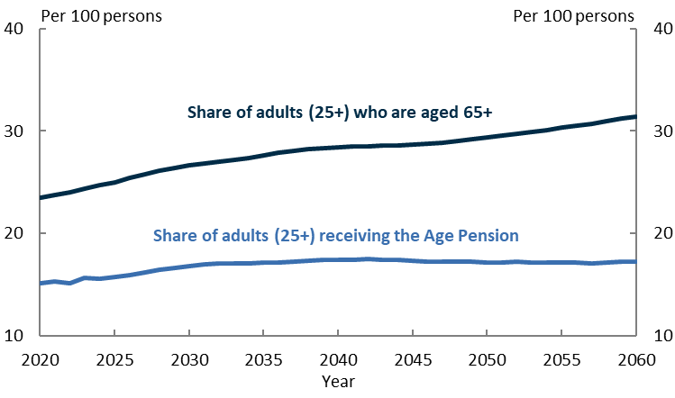  The maturing of the superannuation system also contributes to the increase in drawdowns. Many of the current generation of retirees spent a minority, or even none, of their working career with today’s superannuation system in place, and will not benefit from compound earnings to the same degree as future retirees. This means the current generation of retirees will have lower levels of superannuation savings than future retirees.  This, combined with the indexation of the Age Pension income and assets means test thresholds to inflation rather than earnings, means most future retirees are likely to derive a smaller proportion of their retirement income from the Age Pension than retirees at present.  Chart 4 shows that public Age Pension expenditure is expected to remain stable relative to the size of the economy, with future retirees more reliant on average on superannuation drawdowns to finance their retirement spending.  Chart 4: Superannuation drawdowns and Age Pension Expenditure  Summary  - MARIA provides useful insights on the evolution of the superannuation system in the coming decades.  - The total value of superannuation balances is projected to continue to grow over the long-term.  - Superannuation contributions are expected to remain broadly steady relative to the size of the economy, while drawdowns will increase. In the long run, continued growth in the value of superannuation balances is largely predicated on investment returns continuing to exceed nominal GDP growth.  - MARIA projects that Age Pension expenditure relative to the size of the economy remains steady, with falling eligibility for the Age Pension offsetting an ageing population.

The views expressed in this note are those of The Treasury and do not necessarily reflect those of the Australian Government. This note was prepared by Jacob Stone, Mark Bott, Katarina Trinh, Elliot Lavers and Jarek Kowcza in Revenue Group.
MARIA simulates a range of life events each year for each individual in the model to project people’s income and assets in retirement.
For more detail on the modelling methodology used in MARIA, see http://research.treasury.gov.au/treasury-working-paper/2017-02/.
MARIA does not capture defined benefits, regulatory capital and life office statutory funds. For this reason, the estimates are not comparable to estimates of total superannuation funds under management produced by the Australian Prudential Regulation Authority (APRA).
Growth in lifetime superannuation balances and at retirement is explored in the Information Notes: ‘Superannuation balances at retirement’ http://research.treasury.gov.au/treasurys-two-cents/superannuation-balances-retirement and ‘Accumulation of superannuation across a lifetime’ http://research.treasury.gov.au/treasurys-two-cents/accumulation-superannuation-across-lifetime.

