Development of Treasury’s New Model of Australian Retirement Incomes and Assets: MARIA

Bruce Bastian, Matthew Smith, Belinda Cheong, Virginia Pineda, Martin Stevenson, Owen Hutchison, Madeleine Nargar, Susie Kluth[[1]](#footnote-1)

Treasury Working Paper[[2]](#footnote-2)

2017‑02

Date created: February 2017

Date modified: February 2017

© Commonwealth of Australia 2017

ISBN 978-1-925504-34-7

This publication is available for your use under a [Creative Commons BY Attribution 3.0 Australia](http://creativecommons.org/licenses/by/3.0/au/deed.en) licence, with the exception of the Commonwealth Coat of Arms, the Treasury logo, photographs, images, signatures and where otherwise stated. The full licence terms are available from <http://creativecommons.org/licenses/by/3.0/au/legalcode>.

CC by_grey

Use of Treasury material under a [Creative Commons BY Attribution 3.0 Australia](http://creativecommons.org/licenses/by/3.0/au/deed.en) licence requires you to attribute the work (but not in any way that suggests that the Treasury endorses you or your use of the work).

**Treasury material used 'as supplied'**

Provided you have not modified or transformed Treasury material in any way including, for example, by changing the Treasury text; calculating percentage changes; graphing or charting data; or deriving new statistics from published Treasury statistics — then Treasury prefers the following attribution:

*Source: The Australian Government the Treasury*

**Derivative material**

If you have modified or transformed Treasury material, or derived new material from those of the Treasury in any way, then Treasury prefers the following attribution:

*Based on The Australian Government the Treasury data*

**Use of the Coat of Arms**

The terms under which the Coat of Arms can be used are set out on the It’s an Honour website (see [www.itsanhonour.gov.au](http://www.itsanhonour.gov.au)).

**Other uses**

Enquiries regarding this licence and any other use of this document are welcome at:

Manager

Media Unit

The Treasury

Langton Crescent  
Parkes ACT 2600

Email: [medialiaison@treasury.gov.au](mailto:medialiaison@treasury.gov.au)

Development of Treasury’s new Model of Retirement Incomes and Assets (MARIA)

Bruce Bastian, Matthew Smith, Belinda Cheong, Virginia Pineda, Martin Stevenson, Owen Hutchison, Madeleine Nargar, Susie Kluth

2017‑02

17 March 2017

# Abstract

Treasury currently has a project underway to significantly enhance its capability to produce detailed modelling of retirement incomes in Australia. The Model of Australian Retirement Incomes and Assets (MARIA) is a long-term dynamic microsimulation model of Australia’s retirement income system. When fully operational, MARIA will provide whole-of-population projections beyond the medium term of: Age Pension expenditure and take-up; superannuation funds under management; and retirement income adequacy. It will also enable detailed distributional analysis of both current and hypothetical policy settings. This paper provides high-level details of the model and outlines a number of challenges and research questions for further consideration by Treasury and interested researchers.

Keywords: Retirement incomes, superannuation, pensions, modelling, microsimulation, Tax Analysis Division, Revenue Group

Matthew Smith

Tax Analysis Division

Revenue Group

The Treasury

Langton Crescent

Parkes ACT 2600

Dr Susie Kluth

Tax Analysis Division

Revenue Group

The Treasury

Langton Crescent

Parkes ACT 2600

Introduction

A clear understanding of how retirement income policies affect both the Commonwealth budget and retirement incomes of individual Australians is essential for effective policy development. However, because retirement income policies take decades to mature, it is necessary to model 40 or more years into the future to fully understand their effects, and this is an intrinsically challenging task.

Treasury has been producing detailed modelling of retirement incomes since the substantial reform of the superannuation system in the 1990s[[3]](#footnote-3) and currently has a project underway to significantly enhance this capability. The new Model of Australian Retirement Incomes and Assets (MARIA) will provide detailed information regarding sustainability issues, such as long-term estimates of superannuation tax concessions, Age Pension expenditure and the savings held outside superannuation; and adequacy issues, such as distributional analysis of superannuation assets and retirement incomes. MARIA will be capable of projecting the current retirement income policy settings and generating forecasts for key variables, as well as the impacts of changes to these policies or economic conditions.

Treasury’s previous retirement income model RIMGROUP was initially built in the early 1990s and served the department well, including through four Intergenerational Reports.[[4]](#footnote-4) RIMGROUP was so named because it grouped the population into cohorts based on year of birth, gender and life-time income decile. Each group was further sub-divided into six accumulation account types with different numbers in each, but the accumulation account types were pooled at retirement. It was built at a time when computing power was limited and detailed administrative data and longitudinal data were not available to the Treasury. Instead RIMGROUP relied on ABS Survey of Income and Housing and Australian Prudential Regulation Authority information supplemented by Treasury analysis. The modelling had some limitations due to ‘pooling’ of work histories, account balances, voluntary saving levels and so on within each account type within each group. For example, if a group contained both voluntary savers and super guarantee-only cases their voluntary saving and outcomes were averaged at retirement, giving the whole group moderate levels of assets. Similarly migrants were pooled with others in the model and were assumed to have similar assets to the income group they joined.[[5]](#footnote-5)

In addition, the make-up of the retirement income system has changed fundamentally since the model was built, for example self-managed superannuation funds have become an increasingly large component of the sector and non-concessional savings have significantly increased for a group of high‑saving individuals.[[6]](#footnote-6) There have also been substantial changes in the diversity of income stream products like defined benefit pensions, annuities and term products. These changes were not straightforward to incorporate into the existing model structure. As the superannuation system has matured, a new broad range of administrative and longitudinal data on drivers of retirement have become available. This, combined with substantial advances in computing power and modelling software, allow for modelling of life paths at an individual level. In light of these developments, Treasury has decided to invest in the development of a new microsimulation model. Such a model can better capture the diversity of the population, and allows for greater versatility of output and analysis than cohort models like RIMGROUP.

Dynamic microsimulation models

Dynamic microsimulation models are a key tool used by Governments and academics to analyse issues relating to distributional and intergenerational equity. They are used for analysing retirement incomes in a broad range of countries[[7]](#footnote-7) including the UK[[8]](#footnote-8),[[9]](#footnote-9) and the US.[[10]](#footnote-10)

A microsimulation model involves a record by record simulation of policy on a large, representative sample of an overall population. This can be contrasted with macroeconomic models, or even cohort models, which tend to group individuals into representative clusters. The advantage of microsimulation models is their ability to model outcomes for individuals in a broad variety of different circumstances while allowing the user to aggregate individual records to determine outcomes for sub-groups of the population or the population as a whole.

There are two classes of microsimulation models: static and dynamic. The key difference is how they adjust the representative sample to account for changes in the population over time. A static model is based on a snapshot of the population taken at a given point in time with the characteristics of these people remaining constant over the simulated period, although the weight given to individuals within the sample may be adjusted to account for broad demographic trends. Dynamic models, on the other hand, simulate the characteristics of each individual every year based on their characteristics in the previous year. This method, which is used in MARIA, produces a lifepath for each individual and thereby seeks to capture the heterogeneity of Australian lifetimes and how they are expected to change in the future.

The dynamic aspect is crucial for modelling Australia’s retirement income system as the characteristics of future retirees are likely to differ from current retirees as the superannuation system matures.

There are a whole range of circumstances that can affect the retirement incomes of individuals. These include: their family composition; how much time they spend in the workforce and how much they get paid; how much they save for their retirement; any inherited wealth; the impact of disability or illness and whether they have a partner whose wealth they can draw upon. Simulating detailed distributions of retirement income and assets in the long-term requires predicting all of these factors for each of the individuals in MARIA. This is important when modelling retirement income policy, as its effects can take many years to be realised. In this way MARIA can capture drivers that are cumulative in nature – particularly in terms of contributions and the effect of the Superannuation Guarantee.

Dynamic microsimulation models are notoriously resource intensive to build and maintain.[[11]](#footnote-11) With this in mind Treasury has adopted a phased approach to the development of MARIA by building a basic functioning model in the initial phase to use as a base for future enhancements. The model will be refined and improved through further analysis, use and insight, and with newly available data and modelling techniques.

MARIA model details

Overview

MARIA begins with base data which captures the Australian population aged 25 and over at a set point in time. The model is run on a representative sample of this complete data set. MARIA then uses Treasury analysis and projections – the ‘input parameters’ – to model the lifepaths (including employment status, superannuation contributions and balance) of these individual records for one year. The output from the model becomes the input for the following year, and so on, year by year, as individuals age from working life to retirement and death. Each year new records are introduced to represent new 25 year olds in the population. Typically the model comprises 40 annual loops keeping track of each individual throughout his or her lifetime. The model structure is summarised in Figure 1.

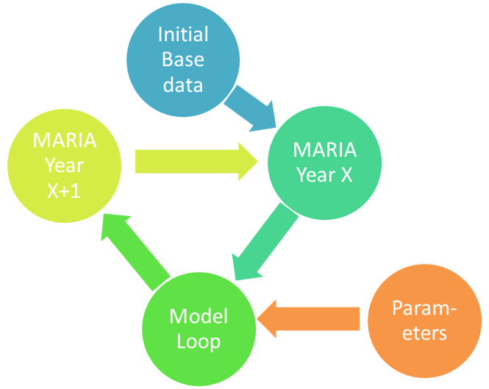

Figure 1: MARIA model structure

The base data

The base data is constructed using the 2013-14 confidentialised full administrative datasets from personal income tax returns, superannuation member contribution statements, and the Department of Social Services and Department of Veterans Affairs pensions systems. Adjustments are made to the administrative datasets to remove overlaps and exclude non-residents. To ensure that the base data aligns with demographic benchmarks, the administrative datasets are augmented with records from the Australian Bureau of Statistics Survey of Income and Housing[[12]](#footnote-12) to represent any individuals not captured in the administrative datasets.

MARIA requires demographic characteristics for each individual such as age, education level, amount of work experience, whether the individual is in a couple and whether the individual has children. However, administrative data generally lacks some of this information. For instance, there may be little or no information on whether an individual works full- or part-time, or the number and age of their children. To fill out this picture, the base data estimates these characteristics using information from the Survey of Income and Housing and from the Household, Income and Labour Dynamics in Australia Survey (HILDA[[13]](#footnote-13)).

Figure 2 shows groups of people typically captured by each of the base data sources. The result is a unique, representative snapshot of the Australian population aged over 25 at a given point in time.

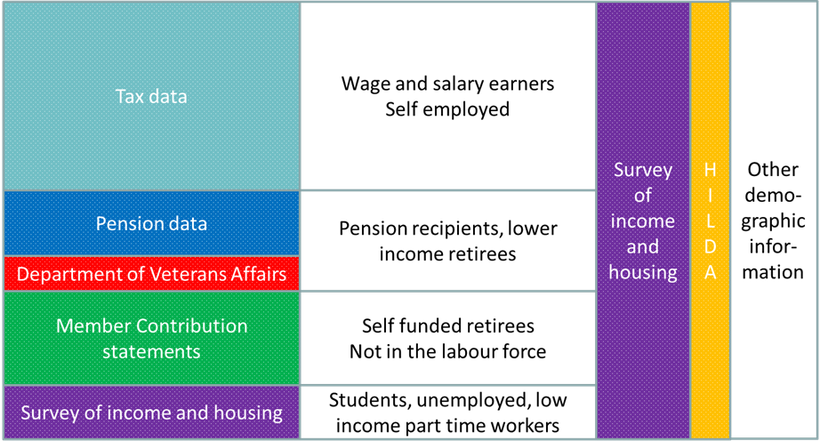

Figure 2: The MARIA base data

Outcomes modelled

A number of steps are performed sequentially to generate a picture of each individual for each year.[[14]](#footnote-14) The output then becomes the input for the following year. In each model loop the steps are performed by stand-alone ‘modules’ in the model which operate in sequence. These modules for a single loop are summarised in Figure 3.

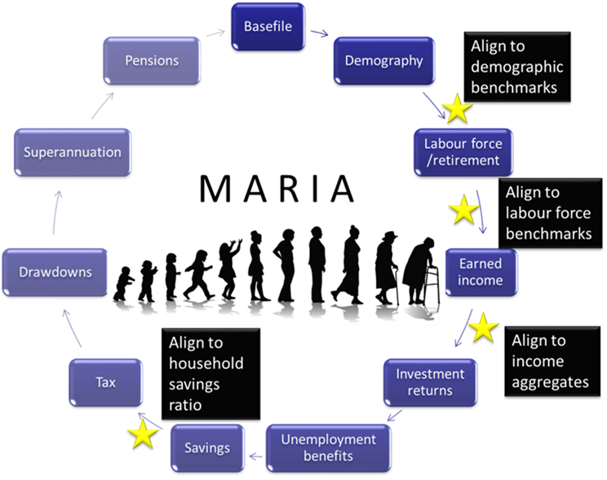

Figure 3: The model loop

First, the model performs a number of demographic changes while ageing individuals by one year and adding in a new cohrot of 25 year olds. This includes simulating births, immigration and emigration, deaths and changes to relationship status for those in the model.

The labour force module then determines the labour force status of each individual including whether they decide to retire. These decisions are based on parameters such as labour force status in the previous year, age and length of work experience. In MARIA, an individual’s labour force status can be either be full time, part time, unemployed or not in the labour force.

For those individuals who are either full time or part time, a level of earned income is then estimated. Earned income can either be salary and wages or business income. An individual’s earned income is estimated based on a combination of their income from previous periods, current labour force status and demographic characteristics.

Investment income from assets is estimated in the investment returns module. Based on the individual’s income from salary and wages, business and investment and their labour force status, the transfers module estimates whether the individual is entitled to an unemployment allowance.

The savings module determines superannuation contributions and other savings. Superannuation contributions have to meet minimum legislative requirements determined by the superannuation guarantee with additional superannuation contributions based on estimates from past returns data and the applicable legislation. Other savings are based on Treasury analysis of survey data.

Based on the income variables estimated, a simplified personal income tax calculation is performed in the tax module. Personal income tax, including the Medicare Levy, the Low Income Tax Offset, the Seniors and Pensioners Tax Offset and the Beneficiary Tax Offset, is calculated to give an overall net income tax amount.

In the drawdown module, the amount of superannuation for retired individuals with superannuation is estimated. MARIA currently allows four options for drawdowns: the legislated minimum drawdown requirements; a deterministic rate above the minimum drawdown requirements (either a fixed percentage point or fixed multiple above the minimum); stochastic drawdown rates based on observed behaviour from longitudinal analysis of superannuation and pension data; or stylised self-annuitisation, where individuals in effect pick a pattern of drawdowns to smooth their lifetime consumption.

The superannuation module contains a number of elements. It calculates the earnings an individual’s superannuation balance has accrued over the year based on historical rates of return, estimates the fees associated with an individual’s superannuation account and also calculates the amount of taxes related to an individual’s superannuation account balance. This, together with the amount of superannuation drawn down by an individual, allows the calculation of the superannuation account’s closing balance for the year. Additionally the superannuation module determines if an individual holds an Australian Prudential Regulation Authority regulated accumulation or pension account or is a member of a self-managed superannuation fund.

Finally, the pensions module determines an individual’s entitlement to the Age Pension, Disability Support Pension or Carer Payment based on his or her couple status and level of income and assets. The model then iterates for the next year following the same process.

Estimating transitions

As noted above, MARIA simulates a range of life events each year for each individual in the model to project people’s income and assets in retirement. For example the model simulates whether someone is working, how much income they earn, how much they save, whether they have children, whether they have a partner and when they retire. These life events simulated in the model can be categorised as either discrete choice events (such as whether someone is working or not) or continuous events (such as a nominal amount of salary and wage income someone earns).

Discrete choice events are simulated by calculating the probability that someone will have a particular life event in a given year. To highlight one example, the model calculates the probability that someone will be either: working full time, working part time, will not be in the labour force or unemployed that year. A person is then randomly allocated a labour force status based on these probabilities. The probability that someone will be working is based on factors including their work history, whether they have children, whether they have a partner and their education level. These probabilities are estimated using the HILDA dataset.

Continuous events are simulated using a relevant distribution from an ‘auxiliary’ dataset. For example, the distribution of salary and wage income and the information about the distribution of past salary and wages on the HILDA dataset is used to simulate a level of salary and wage income for an individual in MARIA. A person’s simulated salary and wage income depends upon their past salary and wage income, their education level, their partner status and whether they have any children.

Model benchmarking

A particular limitation of dynamic microsimulation for use in economic forecasting or costing is that projecting data at an individual by individual level alone can result in aggregate totals that differ from other Treasury headline projections. To ensure the model is fit for purpose, Treasury forces the projections to align with certain known aggregate variables each year. In this sense, MARIA outcomes for individuals may depend on more than just their own personal histories and individual projections. However, having a model which maintains an accurate and consistent picture of Australia makes the model’s output more reliable and consistent with other Treasury products, while still generating the richness of individual lifetime outcomes from a population simulation.

MARIA ‘calibrates’ itself each year to key variables at four points in the model, as shown in the diagram in Figure 3. The first is to ensure that mortality and population growth is in line with aggregate population estimates. The second, to match specifically to labour force split aggregates (full-time,  
part-time, unemployed and not in the labour force). The third ensures that incomes grow at trend. The fourth aligns national savings to the expected macroeconomic savings ratio. While it would possible to benchmark MARIA to many more variables, more extensive benchmarking may distort the distribution of the underlying population and obscure trends in the model’s output.

Again using the labour force projection as an example, record by record simulation may not aggregate precisely to overall projections for the expected number of unemployed in 2030, say. MARIA will adjust the labour force status of selected individual records in 2030 by changing selected records from unemployed to not in the labour force to match unemployment rate projections.

Validation and output

Testing and validation of a prototype of the model is currently underway. Testing has focused on both assessment of the model’s outputs against other available projections[[15]](#footnote-15) and against historical series of outcomes from HILDA and elsewhere.

Testing a dynamic microsimulation model involves checking both whether the individual lifepaths created give an accurate reflection of individual lives, and also whether the aggregated totals of these individuals at a point in time align with expectations. If individuals in the model show too much, or too little, variation in their level of wages or superannuation contributions from year to year, then the model would not be giving a proper reflection of individual diversity. Similarly, even if person by person paths look sensible, if the total value for funds under management does not accurately reflect the industry, then this suggests the model requires further refinement.

Once operational, MARIA will be able to analyse key questions around the size and coverage of the superannuation system into its maturity, including the related question of the role played by the aged pension. By considering microeconomic data, MARIA will also be able to offer a unique distributional perspective on adequacy and equity of retirement incomes. This could include further work on projecting and disaggregating the underlying causes of the gender retirement income gap[[16]](#footnote-16) or on the lifetime concessions offered through superannuation. Finally, the model will be able to offer a  
long-term perspective on the effect of proposed policy changes, and also suggest potential solutions to challenging policy questions.

Further research questions

Treasury would welcome any insights on the more challenging issues encountered in MARIA. Some of these issues are outlined below. Interested parties should contact Dr Susie Kluth, manager of the Model Development and Practice unit in Treasury’s Tax Analysis Division.

Treasury would like to better model the dynamics between different savings vehicles and individual choices. This would include understanding trade-offs made by individuals between compulsory superannuation, voluntary superannuation contributions, housing and other non-superannuation savings and how savings decisions respond to changes in taxation. In particular, Treasury would like a better understanding of the role of owner-occupied housing as a savings vehicle and the impact of aged care costs on lifetime savings and consumption-smoothing decisions.

Treasury modelling uses a fixed rate of return assumption for superannuation fund earnings. Making this assumption allows the analysis to focus on the effects of other policy levers and demographic factors. However, building in greater intertemporal (that is, changing from year to year) and  
cross-sectional (between different account holders in the same year) heterogeneity of fund returns and available products would provide for important sensitivity analysis at both a systemic level and also in terms of individual adequacy. In particular, Treasury is interested in examining the effects of persistently below-average returns for certain groups and the way this can change retirement outcomes.

Preliminary analysis on the drivers of the retirement decision on administrative data and in HILDA has proved inconclusive. This is presumably because the wealth (in terms of superannuation and availability of the aged pension) and demographic factors on the dataset (such as age, gender, access to tax-free superannuation) do not capture key drivers of retirement.[[17]](#footnote-17) Both the short- and long-term effects on participation rates from announced changes to the aged pension age and preservation age remain uncertain. Better modelling and understanding of retirement decisions will allow for better modelling of the retired population, and improve the ability of the model to capture behavioural responses to changing incentives.

Bequest motivation, the observed phenomenon of many individuals leaving substantial estates at their death, is still inadequately understood or captured in the model. Getting a better understanding of the drivers and implications of the bequest motive, and lifetime drawdown planning and behaviour more generally, will improve the model’s ability to both model savings decisions while in the accumulation phase and in predicting retirement outcomes.

Conclusion

Treasury’s new MARIA model aims to provide new and worthwhile insights into an important and challenging policy area. By utilising dynamic microsimulation, and taking advantage of a unique snapshot of Australian individuals formed from a combination of de-identified administrative and survey data, the model offers a range of valuable insights that can shed new light on retirement income policy challenges.

# References

The Australia’s Future Tax System Review (2008); ‘Retirement Income Consultation Paper’.

Australian Human Rights Commission (2011); ‘The gender gap in retirement savings’; <https://www.humanrights.gov.au/publications/gender-gap-retirement-savings>.

Congressional Budget Office (2009); The CBO’s long-term model: An Overview.

Department of Work and Pensions (2012); Estimates of the number of people facing inadequate retirement incomes.

Emmerson, C. Reed, H. and Shephard, A. (2004); ‘An assessment of Pensim2’.

Australian Prudential Regulation Authority (2007); ‘Insight: Celebrating 10 years of superannuation data collection 1996-2006’.

Li, J and O’Donoghue, C. (2012); ‘A methodological survey of dynamic microsimulation models’;  
UNU-MERIT Working Paper Series.

Levell, P. Roantree, B. and Shaw, J. (2016); ‘Mobility and the lifetime distributional impact of tax and transfer reforms’ <https://www.ifs.org.uk/publications/8468>.

Retirement and Retirement Intentions, Australian Bureau of Statistics cat no. 6238.0.

Rice Warner (2014); ‘Submission to the Financial System Inquiry’.

Rothman, G.P.(2012); Modelling the sustainability of Australia’s retirement income system; Paper presented to the Twentieth Colloquium of Superannuation Researchers.

Survey of Income and Housing, Australian Bureau of Statistics cat no. 6553.0.

Watson, N. and Wooden, M. (2012); 'The HILDA Survey: A Case Study in the Design and Development of a Successful Household Panel Study', *Longitudinal and Life Course* Studies, vol. 3, no. 3, pp. 369–381.

Zaidi A, Rake K (2001); ‘Dynamic Microsimulation Models: A Review and Some Lessons for SAGE’; SAGEDP/02.

1. Tax Analysis Division, Revenue Group, The Treasury, Langton Crescent, Parkes ACT 2600, Australia. Correspondence: [department@treasury.gov.au](mailto:department@treasury.gov.au). [↑](#footnote-ref-1)
2. The views expressed in this paper are those of the authors and do not necessarily reflect those of The Australian Treasury or the Australian Government. We thank Phil Gallagher, Matt Brine, Robert Ewing, Gareth Wett, Mark Bott and William Young for their valuable feedback on an early draft of this paper. [↑](#footnote-ref-2)
3. This was the effective birth of the current retirement income system comprised of a means tested aged pension; superannuation and voluntary savings outside of superannuation. A more fulsome historical overview of the superannuation system was provided in Appendix B of the Australia’s Future Tax System Review. [↑](#footnote-ref-3)
4. Available at <http://www.treasury.gov.au/igr>. [↑](#footnote-ref-4)
5. Rothman, G.P.(2012). [↑](#footnote-ref-5)
6. Australian Prudential Regulation Authority (2007). [↑](#footnote-ref-6)
7. Li, J and O’Donoghue, C. (2012); ‘A methodological survey of dynamic microsimulation models’; UNU-MERIT Working Paper Series. [↑](#footnote-ref-7)
8. See Department of Work and Pensions (2012). [↑](#footnote-ref-8)
9. Emmerson, C. Reed, H. and Shephard, A. (2004). [↑](#footnote-ref-9)
10. Congressional Budget Office (2009). [↑](#footnote-ref-10)
11. Zaidi A, Rake K (2001). [↑](#footnote-ref-11)
12. Survey of Income and Housing, Australian Bureau of Statistics; Cat. no. 6553.0. [↑](#footnote-ref-12)
13. HILDA is a household based panel study consisting of 15 annual waves. It collects information about economic and subjective well-being, labour market dynamics and family dynamics. This type of longitudinal data, which capture individuals’ histories, is highly desirable for the development of a dynamic microsimulation model. [↑](#footnote-ref-13)
14. In reality some decisions, such as coupling and having children may occur concurrently, or in a different order than in the model. However, the sequential approach is typical in dynamic microsimulation models, see for instance Levell, Roantree and Shaw (2016) at page 7. [↑](#footnote-ref-14)
15. Such as existing RIMGROUP output and the work done by Rice Warner as part of its submission to the Financial System Inquiry – see Rice Warner (2013). [↑](#footnote-ref-15)
16. This includes work done by the Australian Human Rights Commission: see <https://www.humanrights.gov.au/publications/gender-gap-retirement-savings>. [↑](#footnote-ref-16)
17. See also <http://www.abs.gov.au/ausstats/abs@.nsf/mf/6238.0>. [↑](#footnote-ref-17)