Does payroll tax affect firm behaviour?

Ben Ralston[[1]](#footnote-2)

Treasury Working Paper[[2]](#footnote-3)

2018–02

Date created: April 2018

Date modified: April 2018

© Commonwealth of Australia 2018

ISBN 978-1-925504-78-1

This publication is available for your use under a [Creative Commons BY Attribution 3.0 Australia](http://creativecommons.org/licenses/by/3.0/au/deed.en) licence, with the exception of the Commonwealth Coat of Arms, the Treasury logo, photographs, images, signatures and where otherwise stated. The full licence terms are available from <http://creativecommons.org/licenses/by/3.0/au/legalcode>.

CC by_grey

Use of Treasury material under a [Creative Commons BY Attribution 3.0 Australia](http://creativecommons.org/licenses/by/3.0/au/deed.en) licence requires you to attribute the work (but not in any way that suggests that the Treasury endorses you or your use of the work).

*Treasury material used 'as supplied'*

Provided you have not modified or transformed Treasury material in any way including, for example, by changing the Treasury text; calculating percentage changes; graphing or charting data; or deriving new statistics from published Treasury statistics — then Treasury prefers the following attribution:

*Source: The Australian Government the Treasury*

Derivative material

If you have modified or transformed Treasury material, or derived new material from those of the Treasury in any way, then Treasury prefers the following attribution:

*Based on The Australian Government the Treasury data*

**Use of the Coat of Arms**

The terms under which the Coat of Arms can be used are set out on the It’s an Honour website (see [www.itsanhonour.gov.au](http://www.itsanhonour.gov.au))

**Other uses**

Enquiries regarding this licence and any other use of this document are welcome at:

Manager

Media Unit

The Treasury

Langton Crescent

Parkes ACT 2600

Email: [medialiaison@treasury.gov.au](mailto:medialiaison@treasury.gov.au)

Does payroll tax affect firm behaviour?

Ben Ralston

2018‑01

13 April 2018

# Abstract

Payroll tax has been frequently singled out as having an adverse effect on businesses and the economy in general. Payroll tax is levied by the States against the total sum of remuneration of employees within a firm for each dollar above a threshold. The threshold exempts small businesses from payroll tax. This could cause firms to try to avoid payroll tax by staying small and therefore bunching just below the threshold. To mitigate the potential distortions of payroll tax, the policy prescription is to have a low rate and a low threshold.

This paper uses administrative business income tax data covering 2001-02 to 2014-15 to determine whether payroll tax affects the behaviour of businesses. The key observations that emerge are:

1. Firms generally do not bunch below the payroll tax threshold.

2. The limited bunching in Victoria, which had one of the lowest thresholds and one of the lowest tax rates during the sample period, is unexpected as Victoria had followed the policy prescription designed to mitigate the adverse effects of payroll tax.

3. Firms, in general, do not attempt to avoid payroll tax by hiring contractors.

JEL Classification Number: H25

Keywords: Payroll tax, business tax, bunching, distortionary tax

Ben Ralston

Macroeconomic Modelling and Policy Division

Macroeconomic Group

The Treasury

Langton Crescent

Parkes ACT 2600

# Contents

[1. Introduction 2](#_Toc509306060)

[2. Description of payroll taxes across Australia 4](#_Toc509306061)

[3. Data 6](#_Toc509306062)

[4. Methodology 10](#_Toc509306063)

[5. Results 14](#_Toc509306064)

[6. Conclusion 19](#_Toc509306065)

[References 20](#_Toc509306066)

[Appendix A – Payroll tax thresholds and rates 21](#_Toc509306067)

[Appendix B – Descriptive statistics – Taxable Wages 23](#_Toc509306068)

[Appendix C 27](#_Toc509306069)

[Appendix D 28](#_Toc509306070)

[Appendix E 31](#_Toc509306071)

## Introduction

Payroll tax is frequently singled out as having an adverse effect on businesses and the economy in general. This view has generally been guided by economists (through theory and modelling) and the business sector. This paper uses administrative business income tax (BIT) data from the Business Longitudinal Analysis Data Environment (BLADE) to determine whether payroll tax affects the behaviour of businesses in the way many have suggested. Three propositions regarding payroll tax are examined, namely: does the payroll tax threshold lead to inefficiently small firms; is the low-rate, low-threshold policy prescription to reduce distortions effective; and, are firms (mistakenly) attempting to avoid payroll tax by hiring contractors.

The IMF (2017) notes that countries can reduce resource misallocation by ensuring firms’ decisions are made for business and not tax reasons. In Australia, tax settings may provide a disincentive for even highly productive firms to grow and increase their market share, and thus provide a drag on aggregate productivity growth, and should be carefully examined.

Payroll tax is levied against the total sum of remuneration of employees within a firm. Remuneration includes wages, salaries and superannuation. A tax free threshold exists for payroll tax, which is called the small business exemption threshold. This threshold means that businesses with total remuneration below this threshold are not liable to pay the tax. Businesses with total remuneration above the threshold are liable for every dollar more than the threshold. Due to the operation of the small business exemption, smaller firms have a cost advantage over larger firms. This cost advantage could encourage firms to stay small to avoid the tax which could result in an economic distortion.

Payroll tax is a tax on labour, where the legal incidence falls on firms. Similarly, labour income tax is a tax on labour, but the legal incidence falls on the individual. However, in the Australian context the economic distortion of payroll tax is far greater than labour income tax (KPMG Econtech 2010). This primarily reflects the significant difference between payroll tax and labour income tax: the small business exemption. The KPMG Econtech report identified the small business exemption as creating an incentive for businesses to be “inefficiently small”.

The KPMG Econtech report is not alone in stating that payroll tax has a detrimental effect on the size of firms. Other examples include Gabbitas and Eldridge (1998), Murphy (1999), Dixon, Picton and Rimmer (2004), and Murphy (2016). If the theoretical arguments are correct, one manifestation of this distortion could be that there are more firms just below the threshold than just above the threshold. Put differently, firms could bunch just below the threshold. This paper empirically tests this proposition.

Payroll taxes raise a large amount of money for the various state and territory governments[[3]](#footnote-4). In 2015‑16 this was around $22.7 billion or about 28 per cent of total taxation revenue for the states (ABS 2017). Therefore, the states are reliant on payroll tax as a source of tax revenue. Appreciating this fact, the policy ideal put forward by tax economists has been to minimise the distortion created. This is done by reducing the negative effect of the exemption, while still raising the same amount of tax revenue. The general policy prescription is for a low exemption threshold and a low tax rate. During the observation period, Victoria appears to be following this policy prescription the most in the latter half. If the theoretical argument is correct that a low exemption threshold and low tax rate are less distortionary, we might expect to see less bunching in Victoria compared with the other states. This is the second proposition examined.

Anecdotally some firms state that they hire contractors to try to avoid payroll tax. This cannot be done legally where the true nature of the work performed by the contractor is that of an employee. Labour hire firms charge payroll tax either implicitly (by higher fees) or explicitly (by including an item for payroll tax) in this circumstance.[[4]](#footnote-5) If firms in general hire contractors under the mistaken view that they can avoid payroll tax, this will weaken the likelihood of observing bunching around the threshold. The third proposition examined is whether firms just below the exemption threshold hire significantly more contractors. Other differences in firm characteristics around the thresholds are also examined for robustness.

The analysis conducted in this paper is based on BIT data submitted by individual firms. Ready access to this data source is relatively new. Examination of the dataset shows that firms largely do not bunch around the threshold. However, for a short period late in the period examined Victoria and Western Australia had bunching of firms around the relevant payroll tax threshold for certain consecutive years. Robustness tests of firm characteristics found that, in general, firms just above the threshold are largely the same as firms just below the threshold, including with respect to the hiring of contractors.

These results are surprising for two reasons. Firstly, it shows that empirically bunching generally does not occur. This is despite various analyses suggesting that it should. Secondly, bunching occurred in Victoria despite it having a low threshold and a low tax rate. Both of these factors should have minimised this type of distortion and therefore made Victoria the least likely to experience bunching. Though less surprising, there is no evidence in the data to support anecdotal reports that firms attempt to avoid payroll tax by hiring contractors, which suggests firms are aware that the tax is passed on by labour hire firms.

This paper shows that an expected distortion caused by payroll tax relative to labour income tax has not been detected empirically. A possible interpretation of this result is that payroll tax is not as distortionary as previously believed. However, at this point in time such an interpretation would be premature. The distortion could manifest in another way, such as slower growth for businesses as they approach the threshold. Therefore, further analysis is needed before a conclusion can be made about the effect of payroll tax on the behaviour of businesses.

The rest of the paper is structured as follows, a description of payroll tax thresholds and rates is presented in Section 2. Then the data employed in the analysis is discussed in Section 3. Discussion of the methodology is in Section 4 followed by results in Section 5. Section 6 concludes.

## Description of payroll taxes across Australia

In 1941 payroll tax was introduced by the Commonwealth Government. The tax was then ceded to the states in 1971.[[5]](#footnote-6) Since then, different payroll tax rates and small business exemption thresholds have emerged between the states.

The period of interest for this paper is from 2001-02 to 2014-15. The policy ideal is to minimise the potential distortions created by payroll tax, which entails a low tax rate and a low threshold. During the latter half of the period examined, Victoria was the closest to the policy ideal with the lowest threshold and the lowest tax rate. From 2001-02 to 2014-15 Victoria had a very slow increase in the nominal threshold. The nominal threshold increased at an annualised rate of 0.5 per cent during this period. The real threshold, adjusted using the Wage Price Index, fell during this period to be a little over $355,000 in 2001-02 dollars in 2014-15. The annualised growth rate in the real threshold was -2.8 per cent.

The real payroll tax threshold for Western Australia in 2014-15 of $482,634 (in 2001-02 dollars) was lower than the real threshold for New South Wales of $491,206, this is despite Western Australia having a higher nominal threshold. This was due to the stronger wages growth in Western Australia during this period.

Except for the Northern Territory, the other states also saw their payroll tax thresholds decrease in real terms during this period. The increase in the real threshold in the Northern Territory was due to the strong nominal increase in the threshold of 7.3 per cent. Table 1 displays the nominal and real payroll tax thresholds for the various states in 2001-02 and 2014-15.

Table 1: Start and end payroll tax thresholds, sorted by growth rate

|  |  |  |  |  |  |
| --- | --- | --- | --- | --- | --- |
| State | 2001-02 Threshold ($) | 2014-15 Threshold ($) Nominal | 2014-15 Threshold ($) Real\* | Annualised Growth rate (%) Nominal | Annualised Growth rate (%) Real\* |
| Victoria | 515,000 | 550,000 | 355,532 | 0.5 | -2.8 |
| Western Australia | 675,000 | 800,000 | 482,634 | 1.3 | -2.5 |
| Tasmania | 1,000,000 | 1,250,000 | 803,125 | 1.7 | -1.7 |
| New South Wales | 600,000 | 750,000 | 491,206 | 1.7 | -1.5 |
| Queensland | 850,000 | 1,100,000 | 699,168 | 2.0 | -1.5 |
| South Australia | 456,000 | 600,000 | 383,223 | 2.1 | -1.3 |
| Australian Capital  Territory | 1,250,000 | 1,850,000 | 1,209,975 | 3.1 | -0.3 |
| Northern Territory | 600,000 | 1,500,000 | 950,826 | 7.3 | 3.6 |

\* The Wage Price Index was used to calculate the real threshold in 2001-02 dollars. Data source: Australian Bureau of Statistics publication cat. No. 6345.0 Table 3a, Total Hourly Rates of Pay Excluding Bonuses: Private Sector by State. Thresholds source: Various State Governments.

Although Queensland did have a lower legislated payroll tax rate, Victoria had the lowest effective marginal payroll tax rate during this period for firms near the threshold. This occurs due to Queensland phasing out its payroll tax exemption threshold by one dollar for every four dollars of total remuneration above the threshold. The Northern Territory introduced phasing out of the threshold from the 2011-12 financial year. This had the effect of increasing the effective marginal payroll tax rate for firms near the threshold despite the legislated headline rate falling.

Table 2: Payroll tax rates for selected financial years sorted by effective\* marginal payroll tax rates for 2014-15

|  |  |  |  |  |  |  |
| --- | --- | --- | --- | --- | --- | --- |
| State | 2008–09 Headline | 2008–09 Effective marginal | 2014–15 Headline | 2014–15 Effective marginal | Headline change | Effective marginal change |
| Victoria | 4.9500 | 4.9500 | 4.8500 | 4.8500 | -0.1000 | -0.1000 |
| South Australia | 5.0000 | 5.0000 | 4.9500 | 4.9500 | -0.0500 | -0.0500 |
| New South Wales | 5.8750 | 5.8750 | 5.4500 | 5.4500 | -0.4250 | -0.4250 |
| Western Australia | 5.5000 | 5.5000 | 5.5000 | 5.5000 | 0.0000 | 0.0000 |
| Queensland | 4.7500 | 5.9375 | 4.7500 | 5.9375 | 0.0000 | 0.0000 |
| Tasmania | 6.1000 | 6.1000 | 6.1000 | 6.1000 | 0.0000 | 0.0000 |
| Australian Capital  Territory | 6.8500 | 6.8500 | 6.8500 | 6.8500 | 0.0000 | 0.0000 |
| Northern Territory | 5.9000 | 5.9000 | 5.5000 | 6.8750 | -0.4000 | 0.9750 |

\* The effective marginal tax rate and headline tax rate only differ for the Northern Territory and Queensland. Firms beyond the phase out range will have an effective marginal rate equal to the headline rate. Source: Various State Governments and author’s calculations. Note: The New South Wales payroll tax rate for 2008–09 is an average due to the rate changing part way through the financial year.

## Data

The data in this analysis is administrative business income tax (BIT) data. To ensure that the dataset is suitable for the analysis to be undertaken, a number of manipulations are done first.

The data is initially provided by firms to the Australian Taxation Office (ATO) when completing annual reporting requirements. As part of a broader Government data sharing initiative, the ATO forwards this data to the Australian Bureau of Statistics (ABS). The ABS has a number of processes in place that make the administrative dataset it receives more amenable for research purposes.[[6]](#footnote-7) The dataset is confidentialised by the ABS and a number of arrangements are in place to ensure that this information cannot be used to identify individual firms.

For this paper, further manipulations are done to the dataset to ensure that it is suitable for analysis. These manipulations are spelt out in detail in the following sections, but the first set of manipulations is concerned with data cleaning and the second set is deriving taxable wages for payroll tax purposes.

The first part of the data cleaning is to ensure that the correct state of operation is identified. If a large number of businesses are attributed to an incorrect state, this could lead to incorrect conclusions. The next part of the data cleaning is to remove businesses that may be operating for lifestyle reasons. The inclusion of these businesses may also affect the results.

The next phase is concerned with trying to derive taxable wages for payroll tax purposes with the BIT dataset. This means removing firms from the dataset that are in industries that are not liable for payroll tax in the first instance. The next phase is to derive an estimate of taxable wages for payroll tax purposes for individual firms using the BIT data.

To provide an overview of the cleaned data, a commentary on some of the descriptive statistics concludes the data section.

### Data cleaning - state of operation

Identifying the correct state of operation for firms is essential for the analysis. There are three filters used to ensure that the correct firm location is identified. The first filter is based on postcode, while the second and third filters are based on ABS derived measures of location and operation. These are discussed in turn below.

#### Postcode

Border areas have the possibility of creating unnecessary complications. A business operating close to a border can easily undertake work in the neighbouring state. Payroll tax is generally based on where the economic activity is undertaken.[[7]](#footnote-8) The uncertainty over which side of the border a business operates has the possibility of affecting the results. Cities on state borders, such as Albury and Wodonga or Tweed Heads and Coolangatta, only amplify this potential problem.

To negate this problem, postcodes in border areas are removed. For data collection purposes, the ABS defines its own statistical areas. The largest statistical area is statistical area level 4 (SA4).[[8]](#footnote-9) The ABS has also mapped postcodes onto these SA4s. SA4s that touch a state border, along with the postcodes inside them, are excluded from this analysis.

The SA4s for the Australian Capital Territory all touch a state border. This results in the Australian Capital Territory being excluded from the analysis. For the remaining states, sensitivity analysis is conducted to determine if removing SA4s has an impact on the results. The exclusion of the SA4s on state borders does not alter the conclusions.

#### ABS derived measures – location and operation

Inside BLADE the ABS includes two separate measures, one for firm location and another for where the firm operates. These measures are used to filter the data to ensure that the correct state is identified. The ABS is able to leverage off the information it collects on firms for its numerous surveys to inform these measures of location and operation.

### Data cleaning - market wage

The point of this entire analysis is to determine whether payroll tax affects a firm’s decision to hire employees at the prevailing market wage. Therefore, it would be anomalous to include firms that do not hire employees at the prevailing market wage. An example of a firm that does not hire employees at the prevailing market wage is one that operates for a lifestyle reason. To mitigate the impact of these firms, the total sum of remuneration needs to be in excess of $50,000. During sensitivity analysis, altering this threshold to zero and $75,000 made no difference to the main results.

### Deriving taxable wages for payroll tax purposes – exempt entities

Many entities are exempt from payroll tax because they are not businesses or due to the type of sector that they operate in. Therefore, all government agencies, educational institutions, health services providers, and non-profit institutions serving households are excluded. The dataset has information from two different classification regimes:

* Australia New Zealand Standard Industry Classification (ANZSIC); and
* Standard Institutional Sector Classification of Australia (SISCA);

For each of these classification regimes, the following exclusions are made.

Table 3: Exclusions based on classification code

|  |
| --- |
| ANZSIC 2006 |
| Division O – Public Administration and Safety |
| Division P – Education and Training |
| Division Q – Health Care and Social Assistance |
| SISCA 2008 |
| 211 – Reserve Bank of Australia |
| 3 – General Government |
| 5 – Non-Profit Institutions Serving Households |

### Deriving taxable wages for payroll tax purposes – BIT data

A firm’s liability to payroll tax is assessed on the total sum of taxable wages for payroll tax purposes. Therefore, correctly estimating taxable wages is important. BIT data is used to provide an estimate of taxable wages. The two key data items from the BIT dataset that are used to derive taxable wages are wages and salaries, and superannuation.

Wages and salaries, and superannuation from the BIT dataset align reasonably well with the definition of taxable wages for payroll tax purposes. These items include not only wages, salary and superannuation but also director’s fees, bonuses, grossed up reportable fringe benefits and other remuneration types considered taxable wages for payroll tax purposes.

However, minor exemptions exist so that not all of the dollars reported are subject to payroll tax and are therefore out of scope for payroll tax purposes. These exemptions vary over time and from state to state. These minor exemptions include, but are not limited to, leave types (such as those related to having a child and volunteer emergency services work), trainees (part of a government scheme and apprenticeships), and workers’ compensation paid by an employer from payroll.

The exemptions mean that the estimate of taxable wages made using the BIT data could be larger than the actual taxable wages. This should not be a concern because the exemptions are generally small and/or should wash out in a large dataset. Secondly, some of the exemptions are of a nature that could not be anticipated by an employer and therefore should not affect immediate behaviour (that is, it is difficult to anticipate at the hiring stage whether an employee would participate in volunteer work which would then be subsequently declared exempt from payroll tax).

To allay concerns that the results presented here may be biased, a scenario was also run applying an increase of 10 per cent to the small business exemption threshold. The results are presented in the appendix and are consistent with the main findings of the paper.

#### Contractors and labour hire firms

There is the possibility that some employers near the threshold employ contractors to try to avoid liability to payroll tax. It should be noted that the definition of an employee for payroll tax purposes is an employee in common law.[[9]](#footnote-10) This includes individuals who may otherwise be considered independent contractors (that is, not employees of labour hire firms). Therefore, hiring independent contractors should not negate liability to the tax. Whether this applies in practice is another issue. Special provisions exist for contractors in each state.

The liability to payroll tax for labour hire firms varies between states. In some states liability is determined by the total remuneration of the labour hire firm. While for other states an exemption to payroll tax can be made where the firm utilising the services of the contracted employee would not attract payroll tax if the contractor’s salary were included.

Contractors are reported in the BIT data; however, agency fees (for example, advertising expenses) are reported under the same data item. As such it is difficult to correctly ascertain how much can be attributed to actual contractor expenses. If firms sought to avoid payroll tax by contracting, this suggests that firms immediately below the threshold would have a higher share of contractors in their wage bill than firms above the threshold. Contractors as a share of the wage bill is one of the factors examined to see if firms near either side of the threshold are fundamentally different from each other.

### Descriptive statistics

Tables that summarise the estimated taxable wages data for each of the states by year are presented in Appendix B. These tables present the dataset that is used for the analysis after making the aforementioned adjustments (for example, removing firms with taxable wages below $50,000, removing firms that operate across multiple states, etc.).

The mean of estimated taxable wages for each of the states are generally in line with each other. Tasmania consistently has the lowest mean, while Western Australia has the highest mean. It is interesting to note that on average, Victoria has slightly larger firms than New South Wales despite Victoria having a lower payroll tax threshold. This could suggest that the policy of a low payroll tax threshold and a low payroll tax rate had the desired effect of minimising the distortionary impact of payroll tax.

The estimated taxable wages data also suggests that the majority of firms do not pay payroll tax. The tables show for each of the states that it is only firms beyond the 75th percentile that are liable for payroll tax. That is, each of the 75th percentiles by year and state are below the respective payroll tax threshold. However, it needs to be noted that firms that operate across multiple states are excluded from the analysis so that the actual proportion of firms that pay payroll tax would likely be greater than those presented in Appendix B.

## Methodology

This paper examines whether firms bunch near the payroll tax thresholds. If firms do bunch near the payroll tax thresholds, this suggests that the thresholds are influencing the behaviour of firms. This paper employs a formal statistical test to detect bunching.

The following sections discuss what is formally meant by bunching, this is followed by a discussion of the merits of a formal test. The hypothesis test for the formal test is then presented. The key assumptions when carrying out the formal test are then explored.

A key assumption of the formal test for bunching is that firms on either side of the threshold are largely the same. If this assumption did not hold, this would call into question the results as the bunching could be due to the differences in firms rather than being caused by the payroll tax threshold. The testing procedure of this assumption is then outlined.

### Detecting bunching

Bunching is defined as a discontinuity in the probability density function for the variable of interest. Formally, where $\overline{x}$ is the threshold point for the variable of interest (*x*);

$$\lim_{x↑\overline{x}}{f(x)}≠\lim_{x↓\overline{x}}{f(x)}$$

Graphically, the concept is illustrated in Figures 1A and 1B. The Figures show variable (*x)* from zero to 100 along the horizontal axis. The threshold point is at 50 and is represented with a black line. The stylised result is shown as a blue line. In Figure 1A the blue line approaching 50 from the left and from the right is smooth so there is no bunching present. Conversely, in Figure 1B the blue line is not smooth and jumps as it approaches the threshold point and bunching is present.

|  |  |
| --- | --- |
| Figure 1A | Figure 1B |
|  |  |
| Source: Treasury. | |

A graphical representation can be sufficient to determine if bunching is present. This was used in Saez (2010), Kleven and Waseem (2013) and Garicano, Lelarge and Van Reenen (2016). However, conclusions using this technique can be influenced by the size of the bins chosen.

To illustrate the effect that the size of the bins has on the results, Charts 2A and 2B have different bin sizes. Chart 2A shows the distribution of total wages of firms in Western Australia in 2013-14 for a selected range. The bins increase by $10,000. In 2014 the payroll tax threshold was $750,000. The two red bars represent firms just above and just below the threshold. There is a slight difference in height between these red bars, but it is difficult to state categorically whether the difference is large enough to claim that bunching has occurred.

Chart 2B is the same as Chart 2A, except that the bin size is $20,000 instead of $10,000. The gap between the two red bars is much more pronounced in Chart 2B than the gap in Chart 2A. This demonstrates that the size of the bins can influence the perception of whether bunching has occurred.

Taxable wages in Western Australia 2013-14 - selected range and different bin sizes

|  |  |
| --- | --- |
| Chart 2A: Bin size $10,000 | Chart 2B: Bin size $20,000 |
|  |  |
| Source: BLADE. | |

To negate this issue, formal testing methods for bunching do exist. An early test was developed by McCrary (2008). This test requires the binning of the data then the bins are used to estimate a curve using local linear regression.[[10]](#footnote-11) Cattaneo, Jansson and Ma (2017a) introduce another method that does not require pre‑binning of the data and uses local polynomial regression to smooth the data. According to Cattaneo, Jansson and Ma (2017a) this technique leads to improvements in size and power, under certain assumptions. This paper follows Cattaneo, Jansson and Ma (2017b) in implementing this technique.

The method used in this paper is akin to smoothing the observed data. The smoothing is done separately for observations above and below the cut off threshold. As an example, the solid blue lines in Chart 2C are the smoothed data used in Charts 2A and 2B. The dashed red lines in Chart 2C represent the 95 per cent confidence interval. Notice that the solid blue line to the left of the threshold is above the upper bound 95 per cent confidence interval indicated by the top dashed red lines to the right of the $750,000 threshold. This means that the test indicates that bunching has occurred.[[11]](#footnote-12)

|  |
| --- |
| Chart 2C: Distribution of taxable wages in Western Australia in 2013-14 – smoothed series |
| Source: BLADE. |

The formal test is therefore:

$$H_{O}: {\hat{f}}_{+,p}\left(h\right)={\hat{f}}_{-,p}\left(h\right)$$

$$H_{1}:{\hat{f}}_{+,p}\left(h\right)<{\hat{f}}_{-,p}\left(h\right)$$

Where the ${\hat{f}}_{+,p}\left(h_{+}\right)$ and ${\hat{f}}_{-,p}\left(h_{-}\right)$ are the local polynomial estimators for the right and left respectively for the bandwidth (h). The test statistic then becomes:

$$T_{p}\left(h\right)=\frac{{\hat{f}}_{+,p}\left(h\right)-{\hat{f}}_{-,p}\left(h\right)}{{\hat{V}}_{p}\left(h\right)}$$

Where ${\hat{V}}_{p}\left(h\right)$ is the standard error as defined in Cattaneo, Jansson and Ma (2017b) for instances where the bandwidths are unequal.

This is a non-parametric method and is flexible enough to capture turning points in the data. However, some assumptions need to be made. The least sensitive of these are the choice of regression (here a cubic was chosen) and the type of weighting function (Epanechnikov also known as parabolic).

The choice of bandwidth is the most important factor to consider in this type of analysis. If the bandwidth chosen is too large, this would have the effect of smoothing the data too much so that turning points will be missed (that is, create a bias). Conversely, if the bandwidth is too narrow there will be too much noise and the smoothed series will have a large amount of variance. The bandwidth chosen here is determined using a “rule of thumb”. This “rule of thumb” is derived mathematically in Cattaneo, Jansson and Ma (2017a) to minimise the asymptotic mean squared error.[[12]](#footnote-13)

In addition, the end points of the smoothed series are adjusted using a quartic function. Jackknife standard errors are used to estimate the confidence interval. The end points are used in conjunction with the standard errors to determine whether bunching occurred.

### Detecting if bunching is caused by firm type

Detection of payroll size bunching is one thing, but assigning the bunching to payroll tax is another. Conceptually, bunching can occur due to firms on either side of the threshold being fundamentally different from each other rather than the result of payroll tax. Factors that may help explain payroll size include:

* birth date (new firms could be more dynamic than older firms);
* foreign ownership dummy variable (foreign firms could have fundamental differences to wholly owned Australian firms, for example, different access to capital, different management style, etc.);
* export share of total business income and export share of total wages (an attempt to capture export sensitive firms);
* research and development expenses as a share of total expenses (firms that have a high share of research and development expenses could operate differently);
* ANZSIC category at the one digit level (certain industry types may have a different natural size than others);
* total wages growth from the previous period (faster growing firms from the previous period may be more inclined to ignore the payroll tax threshold); and
* contractors as a share of total wages (firms could be using contractors to try to avoid payroll tax).

To test whether any of these factors explain payroll bunching, each of these factors are included in a formal test. A dummy variable for size is used to identify firms above and below the threshold, but within the respective bandwidth. A logit function is used to perform the test.

$${size}_{ij}=X_{ij}β_{ij}$$

Where $i$ is year, $j$ is state, $size$ is a binary variable (1 for observations within the bandwidth and above the threshold and 0 for observations within the bandwidth and below the threshold), $β$ is a matrix of the constant and coefficients, and $X$ is a matrix of the independent variables.

An F-test of overall significance is used to determine whether individual firm characteristics, when combined, are significant in determining which side of the threshold a firm is located. Significance means that any bunching occurring can be a result of fundamental differences of firms on either side of the threshold.

## Results

### Bunching

In general, there does not appear to be bunching around the thresholds for payroll tax. However, there are isolated incidents where bunching appears to occur. The more robust incidents are ones that occur over consecutive years.

Tests for bunching just below the payroll tax thresholds are performed for each state by year of available data. This results in 91 tests; the number of tests varied between states due to the number of observations. A minimum of 20 firms above and 20 firms below the relevant threshold are needed within the bandwidth. Overall, bunching is found in Victoria and Western Australia. Limited evidence of bunching does exist for New South Wales and Tasmania. The table below summarises these results.

Table 5: Instances of bunching found

|  |  |  |
| --- | --- | --- |
| State | No. of tests | No. found significant\* |
| New South Wales | 14 | 2 |
| Northern Territory | 9 | 0 |
| Queensland | 14 | 0 |
| South Australia | 14 | 0 |
| Tasmania | 12 | 2 |
| Victoria | 14 | 4 |
| Western Australia | 14 | 4 |
| **Total** | **91** | **12** |

\* 95 per cent confidence interval.

The more concrete cases of bunching around the payroll tax threshold occur in Western Australia and Victoria. In Western Australia bunching is not rejected for 2010-11, 2012-13, 2013-14 and 2014-15 at the 95 per cent confidence level. Relaxing the confidence interval to 90 per cent also sees the non‑rejection of 2011-12. The fact that there are sequential years that have non-rejection of bunching provides confidence in these results.

In Victoria bunching is not rejected at the 95 per cent confidence level for 2010-11, 2011-12, 2012-13 and 2014-15. Bunching is rejected for 2013-14, even at the 90 per cent confidence level. Despite this, the non-rejection of bunching for three consecutive years provides confidence that the non-rejection is more than just a statistical aberration.

For New South Wales the results are not as clear cut. In 2007-08 and 2009-10 bunching cannot be rejected at the 95 per cent confidence interval. Non-rejection of bunching for a single year is not sufficient to conclude that bunching is occurring. Such an observation can be due to random variation. Therefore, greater weight is placed on consecutive non-rejection of bunching as with Western Australia and Victoria.

If the New South Wales confidence interval for 2008-09 is relaxed beyond 90 per cent to 89 per cent, bunching cannot be rejected either. This tenuously suggests that there are three consecutive years where bunching is observed. However, the purpose of the testing in this paper is to determine whether the bunching is a result of the payroll tax thresholds. It is not entirely clear whether this is the case for New South Wales. This is because the thresholds for New South Wales were indexed to the Consumer Price Index (CPI) for 2008-09 to 2012-13. The absolute soonest that a firm could determine the new threshold would be following the release of the relevant CPI. For 2009-10 this was 22 April 2009. The official 2009–10 payroll threshold appeared in the New South Wales Government Gazette on  
12 June 2009. Either way, the timing appears to be unrealistically tight for a business to make an employment decision. Additionally, indexation was in place for a number of years which did not see bunching. If firms were successfully manipulating their total payrolls in 2009-10 as a result of indexation, it is unclear why firms failed to do so for the other years indexation was in place. Therefore, it is difficult to conclude that the non-rejection of bunching for 2009–10 is a direct result of the payroll tax threshold.

In Tasmania, the result is not as clear cut as for Western Australia or Victoria. Non‑rejection of bunching below the threshold occurs in 2009-10 and 2014-15. The large gap between these two observations suggests that this could be due to random statistical fluctuations and therefore be false positives.

The bunching in Victoria and Western Australia occurs in consecutive years. This suggests that the results are not due to random variation, but are due to more fundamental factors. It should be noted that during this time, Victoria did not increase its threshold. However, Western Australia did increase its threshold in 2014–15 from $750,000 to $800,000.[[13]](#footnote-14) When the old threshold of $750,000 is tested for Western Australia in 2014-15, bunching is not found. This suggests that firms may have altered their payrolls in response to the higher payroll tax threshold.

### Sensitivity testing of bunching

Overall, the sensitivity testing of the bandwidth is consistent with the conclusion that bunching does not generally appear. Victoria and Western Australia do display some instances of bunching when the bandwidth is increased. After decreasing the bandwidth, Western Australia still displays instances of bunching. Victoria has bunching for two consecutive years rather than the previous three. Decreasing the bandwidth for New South Wales appears to increase the instances of bunching. However, the three years are not consecutive.

Table 6: Instances of bunching found – bandwidth reduced by 25 per cent

|  |  |  |
| --- | --- | --- |
| State | No. of tests | No. found significant\* |
| New South Wales | 14 | 3 |
| Northern Territory | 3 | 0 |
| Queensland | 14 | 1 |
| South Australia | 14 | 0 |
| Tasmania | 10 | 1 |
| Victoria | 14 | 2 |
| Western Australia | 14 | 3 |
| **Total** | **83** | **10** |

\* 95 per cent confidence interval.

Table 7: Instance of bunching found – bandwidth increased by 25 per cent

|  |  |  |
| --- | --- | --- |
| State | No. of tests | No. found significant\* |
| New South Wales | 14 | 2 |
| Northern Territory | 14 | 1 |
| Queensland | 14 | 0 |
| South Australia | 14 | 0 |
| Tasmania | 13 | 1 |
| Victoria | 14 | 5 |
| Western Australia | 14 | 3 |
| **Total** | **97** | **12** |

\* 95 per cent confidence interval.

#### Can other factors explain the instances where bunching is occurring?

The more concrete instances of bunching are those that occur over consecutive years and do so at the 95 per cent confidence level. This occurs for both Western Australia and Victoria. A closer examination of the dataset slightly weakens the veracity of the Western Australia result, but also maintains the integrity of the result for Victoria.

The next section examines whether the bunching at the Victorian and Western Australian thresholds are unique to those states. This is then followed by an analysis of the firms on either side of the payroll tax threshold.

#### Nation-wide regulations

Victoria and Western Australia have different payroll tax thresholds compared to the other states. There is the possibility that there could be some nation-wide regulation causing bunching for these years. Two possible regulations are the small business test in the taxation system and the small business exemption from the unfair dismissal laws. The small business test for tax purposes applies to firms that have less than $2 million in turnover. This provides several tax and reporting concessions. The small business exemption from the unfair dismissal laws applies to firms that have fewer than 15 employees.

To test for this, the Victorian and Western Australia thresholds are applied to the other states.[[14]](#footnote-15) The results are in tables 8 and 9 below.

Table 8: Victorian threshold applied to other states 2010-11 to 2012-13

|  |  |  |
| --- | --- | --- |
| State | No. of tests | No. found significant\* |
| New South Wales | 3 | 0 |
| Northern Territory | 3 | 0 |
| Queensland | 3 | 0 |
| South Australia | 3 | 1 |
| Tasmania | 3 | 0 |
| Western Australia | 3 | 0 |
| **Total** | **18** | **1** |

\* 95 per cent confidence interval.

Table 9: Western Australia threshold applied to other states 2012-13 to 2014-15

|  |  |  |
| --- | --- | --- |
| State | No. of tests | No. found significant\* |
| New South Wales | 3 | 0 |
| Northern Territory | 3 | 0 |
| Queensland | 3 | 0 |
| South Australia | 3 | 0 |
| Tasmania | 3 | 0 |
| Western Australia | 3 | 0 |
| **Total** | **18** | **0** |

\* 95 per cent confidence interval.

The results show that bunching broadly did not occur at the Victorian or Western Australian thresholds for the other states. This result is consistent with there being no nation-wide regulation causing the bunching for Victoria and Western Australia.

#### Fundamental differences between firms

As highlighted earlier, a potential reason for the bunching to occur is due to fundamental differences between firms above and below the threshold but within their respective bandwidths. The logit tests for whether these factors help explain the bunching are performed. The p‑values from the overall test of significance are in the table below.

Table 10: Instances of bunching found – significance of firm characteristics (p‑values)

|  |  |  |  |  |  |
| --- | --- | --- | --- | --- | --- |
| State | 2010-11 | 2011-12 | 2012-13 | 2013-14 | 2014-15 |
| Victoria | 0.10 | 0.23 | 0.20 | - | - |
| Western Australia | - | - | 0.28 | 0.13 | 0.00 |

The results show that for Victoria the model was not particularly good at predicting which side of the threshold a firm was likely to be. This means that firms on either side of the threshold are largely the same. The model results for Western Australia are not as clear cut, with 2012-13 and 2013-14 being insignificant, and 2014-15 significant. For Western Australia this suggests that as time progressed firms on either side of the threshold became increasingly different from each other.

For Western Australia it is not clear which way the causality runs. It could be that it is the differences between firms that results in the bunching at the payroll tax threshold. Conversely, the payroll tax threshold could cause firms to be different from each other. This is an unresolved question.

### The use of contractors

Before moving onto the discussion, it is worth noting that firms on either side of the payroll tax threshold are largely the same even when bunching does not occur. This suggests that firms near the threshold do not hire contractors to avoid payroll tax. Table 11 summarises these results.

A logit test is done to see if firms on either side of the threshold, where bunching was not previously found for consecutive years, are significantly different from each other. Further information on the equation and the variables is in a sub-section of the methodology discussion called, *Detecting if bunching is caused by firm type*.

Table 11: Instances of bunching found – significant outcomes

|  |  |  |
| --- | --- | --- |
| State | No. of tests | No. found significant\* |
| New South Wales | 13 | 2 |
| Northern Territory | 9 | 0 |
| Queensland | 14 | 0 |
| South Australia | 14 | 2 |
| Tasmania | 12 | 0 |
| Victoria | 10 | 1 |
| Western Australia | 11 | 2 |
| **Total** | **83** | **7** |

\* 95 per cent confidence interval.

The results show that the variables when combined are not a reliable predictor of which side of the threshold a firm will be. Put differently, the results signify that firms on either side of the threshold are largely the same. In addition, there appears to be no significant differences between firms’ hiring rates of contractors immediately below and immediately above the threshold. Recall that the definition of a firm’s remuneration used for this analysis is total salary and wage expenses plus superannuation expenses. Contractor fees are not included in this definition. Therefore, if firms used more contractors just below the threshold than above the threshold this would alter the ratio of contractors to total remuneration and be a significant predictor of firm size.

### Discussion

In general, it seems that there was no bunching at the payroll tax thresholds. In addition, the instances where bunching does occur seem to be largely robust to explanations based on other firm characteristics. Instances where bunching is found are unique to those states. However, some unknown state‑based regulation may be responsible for this result.

#### Stagnant thresholds

A possible reason for the observed results is that it takes time for firms to adjust. Therefore, the longer the threshold is in place the more likely it is for bunching to occur.

In Victoria the threshold had been in place for nine years when the first instance of bunching occurred. Similarly, Western Australia had a threshold of $750,000 in place for 10 years before bunching started to appear.

However, this argument is weakened by looking further. South Australia had the thresholds of $504,000 (from 2003 to 2008) and $600,000 (2010 to 2015) in place for six years. Yet, bunching was not found for South Australia. Tasmania had a threshold of $1.01 million in place for 11 years, from 2003 to 2013, and no bunching was recorded. Arguably, the Tasmanian threshold was quite high and the sorts of businesses it captures are of a different nature and therefore perhaps not as sensitive to payroll tax. Finally, Western Australia increased its threshold in 2015 and still experienced bunching, although this could be explained by firms being significantly different from each other (see Table 10).

If stagnant thresholds were the sole reason for bunching, it is not clear why it takes so long for firms to adjust. If it were a conscious decision of firms to hold back from hiring due to the threshold, an increase in the threshold could take some time before having an effect. This lag would be due to recognition of the new threshold and the time taken to employ someone (advertising, interview process, etc.). This could take a couple of years at most, not the seven years plus seen in the results.

#### Incidence of the tax

A possible reason for the lack of bunching could be due to the incidence of payroll tax not being borne by employers. The 2010 KPMG Econtech report noted that the incidence could be on labour or consumers. If the incidence is passed through to workers this will see an absence of bunching at the relevant payroll tax threshold.

#### Low impact on decision making of firms

Another reason for the lack of bunching could be that the effect is too small to affect the decisions made by businesses. Most states have a rate around 5 to 5.5 per cent for each dollar over the threshold. So that an additional $100,000 salary would result in an extra $5,000 to $5,500 in tax payable. Of course, this stands at odds with the previously discussed results for Victoria, which has one of the lowest payroll tax rates in the country and observed bunching in 2010–11, 2011–12 and 2012‑13.

## Conclusion

The results show that in general there was not a concentration of firms just below the payroll tax thresholds in most states and in most years. There are some instances of bunching recorded for Victoria and Western Australia. This is despite Victoria following what would be considered the general policy prescription of low thresholds and low rates. Bunching also occurred despite Western Australia increasing its threshold for 2014-15.

These results suggest that in general there is little change in behaviour of firms around payroll tax thresholds. However, firms could still be altering behaviour in the lead up to the threshold. This would then result in no bunching around the threshold, but firms operating below an efficient level. To try and understand whether this is the case, additional analysis could be done to see whether firms alter their behaviour leading up to and/or beyond the payroll tax threshold. This change in behaviour could be captured in the growth rate of taxable wages for payroll tax purposes.

Finally, it should be noted that these results are for the period 2001–02 to 2014–15. They may not hold for other periods beyond this. To see if these same results hold in general, more advanced techniques would be needed (such as a structural model).

References

Australian Bureau of Statistics, 2017, *Taxation Revenue, Australia, 2015-16,* publication no. 5506.0, Canberra.

Cattaneo, M. D., M. Jansson, and X. Ma, 2017a, *Simple Local Polynomial Density Estimators*, Working Paper (27 September 2017), University of Michigan.

Cattaneo, M. D., M. Jansson, and X. Ma, 2017b, *rddensity: Manipulation Testing Based on Density Discontinuity*, Working Paper (7 October 2017), University of Michigan.

Dixon, P. B., M. R. Picton and M. T. Rimmer, 2004, *Payroll Taxes: Thresholds, Firm Sizes, Dead-weight Losses and Commonwealth Grants Commission Funding*, Centre of Policy Studies, Monash University, Melbourne Australia.

Fan, J. and I. Gijbels, *Local Polynomial Modelling and Its Applications*, Published by Chapman & Hall, London, UK.

Fuss, M. A., and V. K. Gupta, 1981, *A Cost Function Approach to the Estimation of Minimum Efficient Scale, Returns to Scale, and Suboptimal Capacity: With an Application to Canadian Manufacturing*, European Economic Review, 15(2), pp. 123-35.

Gabbitas, O. and D. Eldridge, 1998, *Directions for State Tax Reform*, Productivity Commission Staff Research Paper, AusInfo, Canberra.

Garicano, L., C. Lelarge and J. Van Reenen, 2016, Firm Size Distortions and the Productivity Distribution: Evidence from France, American Economic Review, Volume 11, pp. 3439-77.

Hansell, D. and B. Rafi, 2018, *Firm-level analysis using the ABS’ Business Longitudinal Analysis Data Environment (BLADE)*, The Australian Economic Review, vol. 51, no. 1, pp. 132-8.

International Monetary Fund, 2017, *IMF Fiscal Monitor: Achieving More with Less*, April 2017.

Johnson, S. and R. Breunig, 2016, *Taxpayer responsiveness to marginal tax rates: Bunching evidence from the Australian personal income tax system*, 29th PhD Conference in Economics and Business, 2016, University of Western Australia.

Kleven, H.J., and M. Waseem, 2013, *Using notches to uncover optimization frictions and structural elasticities: theory and evidence from Pakistan*, The Quarterly Journal of Economics, Volume 128, Issue 2, 1 May 2013, pp. 669-723.

KPMG Econtech, 2010, CGE Analysis of the Current Australian Tax System: Final Report, Canberra*.*

McCrary, J., 2008, *Manipulation of running variable in the regression discontinuity design: A density test*, Journal of Econometrics 142, pp. 698-714.

Murphy, C.W., 1999, “Payroll Tax: Is it as good as a VAT or as bad as Sales Tax?” in Neil. A. Warren (ed.), State Taxation: Repeal, Reform or Resignation, Australian Tax Research Foundation, 1999, pp 67-105.

Murphy C.W., 2016, *Efficiency of the tax system: a marginal excess burden analysis*, Tax and Transfer Policy Institute, Working Paper 4/2016, June 2016.

Reinhardt, S. and L. Steel, 2006, *A brief history of Australia’s tax system*, Economic Roundup Winter 2006, The Treasury, Canberra.

Saez, E., 2010, *Do Taxpayers Bunch at Kink Points?*, American Economic Journal: Economic Policy, Vol. 2, No. 3 (August 2010), pp. 180-212.

Appendix A – Payroll tax thresholds and rates

Table A1: Thresholds ($) from financial year 2001-02 to 2007-08

|  |  |  |  |  |  |  |  |
| --- | --- | --- | --- | --- | --- | --- | --- |
| State | 2001-02 | 2002-03 | 2003-04 | 2004-05 | 2005-06 | 2006-07 | 2007-08 |
| New South Wales | 600,000 | 600,000 | 600,000 | 600,000 | 600,000 | 600,000 | 600,000 |
| Northern Territory | 600,000 | 600,000 | 600,000 | 800,000 | 1,000,000 | 1,250,000 | 1,250,000 |
| Queensland | 850,000 | 850,000 | 850,000 | 850,000 | 850,000 | 1,000,000 | 1,000,000 |
| South Australia | 456,000 | 504,000 | 504,000 | 504,000 | 504,000 | 504,000 | 504,000 |
| Tasmania | 1,000,000 | 1,010,000 | 1,010,000 | 1,010,000 | 1,010,000 | 1,010,000 | 1,010,000 |
| Victoria | 515,000 | 550,000 | 550,000 | 550,000 | 550,000 | 550,000 | 550,000 |
| Western Australia | 675,000 | 675,000 | 750,000 | 750,000 | 750,000 | 750,000 | 750,000 |

Source: Various State Governments. Note: Financial year commences from 1 July the previous year (that is, financial year 2001-02 is from 1 July 2001 to 30 June 2002).

Table A2: Thresholds ($) from financial year 2008-09 to 2014-15

|  |  |  |  |  |  |  |  |
| --- | --- | --- | --- | --- | --- | --- | --- |
| State | 2008-09 | 2009-10 | 2010-11 | 2011-12 | 2012-13 | 2013-14 | 2014-15 |
| New South Wales | 623,000 | 638,000 | 658,000 | 678,000 | 689,000 | 750,000 | 750,000 |
| Northern Territory | 1,250,000 | 1,250,000 | 1,250,000 | 1,500,000 | 1,500,000 | 1,500,000 | 1,500,000 |
| Queensland | 1,000,000 | 1,000,000 | 1,000,000 | 1,000,000 | 1,100,000 | 1,100,000 | 1,100,000 |
| South Australia | 552,000 | 600,000 | 600,000 | 600,000 | 600,000 | 600,000 | 600,000 |
| Tasmania | 1,010,000 | 1,010,000 | 1,010,000 | 1,010,000 | 1,010,000 | 1,250,000 | 1,250,000 |
| Victoria | 550,000 | 550,000 | 550,000 | 550,000 | 550,000 | 550,000 | 550,000 |
| Western Australia | 750,000 | 750,000 | 750,000 | 750,000 | 750,000 | 750,000 | 800,000 |

Source: Various State Governments.

Table A3: Headline payroll tax rates (%) from financial year to 2008-09 to 2014-15

|  |  |  |  |  |  |  |  |
| --- | --- | --- | --- | --- | --- | --- | --- |
| State | 2008-09 | 2009-10 | 2010-11 | 2011-12 | 2012-13 | 2013-14 | 2014-15 |
| New South Wales | 5.875 | 5.700 | 5.475 | 5.450 | 5.450 | 5.450 | 5.450 |
| Northern Territory | 5.900 | 5.900 | 5.900 | 5.500 | 5.500 | 5.500 | 5.500 |
| Queensland | 4.750 | 4.750 | 4.750 | 4.750 | 4.750 | 4.750 | 4.750 |
| South Australia | 5.000 | 4.950 | 4.950 | 4.950 | 4.950 | 4.950 | 4.950 |
| Tasmania | 6.100 | 6.100 | 6.100 | 6.100 | 6.100 | 6.100 | 6.100 |
| Victoria | 4.950 | 4.950 | 4.900 | 4.900 | 4.900 | 4.900 | 4.850 |
| Western Australia | 5.500 | 5.500 | 5.500 | 5.500 | 5.500 | 5.500 | 5.500 |

Source: Various State Governments. Note: New South Wales in 2008-09, 2009-10 and 2010-11 is an average as the rate changed part way through the financial year.

Table A4: Effective\* marginal payroll tax rates (%) from financial year to 2008–09 to 2014–15

|  |  |  |  |  |  |  |  |
| --- | --- | --- | --- | --- | --- | --- | --- |
| State | 2008–09 | 2009–10 | 2010–11 | 2011–12 | 2012–13 | 2013–14 | 2014–15 |
| New South Wales | 5.8750 | 5.7000 | 5.4750 | 5.4500 | 5.4500 | 5.4500 | 5.4500 |
| Northern Territory | 5.9000 | 5.9000 | 5.9000 | 6.8750 | 6.8750 | 6.8750 | 6.8750 |
| Queensland | 5.9375 | 5.9375 | 5.9375 | 5.9375 | 5.9375 | 5.9375 | 5.9375 |
| South Australia | 5.0000 | 4.9500 | 4.9500 | 4.9500 | 4.9500 | 4.9500 | 4.9500 |
| Tasmania | 6.1000 | 6.1000 | 6.1000 | 6.1000 | 6.1000 | 6.1000 | 6.1000 |
| Victoria | 4.9500 | 4.9500 | 4.9000 | 4.9000 | 4.9000 | 4.9000 | 4.8500 |
| Western Australia | 5.5000 | 5.5000 | 5.5000 | 5.5000 | 5.5000 | 5.5000 | 5.5000 |

\* The effective marginal tax rate and headline tax rate only differ for the Northern Territory and Queensland. Firms beyond the phase out range will have an effective marginal rate equal to the headline rate.

Source: Various State Governments and author’s calculation. Note: New South Wales in 2008-09, 2009-10 and 2010-11 is an average as the rate changed part way through the financial year.

Appendix B – Descriptive statistics – Taxable Wages

Table B1: New South Wales

|  |  |  |  |  |  |  |
| --- | --- | --- | --- | --- | --- | --- |
| Year | 25th percentile | Median | 75th percentile | Mean | Total no. of firms | Standard deviation |
| 2001-02 | 80,853 | 137,154 | 283,189 | 331,205 | 87,758 | 1,608,643 |
| 2002-03 | 82,099 | 141,056 | 298,641 | 341,480 | 79,146 | 1,477,252 |
| 2003-04 | 83,091 | 143,794 | 310,724 | 356,483 | 78,147 | 1,440,355 |
| 2004-05 | 83,493 | 144,380 | 308,162 | 361,217 | 101,446 | 1,591,372 |
| 2005-06 | 84,746 | 148,946 | 319,087 | 378,700 | 108,544 | 1,822,848 |
| 2006-07 | 86,700 | 155,596 | 332,382 | 401,059 | 106,155 | 2,153,451 |
| 2007-08 | 87,288 | 158,701 | 355,273 | 447,966 | 85,067 | 2,319,275 |
| 2008-09 | 89,132 | 162,932 | 356,452 | 435,794 | 105,394 | 2,119,868 |
| 2009-10 | 87,564 | 158,922 | 347,822 | 430,302 | 112,309 | 2,121,863 |
| 2010-11 | 89,000 | 162,751 | 359,311 | 447,235 | 114,248 | 1,995,753 |
| 2011-12 | 89,734 | 164,794 | 366,476 | 462,004 | 117,246 | 2,119,980 |
| 2012-13 | 88,792 | 162,451 | 363,816 | 466,861 | 116,937 | 1,965,559 |
| 2013-14 | 89,900 | 165,288 | 376,152 | 496,225 | 109,780 | 2,379,809 |
| 2014-15 | 92,217 | 171,722 | 388,964 | 512,189 | 118,853 | 2,560,525 |

Source: BLADE.

Table B2: Northern Territory

|  |  |  |  |  |  |  |
| --- | --- | --- | --- | --- | --- | --- |
| Year | 25th percentile | Median | 75th percentile | Mean | Total no. of firms | Standard deviation |
| 2001-02 | 89,437 | 157,184 | 301,605 | 359,054 | 1,363 | 1,115,632 |
| 2002-03 | 91,137 | 165,616 | 318,301 | 386,510 | 1,244 | 1,237,038 |
| 2003-04 | 96,101 | 172,509 | 359,319 | 365,861 | 1,219 | 883,953 |
| 2004-05 | 92,261 | 173,509 | 357,038 | 364,053 | 1,605 | 901,698 |
| 2005-06 | 95,826 | 180,354 | 390,821 | 384,812 | 1,764 | 982,692 |
| 2006-07 | 100,337 | 191,173 | 424,843 | 434,854 | 1,796 | 1,388,193 |
| 2007-08 | 102,407 | 203,856 | 444,100 | 506,033 | 1,528 | 1,665,492 |
| 2008-09 | 114,677 | 226,131 | 478,953 | 498,556 | 1,809 | 1,602,031 |
| 2009-10 | 110,000 | 220,269 | 463,821 | 657,357 | 1,995 | 7,354,275 |
| 2010-11 | 109,974 | 221,514 | 490,617 | 527,762 | 2,019 | 2,040,078 |
| 2011-12 | 111,234 | 226,273 | 501,979 | 564,171 | 2,096 | 2,098,299 |
| 2012-13 | 110,404 | 225,439 | 527,868 | 583,368 | 2,107 | 2,508,020 |
| 2013-14 | 111,933 | 241,448 | 552,194 | 591,827 | 2,006 | 2,160,064 |
| 2014-15 | 120,991 | 257,573 | 580,180 | 621,739 | 2,100 | 1,987,384 |

Source: BLADE.

Table B3: Queensland

|  |  |  |  |  |  |  |
| --- | --- | --- | --- | --- | --- | --- |
| Year | 25th percentile | Median | 75th percentile | Mean | Total no. of firms | Standard deviation |
| 2001-02 | 80,179 | 133,675 | 269,304 | 314,023 | 38,489 | 2,175,764 |
| 2002-03 | 82,237 | 138,500 | 282,805 | 337,597 | 36,618 | 2,307,389 |
| 2003-04 | 84,251 | 145,381 | 302,818 | 347,637 | 36,311 | 2,319,420 |
| 2004-05 | 86,334 | 150,552 | 309,609 | 366,096 | 46,647 | 2,801,599 |
| 2005-06 | 88,778 | 155,246 | 325,124 | 382,227 | 54,740 | 3,568,529 |
| 2006-07 | 91,261 | 164,233 | 348,506 | 412,413 | 55,722 | 3,456,810 |
| 2007-08 | 92,279 | 167,870 | 367,007 | 453,577 | 45,419 | 4,683,080 |
| 2008-09 | 94,414 | 174,079 | 373,233 | 451,709 | 56,434 | 4,582,787 |
| 2009-10 | 92,187 | 168,662 | 364,482 | 436,478 | 58,767 | 4,299,503 |
| 2010-11 | 93,462 | 173,087 | 373,483 | 470,778 | 58,361 | 5,214,095 |
| 2011-12 | 95,200 | 176,947 | 384,395 | 507,735 | 59,839 | 6,128,413 |
| 2012-13 | 95,171 | 178,842 | 389,151 | 517,000 | 57,871 | 5,115,059 |
| 2013-14 | 96,597 | 181,628 | 400,197 | 531,212 | 54,557 | 5,842,520 |
| 2014-15 | 97,882 | 183,827 | 408,919 | 535,946 | 57,647 | 5,529,760 |

Source: BLADE.

Table B4: South Australia

|  |  |  |  |  |  |  |
| --- | --- | --- | --- | --- | --- | --- |
| Year | 25th percentile | Median | 75th percentile | Mean | Total no. of firms | Standard deviation |
| 2001-02 | 83,825 | 145,223 | 296,684 | 324,560 | 15,028 | 1,237,595 |
| 2002-03 | 85,584 | 152,996 | 321,974 | 351,375 | 13,552 | 1,366,116 |
| 2003-04 | 87,704 | 159,021 | 336,853 | 367,870 | 13,379 | 1,377,370 |
| 2004-05 | 89,498 | 160,312 | 331,745 | 365,308 | 16,980 | 1,392,617 |
| 2005-06 | 90,948 | 163,025 | 345,752 | 384,744 | 19,173 | 2,102,531 |
| 2006-07 | 92,736 | 169,330 | 364,689 | 407,002 | 18,843 | 2,209,386 |
| 2007-08 | 93,850 | 176,580 | 396,537 | 461,242 | 14,918 | 3,108,497 |
| 2008-09 | 97,125 | 181,537 | 401,495 | 457,694 | 18,910 | 3,039,142 |
| 2009-10 | 94,689 | 180,389 | 391,365 | 451,140 | 20,059 | 2,914,316 |
| 2010-11 | 95,999 | 183,137 | 406,723 | 483,722 | 20,065 | 3,368,839 |
| 2011-12 | 95,629 | 183,670 | 408,602 | 482,459 | 20,382 | 3,846,431 |
| 2012-13 | 95,561 | 185,720 | 413,198 | 489,554 | 18,612 | 3,181,309 |
| 2013-14 | 99,457 | 192,113 | 431,280 | 515,053 | 17,351 | 3,489,835 |
| 2014-15 | 100,032 | 196,337 | 434,622 | 514,540 | 18,352 | 3,464,232 |

Source: BLADE.

Table B5: Tasmania

|  |  |  |  |  |  |  |
| --- | --- | --- | --- | --- | --- | --- |
| Year | 25th percentile | Median | 75th percentile | Mean | Total no. of firms | Standard deviation |
| 2001-02 | 79,245 | 132,896 | 259,988 | 295,858 | 5,661 | 1,100,125 |
| 2002-03 | 81,925 | 141,073 | 283,355 | 317,266 | 5,210 | 1,144,268 |
| 2003-04 | 85,887 | 148,865 | 306,761 | 353,904 | 5,164 | 1,285,761 |
| 2004-05 | 84,715 | 149,379 | 302,429 | 369,765 | 6,539 | 2,544,400 |
| 2005-06 | 86,695 | 157,404 | 318,756 | 375,301 | 7,312 | 2,084,468 |
| 2006-07 | 89,576 | 163,592 | 334,336 | 423,518 | 7,271 | 3,918,840 |
| 2007-08 | 87,522 | 160,995 | 351,265 | 437,276 | 5,877 | 1,844,850 |
| 2008-09 | 94,229 | 172,213 | 368,549 | 403,006 | 7,260 | 1,335,411 |
| 2009-10 | 92,028 | 168,063 | 359,078 | 410,824 | 7,814 | 1,650,606 |
| 2010-11 | 93,900 | 172,708 | 379,804 | 430,483 | 7,789 | 1,588,609 |
| 2011-12 | 93,650 | 172,436 | 374,169 | 430,489 | 7,839 | 1,476,364 |
| 2012-13 | 94,456 | 175,776 | 385,195 | 440,312 | 7,337 | 1,489,519 |
| 2013-14 | 94,891 | 180,414 | 400,686 | 455,124 | 6,860 | 1,517,628 |
| 2014-15 | 97,356 | 187,943 | 408,768 | 458,293 | 7,301 | 1,536,268 |

Source: BLADE.

Table B6: Victoria

|  |  |  |  |  |  |  |
| --- | --- | --- | --- | --- | --- | --- |
| Year | 25th percentile | Median | 75th percentile | Mean | Total no. of firms | Standard deviation |
| 2001-02 | 81,279 | 136,434 | 285,361 | 350,529 | 61,460 | 2,323,188 |
| 2002-03 | 82,091 | 140,495 | 300,398 | 354,675 | 56,644 | 1,283,017 |
| 2003-04 | 82,901 | 143,700 | 312,036 | 374,466 | 55,354 | 1,411,896 |
| 2004-05 | 84,000 | 146,039 | 316,314 | 378,468 | 71,048 | 1,532,197 |
| 2005-06 | 86,257 | 153,050 | 330,644 | 390,007 | 79,086 | 1,637,587 |
| 2006-07 | 88,833 | 159,815 | 348,321 | 417,216 | 78,110 | 1,807,311 |
| 2007-08 | 89,000 | 162,067 | 364,703 | 451,980 | 61,280 | 1,926,348 |
| 2008-09 | 91,127 | 167,003 | 371,168 | 448,137 | 78,904 | 2,149,518 |
| 2009-10 | 89,805 | 163,769 | 363,418 | 442,663 | 84,174 | 1,963,451 |
| 2010-11 | 91,014 | 167,651 | 380,143 | 463,123 | 85,673 | 2,166,717 |
| 2011-12 | 91,386 | 170,208 | 384,871 | 484,729 | 88,079 | 2,582,060 |
| 2012-13 | 90,641 | 168,925 | 386,550 | 517,744 | 84,354 | 4,086,331 |
| 2013-14 | 91,984 | 172,554 | 398,542 | 528,123 | 78,216 | 2,940,271 |
| 2014-15 | 94,170 | 178,561 | 413,530 | 545,094 | 84,215 | 3,036,955 |

Source: BLADE.

Table B7: Western Australia

|  |  |  |  |  |  |  |
| --- | --- | --- | --- | --- | --- | --- |
| Year | 25th percentile | Median | 75th percentile | Mean | Total no. of firms | Standard deviation |
| 2001-02 | 81,171 | 133,998 | 265,396 | 342,684 | 25,454 | 2,136,228 |
| 2002-03 | 82,775 | 139,465 | 285,088 | 360,177 | 23,929 | 2,174,288 |
| 2003-04 | 84,225 | 143,448 | 296,625 | 372,861 | 23,726 | 2,412,590 |
| 2004-05 | 86,204 | 149,579 | 312,166 | 390,176 | 30,096 | 2,554,020 |
| 2005-06 | 89,189 | 158,445 | 334,991 | 420,913 | 35,482 | 3,799,888 |
| 2006-07 | 94,644 | 173,692 | 365,963 | 485,967 | 36,265 | 5,182,332 |
| 2007-08 | 96,134 | 181,937 | 399,775 | 528,906 | 29,466 | 4,893,864 |
| 2008-09 | 100,000 | 189,330 | 412,488 | 540,428 | 37,547 | 5,367,586 |
| 2009-10 | 97,603 | 183,230 | 404,721 | 557,716 | 39,333 | 6,436,538 |
| 2010-11 | 100,072 | 191,493 | 428,964 | 612,583 | 39,665 | 7,515,693 |
| 2011-12 | 101,860 | 197,143 | 442,856 | 681,243 | 40,879 | 9,773,172 |
| 2012-13 | 102,674 | 200,935 | 459,406 | 711,860 | 39,133 | 10,423,617 |
| 2013-14 | 101,811 | 201,876 | 470,748 | 768,823 | 37,123 | 14,542,252 |
| 2014-15 | 103,184 | 204,324 | 475,926 | 757,128 | 39,003 | 13,072,094 |

Source: BLADE.

Appendix C

Table C1: t-statistics for bunching tests near threshold – 2001-02 to 2007-08

|  |  |  |  |  |  |  |  |
| --- | --- | --- | --- | --- | --- | --- | --- |
| State | 2001–02 | 2002–03 | 2003–04 | 2004–05 | 2005–06 | 2006–07 | 2007–08 |
| New South Wales | 1.1676 | 0.2881 | -0.1252 | 0.3148 | 1.578 | -0.2271 | -2.6061 |
| Northern Territory | -0.4188 | -0.9621 | 0.4742 | N/A | N/A | -0.8357 | 1.2029 |
| Queensland | -1.0859 | -0.3516 | 0.2848 | -1.6433 | 1.1571 | -0.3708 | 0.6796 |
| South Australia | 0.8433 | -0.46 | -0.2815 | -0.5649 | -0.2843 | -0.0014 | 1.3183 |
| Tasmania | N/A | N/A | 0.2967 | -0.9059 | 1.1846 | -1.608 | 0.7368 |
| Victoria | -1.0435 | -0.5067 | -0.1215 | -1.2808 | 0.7766 | -1.2285 | -0.4482 |
| Western Australia | -1.3939 | 0.6149 | 1.2115 | 0.6761 | 0.6017 | 0.7403 | -0.3001 |

Table C1: t-statistics for bunching tests near threshold – 2008-09 to 2014-15

|  |  |  |  |  |  |  |  |
| --- | --- | --- | --- | --- | --- | --- | --- |
| State | 2008–09 | 2009–10 | 2010–11 | 2011–12 | 2012–13 | 2013–14 | 2014–15 |
| New South Wales | -1.2311 | -1.7543 | -0.4286 | 1.614 | -1.1805 | 0.195 | -1.3328 |
| Northern Territory | -0.0552 | 0.9005 | 1.1121 | 1.9128 | N/A | N/A | N/A |
| Queensland | -1.3935 | -0.1428 | -0.518 | 0.2663 | -1.5607 | -0.1295 | -1.2166 |
| South Australia | -0.0579 | 1.0356 | 0.4647 | -0.2159 | -0.5952 | -0.1825 | -0.6028 |
| Tasmania | 0.3651 | -1.8518 | 0.5323 | -0.3376 | -0.723 | 2.4718 | -1.9223 |
| Victoria | -0.6518 | -0.2091 | -2.5197 | -2.7517 | -3.0545 | -0.6509 | -2.0451 |
| Western Australia | -1.0276 | -0.1714 | -1.6538 | -1.3621 | -3.4023 | -2.4761 | -2.9388 |

Appendix D

Chart D1: Taxable wages for Victoria 2010-11 (threshold $550,000)

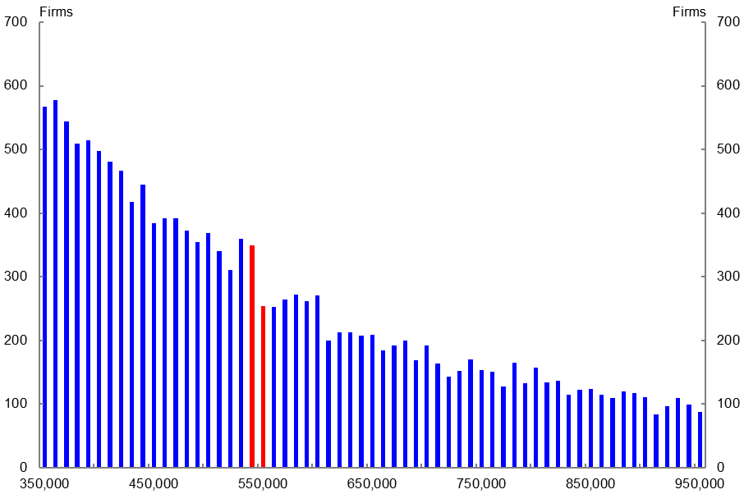

Source: BLADE.

Chart D2: Taxable wages for Victoria 2011-12 (threshold $550,000)

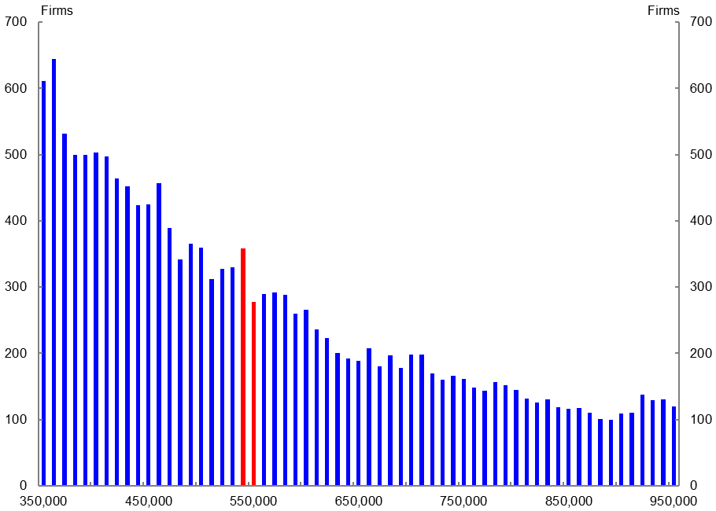

Source: BLADE.

Chart D3: Taxable wages for Victorian 2012-13 (threshold $550,000)

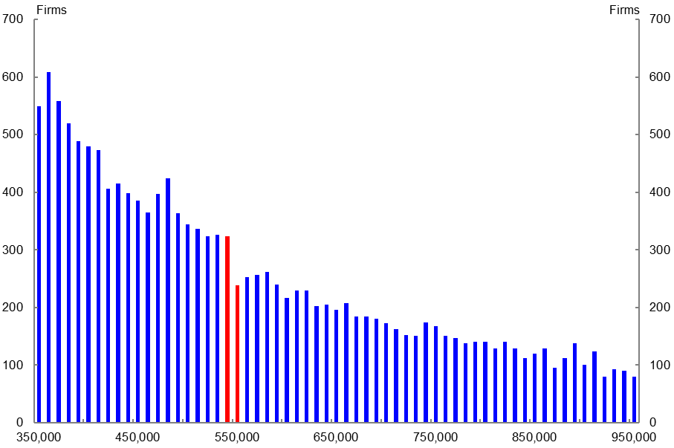

Source: BLADE.

Chart D4: Taxable wages for Western Australia 2012-13 (threshold $750,000)

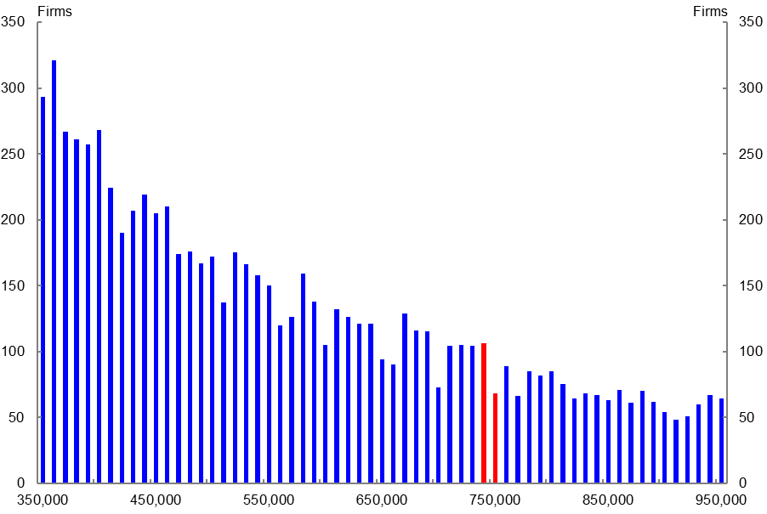

Source: BLADE.

Chart D5: Taxable wages for Western Australia 2013-14 (threshold $750,000)

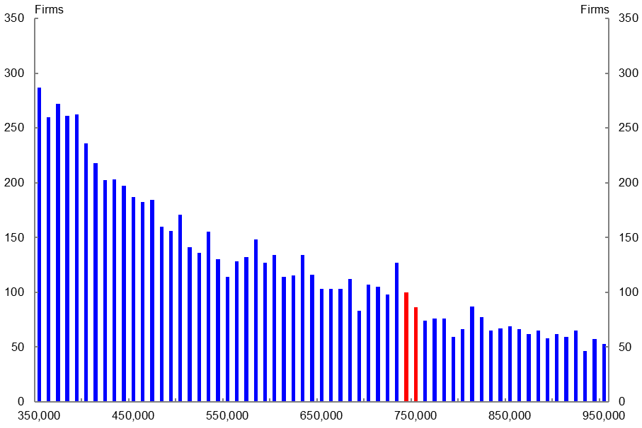

Source: BLADE. Note: The difference between the bars either side of the $750,000 is small, but it is the band near the threshold that is taken into consideration when deciding whether bunching occurs.

Chart D6: Taxable wages for Western Australia 2014-15 (threshold $800,000)

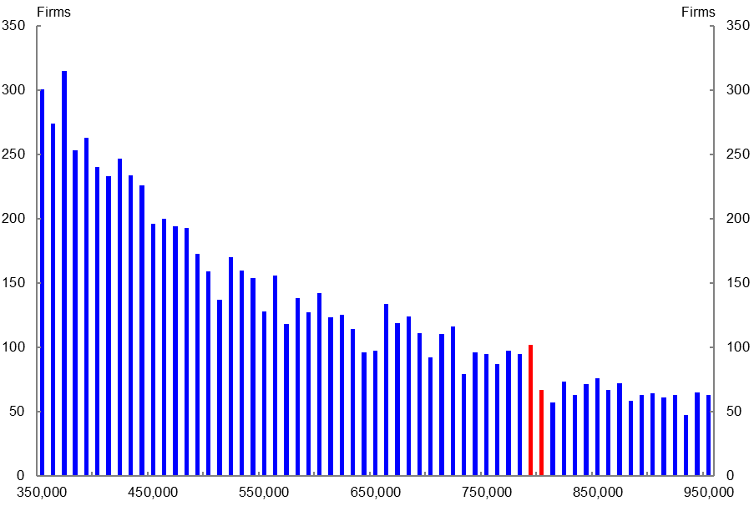

Source: BLADE.

Appendix E

The following table summarises the results when the threshold is increased by 10 per cent. This was done to demonstrate that mismeasurement issues were not a factor in the results obtained. The table shows bunching only occurred once, in New South Wales in 2008-09. This single occurrence is consistent with a false positive.

Table E1: Increasing the threshold by 10 per cent

|  |  |  |
| --- | --- | --- |
| State | No. of tests | No. found significant\* |
| New South Wales | 14 | 1 |
| Northern Territory | 7 | 0 |
| Queensland | 14 | 0 |
| South Australia | 14 | 0 |
| Tasmania | 11 | 0 |
| Victoria | 14 | 0 |
| Western Australia | 14 | 0 |
| **Total** | **88** | **1** |

\* 95 per cent confidence interval.

For completeness, the threshold was decreased by 10 per cent. As before, isolated cases were found but nothing consistently pointing to bunching was found. The two instances in South Australia were for non‑consecutive years (2003–04 and 2008–09).

Table E2: Decreasing the threshold by 10 per cent

|  |  |  |
| --- | --- | --- |
| State | No. of tests | No. found significant\* |
| New South Wales | 14 | 1 |
| Northern Territory | 14 | 0 |
| Queensland | 14 | 0 |
| South Australia | 14 | 2 |
| Tasmania | 12 | 0 |
| Victoria | 14 | 1 |
| Western Australia | 14 | 1 |
| **Total** | **96** | **5** |

\* 95 per cent confidence interval.

1. Macroeconomic Modelling and Policy Division, Macroeconomic Group, The Treasury, Langton Crescent, Parkes ACT 2600, Australia. Correspondence: ben.ralston@treasury.gov.au. I would like to thank John Swieringa, Laura Berger-Thomson, Bob Breunig, Renee McKibbin, David Hansell as well as helpful comments from seminar participants. [↑](#footnote-ref-2)
2. The views expressed in this paper are those of the authors and do not necessarily reflect those of The Australian Treasury or the Australian Government. The results of these studies are based, in part, on ABR data supplied by the Registrar to the ABS under *A New Tax System (Australian Business Number) Act 1999* and tax data supplied by the ATO to the ABS under the *Taxation Administration Act 1953*. These require that such data is only used for the purpose of carrying out functions of the ABS. No individual information collected under the *Census and Statistics Act 1905*  is provided back to the Registrar or ATO for administrative or regulatory purposes. Any discussion of data limitations or weaknesses is in the context of using the data for statistical purposes, and is not related to the ability of the data to support the ABR or ATO’s core operational requirements. Legislative requirements to ensure privacy and secrecy of this data have been followed. Only people authorised under the Australian Bureau of Statistics Act 1975 have been allowed to view data about any particular firm in conducting these analyses. In accordance with the Census and Statistics Act 1905, results have been confidentialised to ensure that they are not likely to enable identification of a particular person or organisation. [↑](#footnote-ref-3)
3. Hereafter, “state and territory” is referred to as “state”. [↑](#footnote-ref-4)
4. Labour hire firms in some states are considered the employer and are required to pay payroll tax, regardless of the total remuneration of the contracting firm. In some other states only the total wages bill of the contracting firm is taken into consideration and not the total wages bill of the labour hire firm. However, in these states the labour hire firm is still required to pay payroll tax. [↑](#footnote-ref-5)
5. Reinhardt and Steel (2006). [↑](#footnote-ref-6)
6. For a detailed discussion of these processes, see Hansell and Rafi (2018). In addition, firms with turnover of less than $75,000 are removed. [↑](#footnote-ref-7)
7. The rules for payroll tax liability are complicated when an employee is engaged in work outside the same state where wages are paid. See New South Wales Revenue Ruling no. PTA 001 as an example. [↑](#footnote-ref-8)
8. SA4 was chosen because these are defined by the ABS as having a self-contained labour market. This would lessen the potential problems of workers crossing state borders. [↑](#footnote-ref-9)
9. New South Wales Revenue ruling no. PTA 038. [↑](#footnote-ref-10)
10. This method is not used as there are concerns with the McCrary test when the bandwidths have different lengths. [↑](#footnote-ref-11)
11. The tests conducted in this paper are one-tailed tests because the concern is whether bunching occurs below the threshold. [↑](#footnote-ref-12)
12. The asymptotic mean squared error is defined as: [↑](#footnote-ref-13)
13. Western Australia announced the increase in the 2014-15 threshold in the 2013-14 Budget on 8 August 2013. [↑](#footnote-ref-14)
14. The bandwidths for Victoria and Western Australia were also applied. [↑](#footnote-ref-15)