INFORMATION NOTE
Superannuation balances at retirement
This is the second in a series of information notes to showcase some results of Treasury’s new dynamic microsimulation Model of Australian Retirement Incomes and Assets (MARIA) .
This note explores the expected evolution of superannuation balances at retirement over time. We use MARIA to analyse the projected trends over the coming decades and take a closer look at how the differences between genders are projected to evolve.
Assuming policy is held constant, we find that in the future retirees will generally have higher balances at retirement compared to retirees today as they will spend more of their working life with higher levels of compulsory superannuation.
Both men and women’s balances will increase over time. The gender gap in balances is expected to reduce, but remain persist. While women continue to have lower labour force participation and incomes than men, they will continue to make up a higher proportion of those with lower balances in retirement.

About MARIA
The Model of Australian Retirement Incomes and Assets (MARIA) is a long-term dynamic microsimulation model of Australia’s retirement income system. It simulates the characteristics of each individual for every year of the model run based on their characteristics in the previous year. This method produces a lifepath for each individual and thereby seeks to capture the diversity of Australian lifetimes and how they are expected to change in the future. The dynamic aspect is crucial for modelling Australia’s retirement income system as the characteristics of future retirees are likely to differ from current retirees as the superannuation system matures.
There are a range of circumstances that can affect the retirement incomes of individuals. These include: their family composition including whether they have a partner; how much time they spend in the workforce and how much they get paid; how much they save for their retirement; if they own a home and the impact of disability or illness. Simulating detailed distributions of retirement income and assets in the long-term requires predicting all of these factors for each of the individuals in MARIA.
MARIA begins with 2013-14 base data which captures the Australian population aged 25 and over at a set point in time. The model is run on a representative sample of this complete data set. MARIA then uses Treasury analysis and projections – the ‘input parameters’ – to model the lifepaths (including employment status, superannuation contributions and balance) of these individuals from working life to retirement and death. Each year, new records are introduced to represent new 25 year olds in the population. While income from work and the accumulation of superannuation of superannuation is modelled in detail, at present, MARIA imputes savings outside superannuation (including home ownership) at the point of retirement based on characteristics including age, education level, work experience and superannuation balance.
MARIA’s long-run assumptions for indexation and economic growth are important to interpreting the analysis in this information note. MARIA assumes long-run inflation growth is 2 ½ per cent, by nominal Gross Domestic Product (GDP) growth is around 5 ¼ per cent and wages growth is around 4 per cent.
Investment returns, fees, insurance and drawdown assumptions are based on historical data. Investment returns before fees are assumed to be 7 ½ per cent in the accumulation phase and 6 ½ per cent in the retirement phase. This reflects a shift to a more conservative investment strategy post retirement. Annual fees are calculated as $74 (indexed to Average Weekly Earnings (AWE)) plus 0.85 per cent of the account balance, and insurance premiums are $214 (indexed to AWE).
MARIA projects defined contributions accounts, including voluntary contributions made to these accounts, at an individual level. The model does not model superannuation funds themselves, or any assets held by funds to support defined benefits or for regulatory capital purposes.
Modelling in MARIA is undertaken in nominal dollars. The choice of most useful deflator to present modelling results in today’s dollars depends on the context of use. The analysis in this paper seeks to compare the impact of a maturing superannuation system on different age cohorts, and for this reason nominal estimates have been deflated by AWE to 2019 dollars. This ensures differences in outcomes reflect differences in policy or income distribution rather than productivity growth. In other situations deflating outcomes by GDP or the CPI would be more useful.
All dates for MARIA output are financial years ending in the year stated, e.g. 2020 represents 2019-20.

Future retirees will generally have higher balances as the system matures | Evolution of the superannuation system  Australia’s compulsory superannuation system requires employers to contribute a minimum percentage of their employee’s earnings into superannuation.  The system was first introduced for all employees in 1992 where the superannuation guarantee rate was set at 3 per cent of earnings, and progressively increased to 9 per cent in 2002. There were further increases in the superannuation guarantee in 2013 and 2014, and today the rate is 9.5 per cent and it is legislated to gradually increase to 12 per cent between 2021 and 2025.  MARIA simulates how people accumulate superannuation over their lifetimes based on a range of personal and broader economic factors. As the superannuation system matures, the balances of the newly retired cohorts will, in general, be higher than those who have retired before them (Chart 1).  MARIA projects that a large proportion of people retiring in 2020 have low superannuation balances and very few have high balances. By 2060, the distribution of balances at retirement is more evenly spread across retirees with a significantly lower proportion of retirees with balances below $250,000.  A person retiring in 2020 after an unbroken 40-year career may have spent the first 12 years of their career without any superannuation, and then a further ten years at a much lower rate of contributions than are being paid today. A person retiring after a similar career in 2040, would have received contributions at 9 per cent or more almost their entire career, and benefitted on compound returns on their contributions for their entire career. As a result, future retirees who have relied on the superannuation guarantee alone to build their superannuation, will have higher balances at retirement compared to comparable workers retiring today.  Chart 1: Projected distribution of superannuation balances at retirement (2019 dollars, AWE deflated)  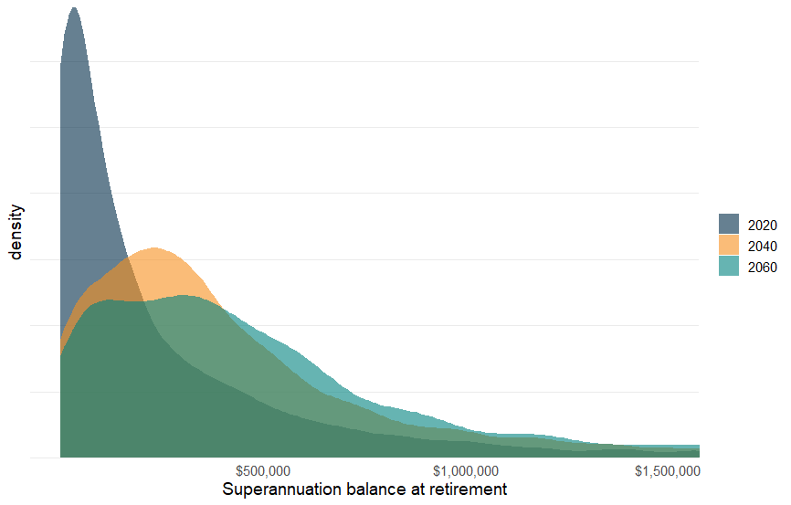  In the coming decades, fewer retirees will have low balances  Under current superannuation policy settings, most workers who retire in 2060 will experience a superannuation guarantee rate of 12 per cent for the majority of their working lives.  Chart 2 shows the projected increase in the number of people with higher superannuation balances at retirement as the system matures.  65 per cent of people retiring in 2020 are expected to have balances below $250,000 at retirement. The proportion is expected to decrease to 30 per cent by 2060.  Conversely, the proportion of people retiring with a superannuation balance of over $1 million is projected to grow over time. MARIA projects that only 7 per cent of people retiring in 2020 will have a balance over $1 million, whereas 13 per cent of people retiring in 2060 will have balances above this amount.

Chart 2: Proportion of superannuation balance ranges at retirement (2019 dollars, AWE deflated)

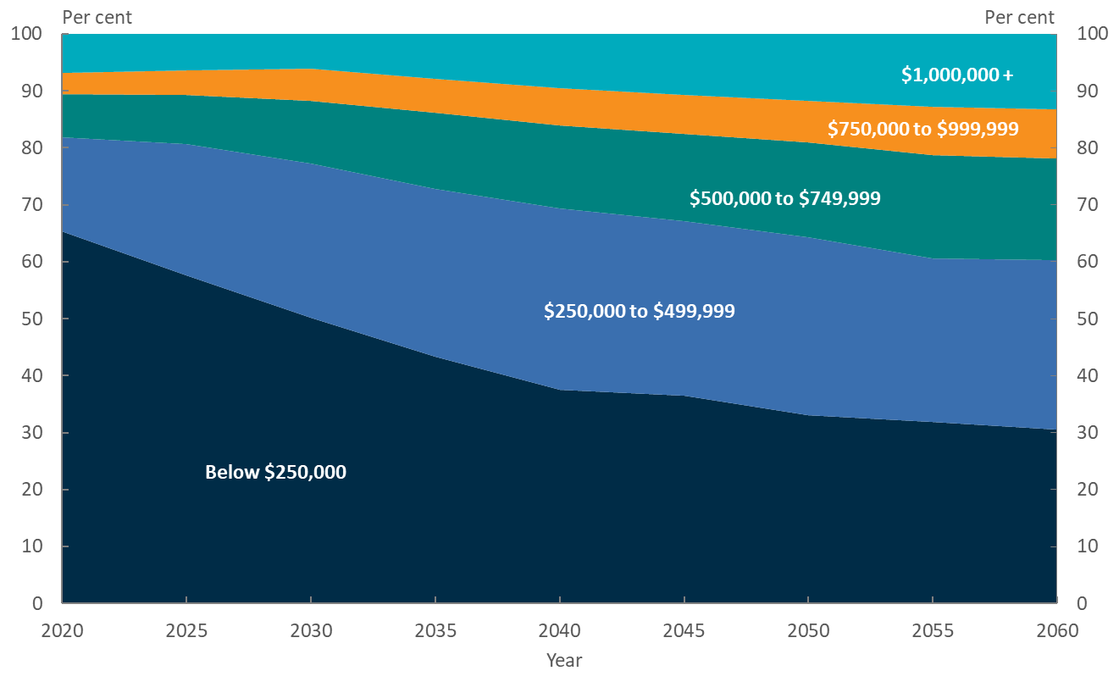

The gender gap remains
Women will continue to have lower average balances at retirement, but the gender gap is expected to narrow in future | MARIA shows that while future superannuation balances at retirement will continue to increase for both genders, women’s balances will continue to lag behind men’s balances.  As superannuation guarantee contributions are linked to employment and income, lower female participation rates and earnings lead to the gender gap in superannuation balances. This gender gap is driven by both a discrepancy in male and female labour force participation rates and that men, on average, have higher incomes than women.  MARIA aligns participation rates to Treasury’s long-run labour force projections. These projections indicate that the labour force participation rate for men over 25 will continue to be higher than for women of the same age.  That said, the gap between male and female labour force participation has narrowed in recent years, and the effect of this narrowing will feed through into retirement balances in the future.
Chart 3: Distribution of superannuation balances at retirement by gender (2019 dollars, AWE deflated)
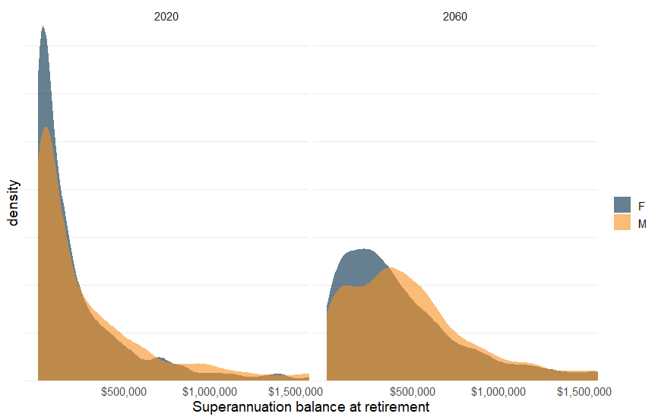

This is expected to result in a reduction in the gender gap in balances over time. In 2020, the average balance at retirement for women is expected to be around 30 per cent less than men. By 2040, this gap is projected to reduce to around 15 per cent, and by 2060 to around 10 per cent.
In 2020, 70 per cent of women are projected to retire with balances below $250,000 compared to 60 per cent of men. By 2060, this falls to around 35 per cent for women and 25 per cent for men.
MARIA projects that only 5 per cent of women retiring in 2020 will have a superannuation balance of more than $1 million, while men are almost twice as likely to reach this outcome. By 2060, superannuation millionaires will be much more common – over 10 per cent of women are projected to retire with over $1 million in superannuation, compared with almost 15 per cent of men.

Summary

- MARIA provides useful insights on the evolution of the retirement income system in the coming decades.
- Future retirees will have spent more of their working life receiving higher rates of superannuation guarantee contributions, so fewer people are projected to retire with low balances.
- Both men and women’s balances increase over time. The gender gap in balances is expected to reduce, but persist. As long as women continue to have lower labour force participation and incomes than men, they will continue to make up a higher proportion of those with lower balances in retirement.

The views expressed in this note are those of The Treasury and do not necessarily reflect those of the Australian Government. This note was prepared by Katarina Trinh, Mark Bott, Jacob Stone, Elliot Lavers and Nancy Luo in Revenue Group.
MARIA simulates a range of life events each year for each individual in the model to project people’s income and assets in retirement.
For more detail on the modelling methodology used in MARIA, see http://research.treasury.gov.au/treasury-working-paper/2017-02/.
Further information on female labour force participation scenarios in MARIA can be found in the Information Note: ‘Female Labour Force Participation and Retirement Outcomes in MARIA’ http://research.treasury.gov.au/treasurys-two-cents/female-labour-force-participation-and-retirement-outcomes-maria.

